Boston (3D-printed/FR4 version) Assembly Instructions, Draft, Incomplete (10/25/2020)
Thanks for your purchase!
To do: write how to flash QMK firmware (QMK Configurator still needs to be set up, so that will need to wait)
What’s in the box:
- The PCB
- The 3D-printed case, which comes in 4 pieces: the left half, right half , left-key-separator, and right-key-separator:
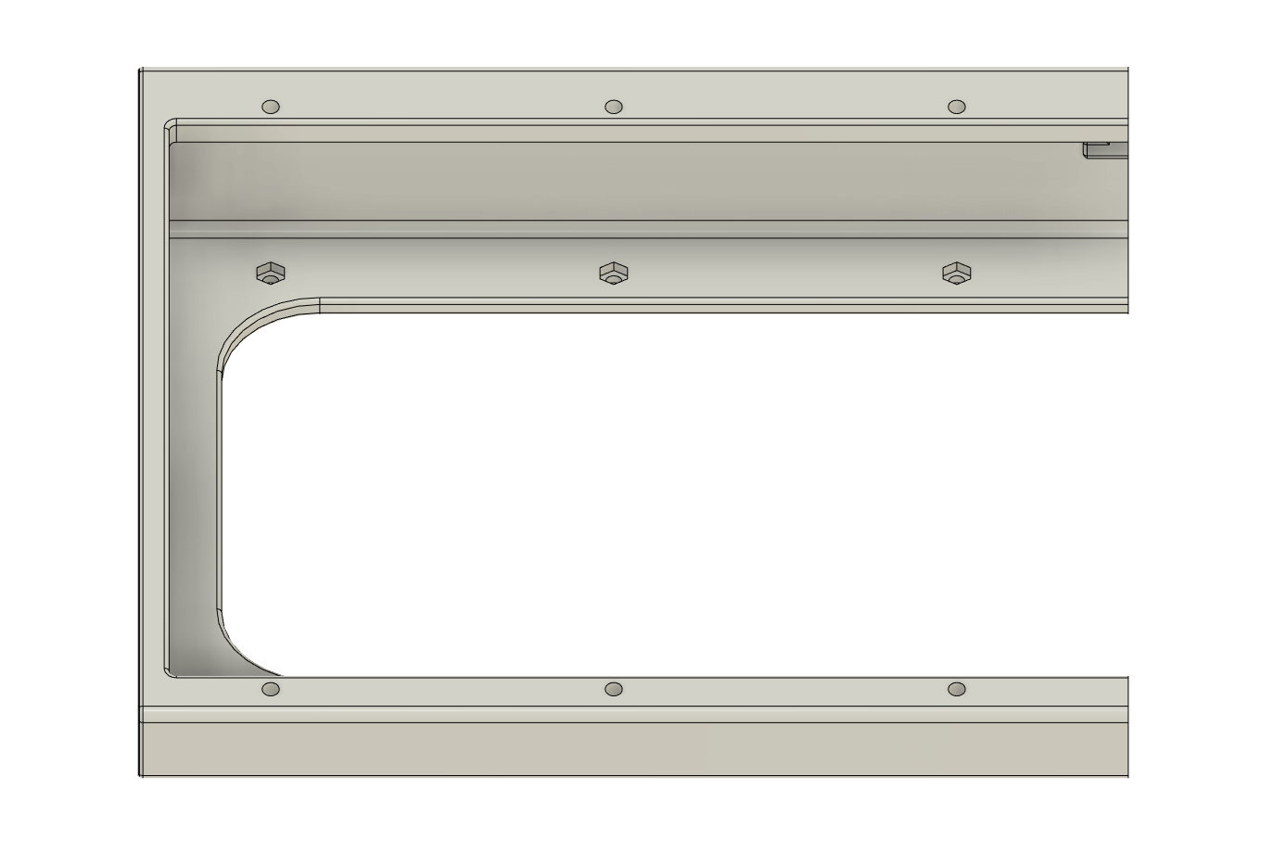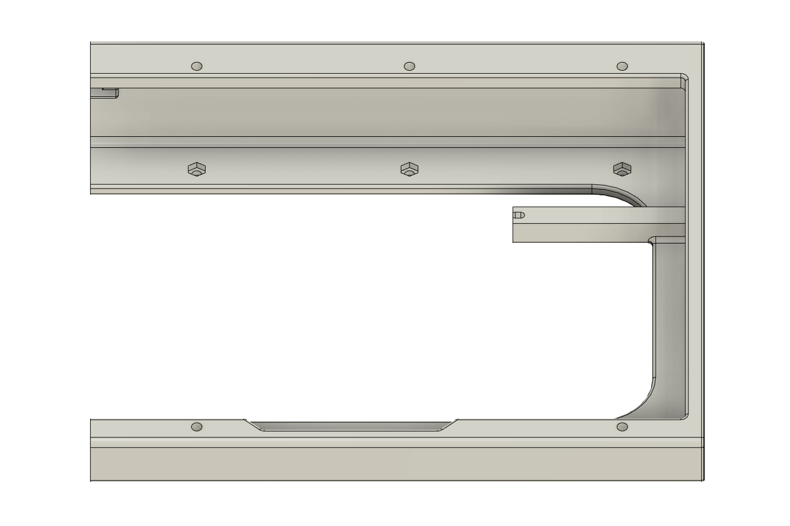

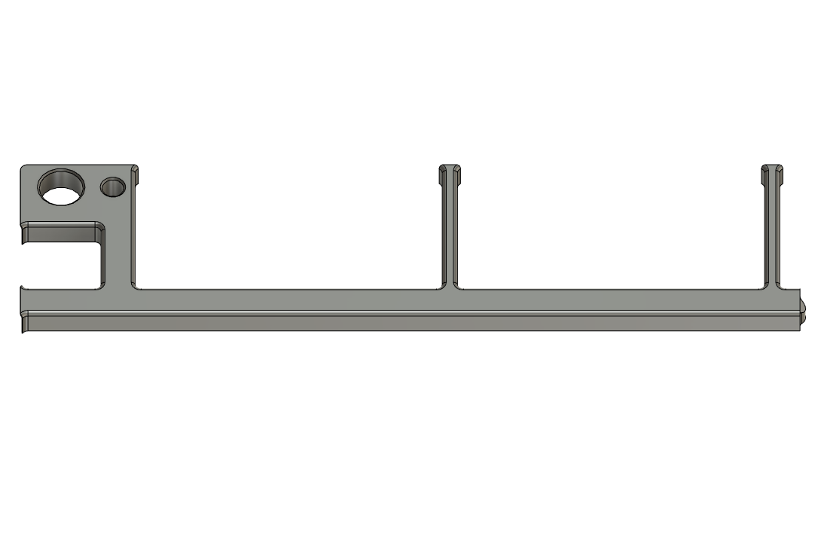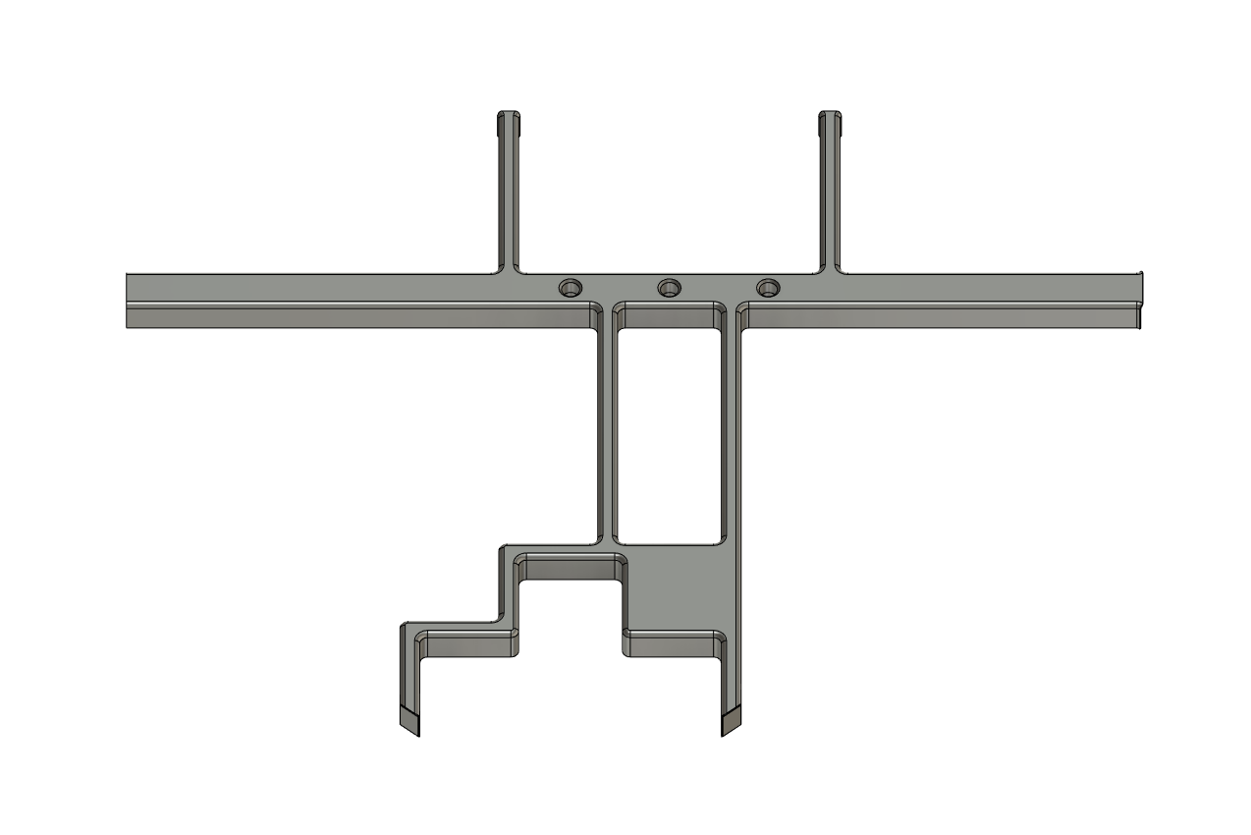
- The FR4 fiberglass plate, and the FR4 bottom panel
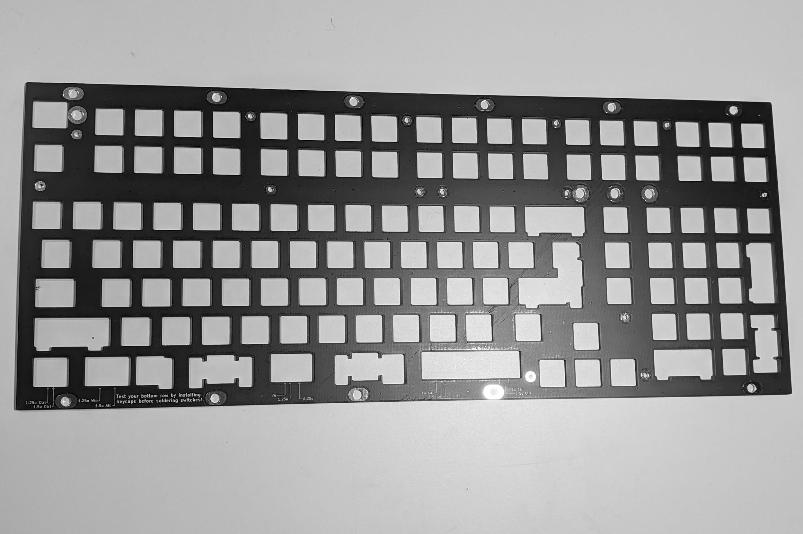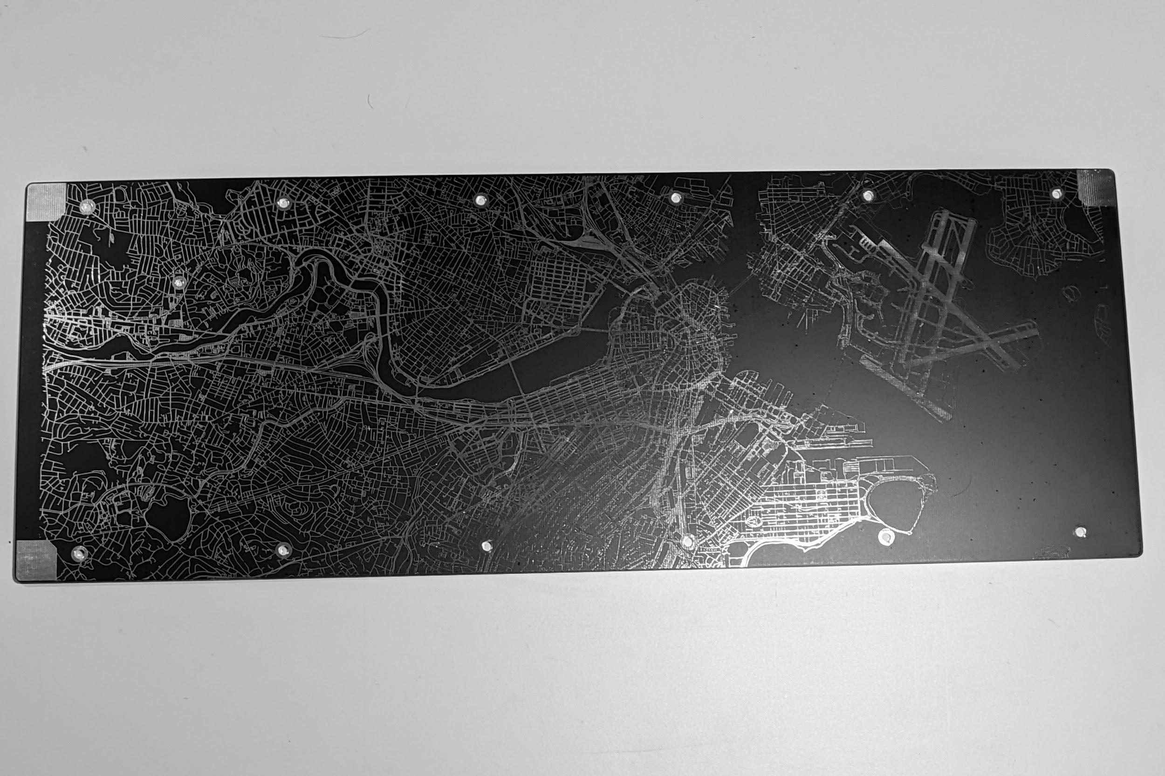

- 2x FR4 rubber feet holders, and the rubber feet
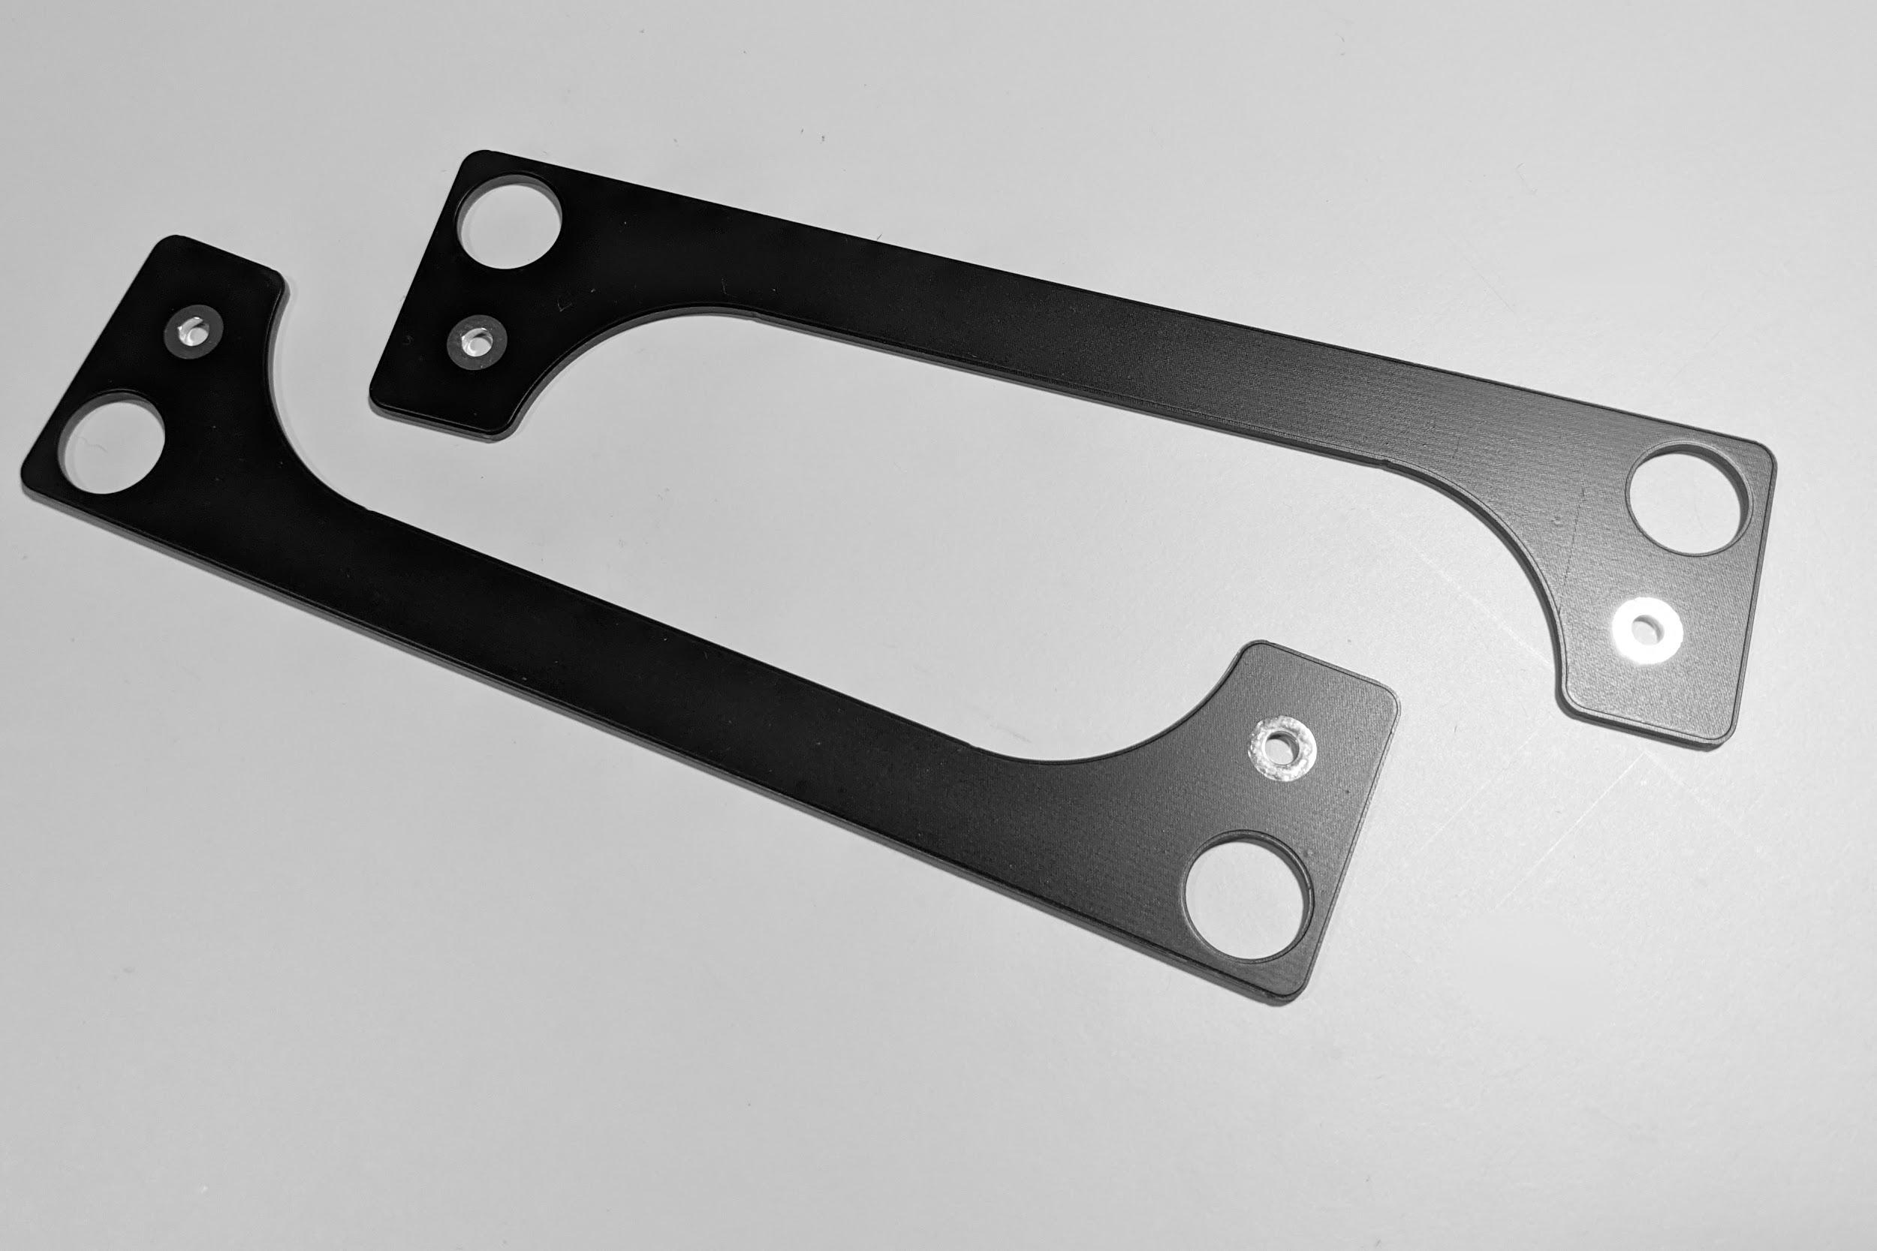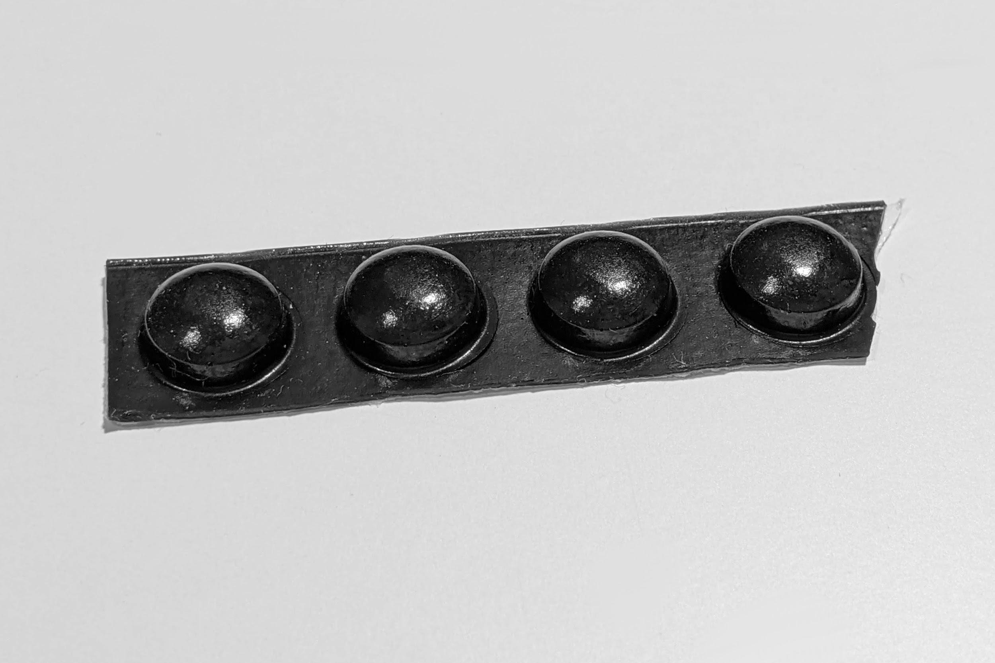
- A 3D-printed spacer for the lock LEDs:
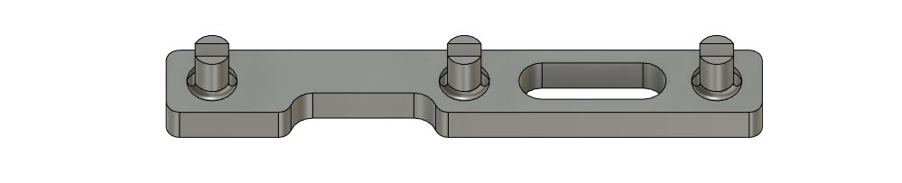
- 3x 1KΩ resistors, and 3x 3mm LEDs:
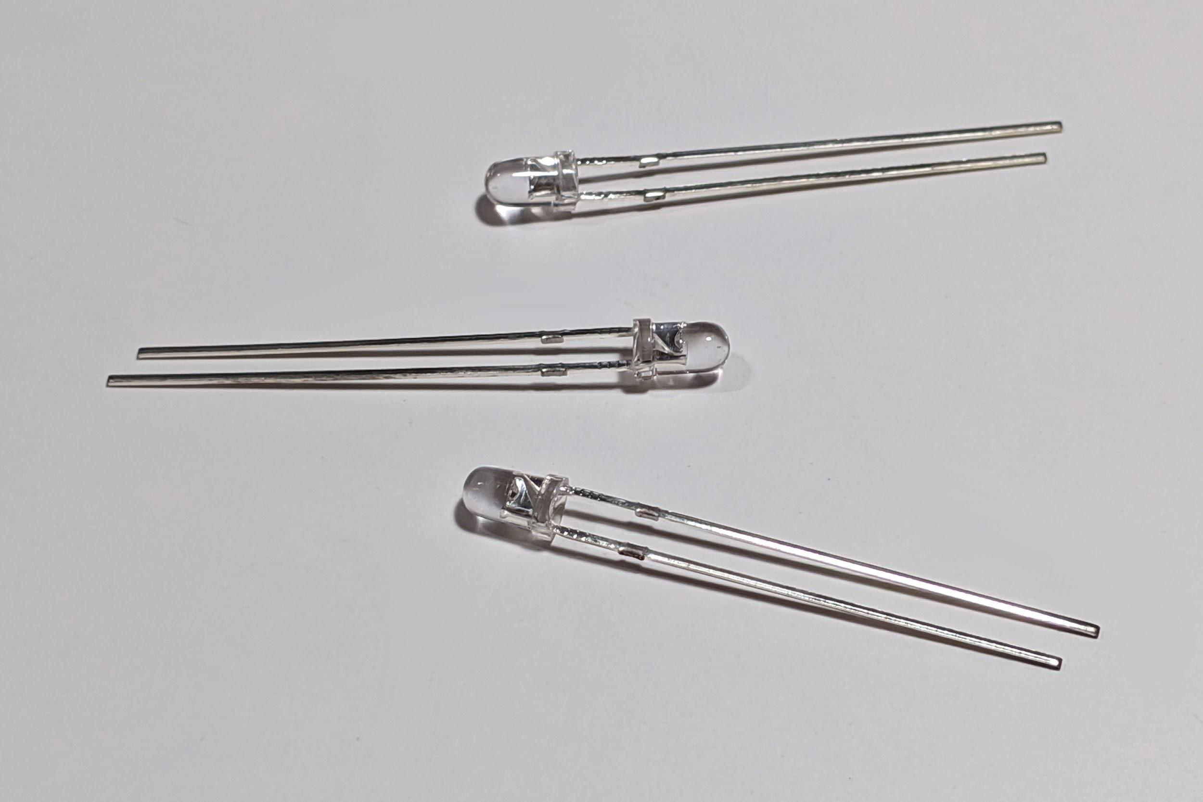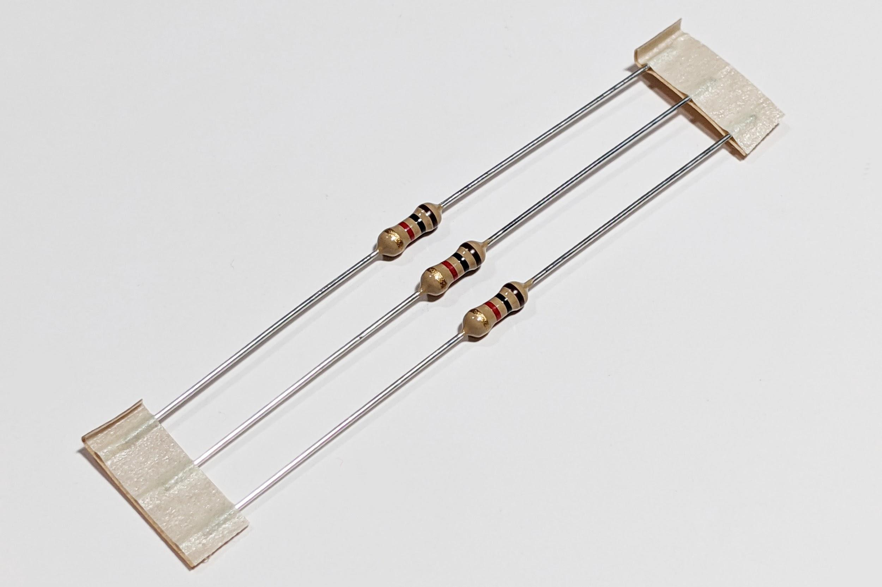

- A rotary encoder and knob:
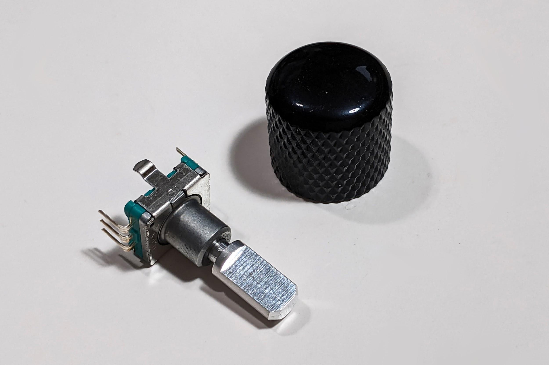

- A reset switch (This may already be soldered on your PCB - TBD)
- 15 M3x10mm screws, and 8 M3x6mm screws
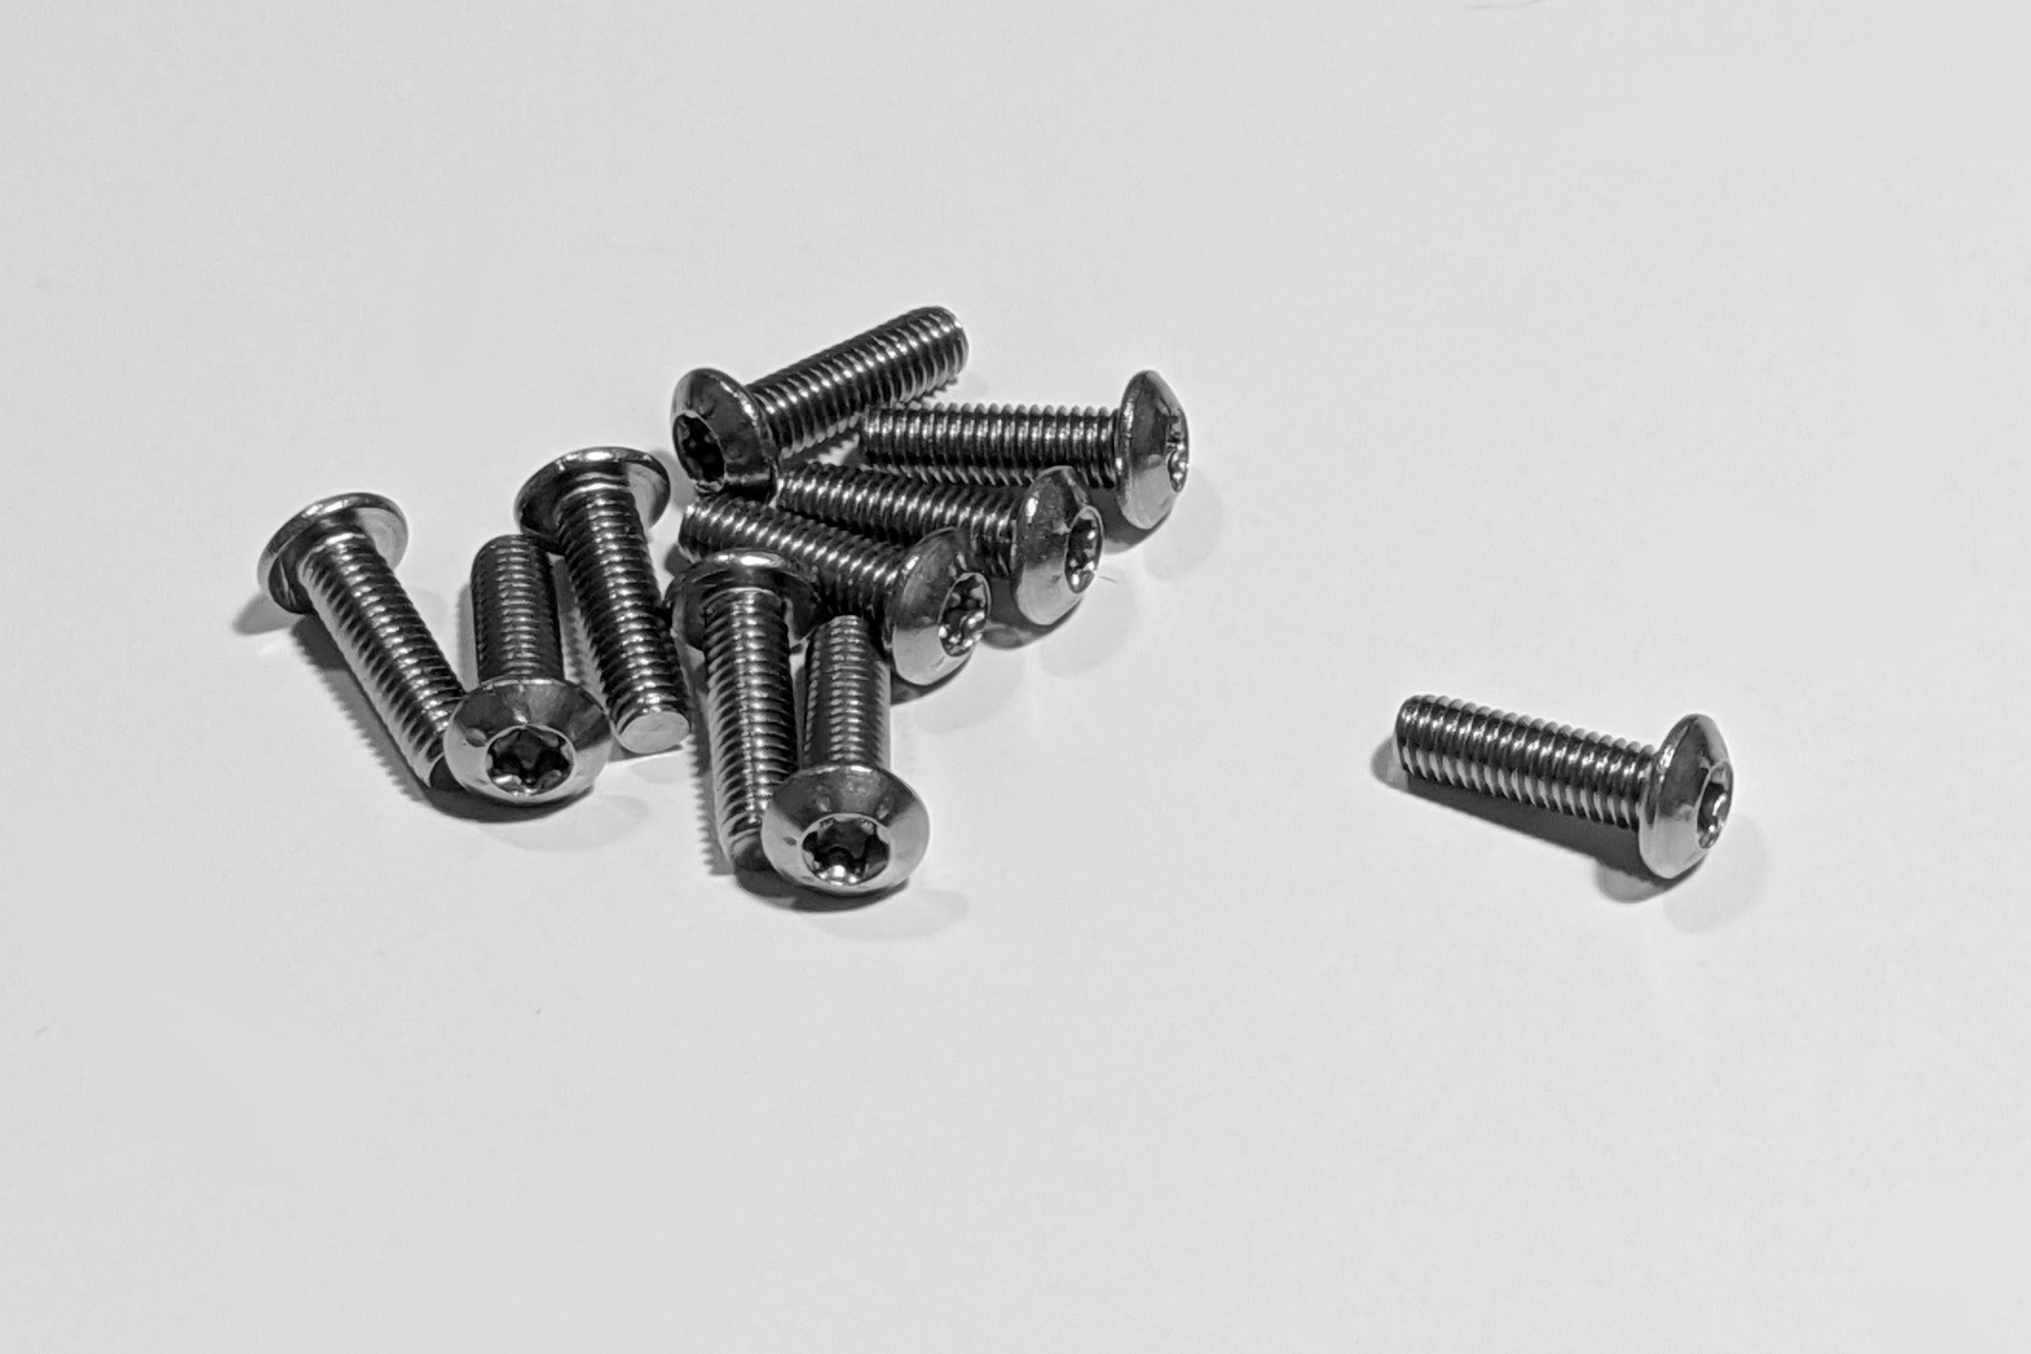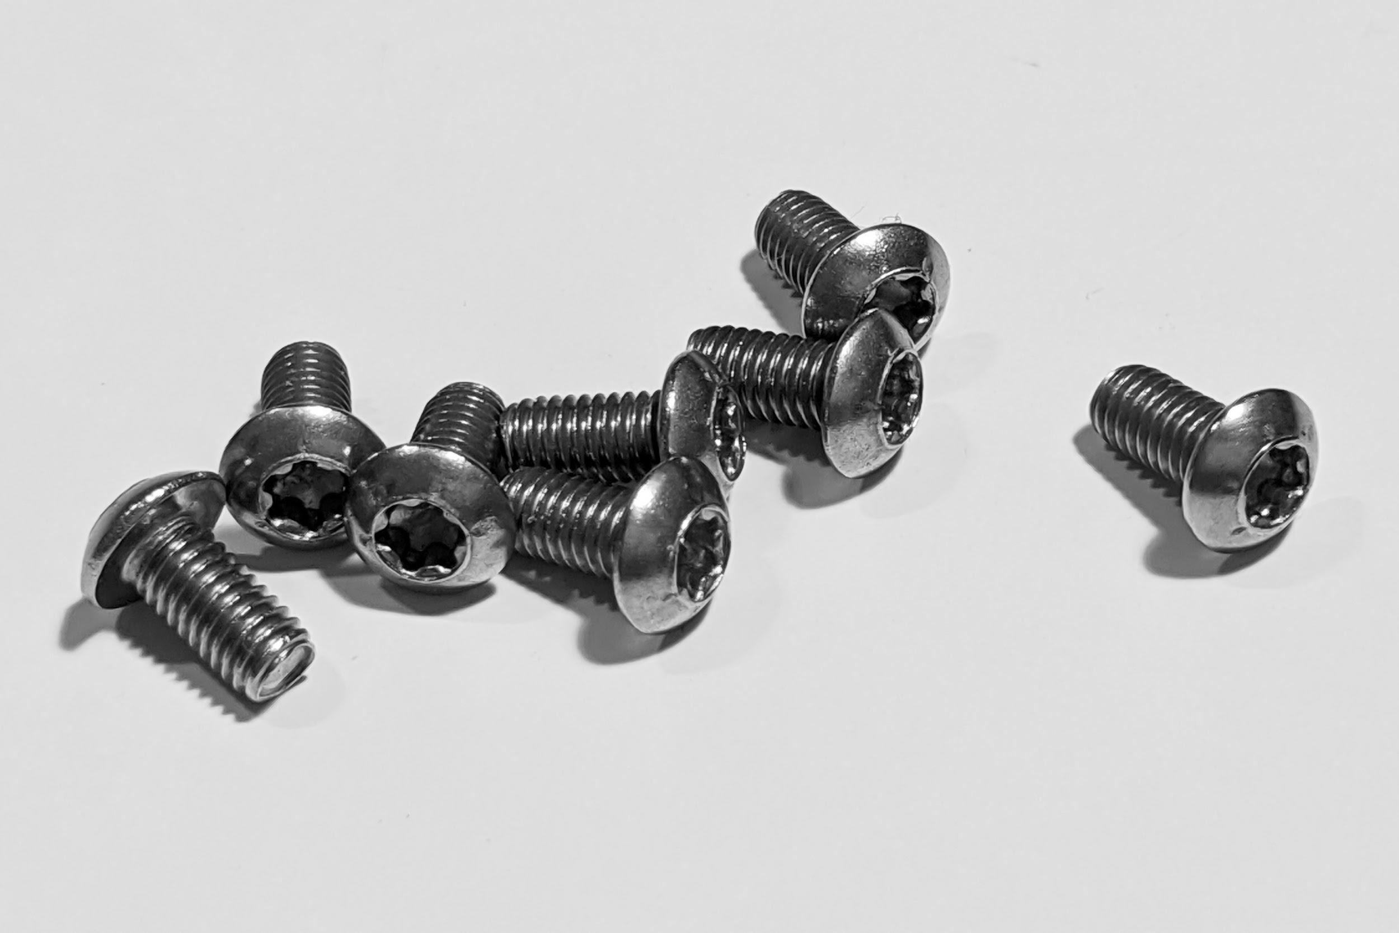
- 11 M3 PEM KF2-M3-ET threaded inserts, and 12 M3 hex nuts
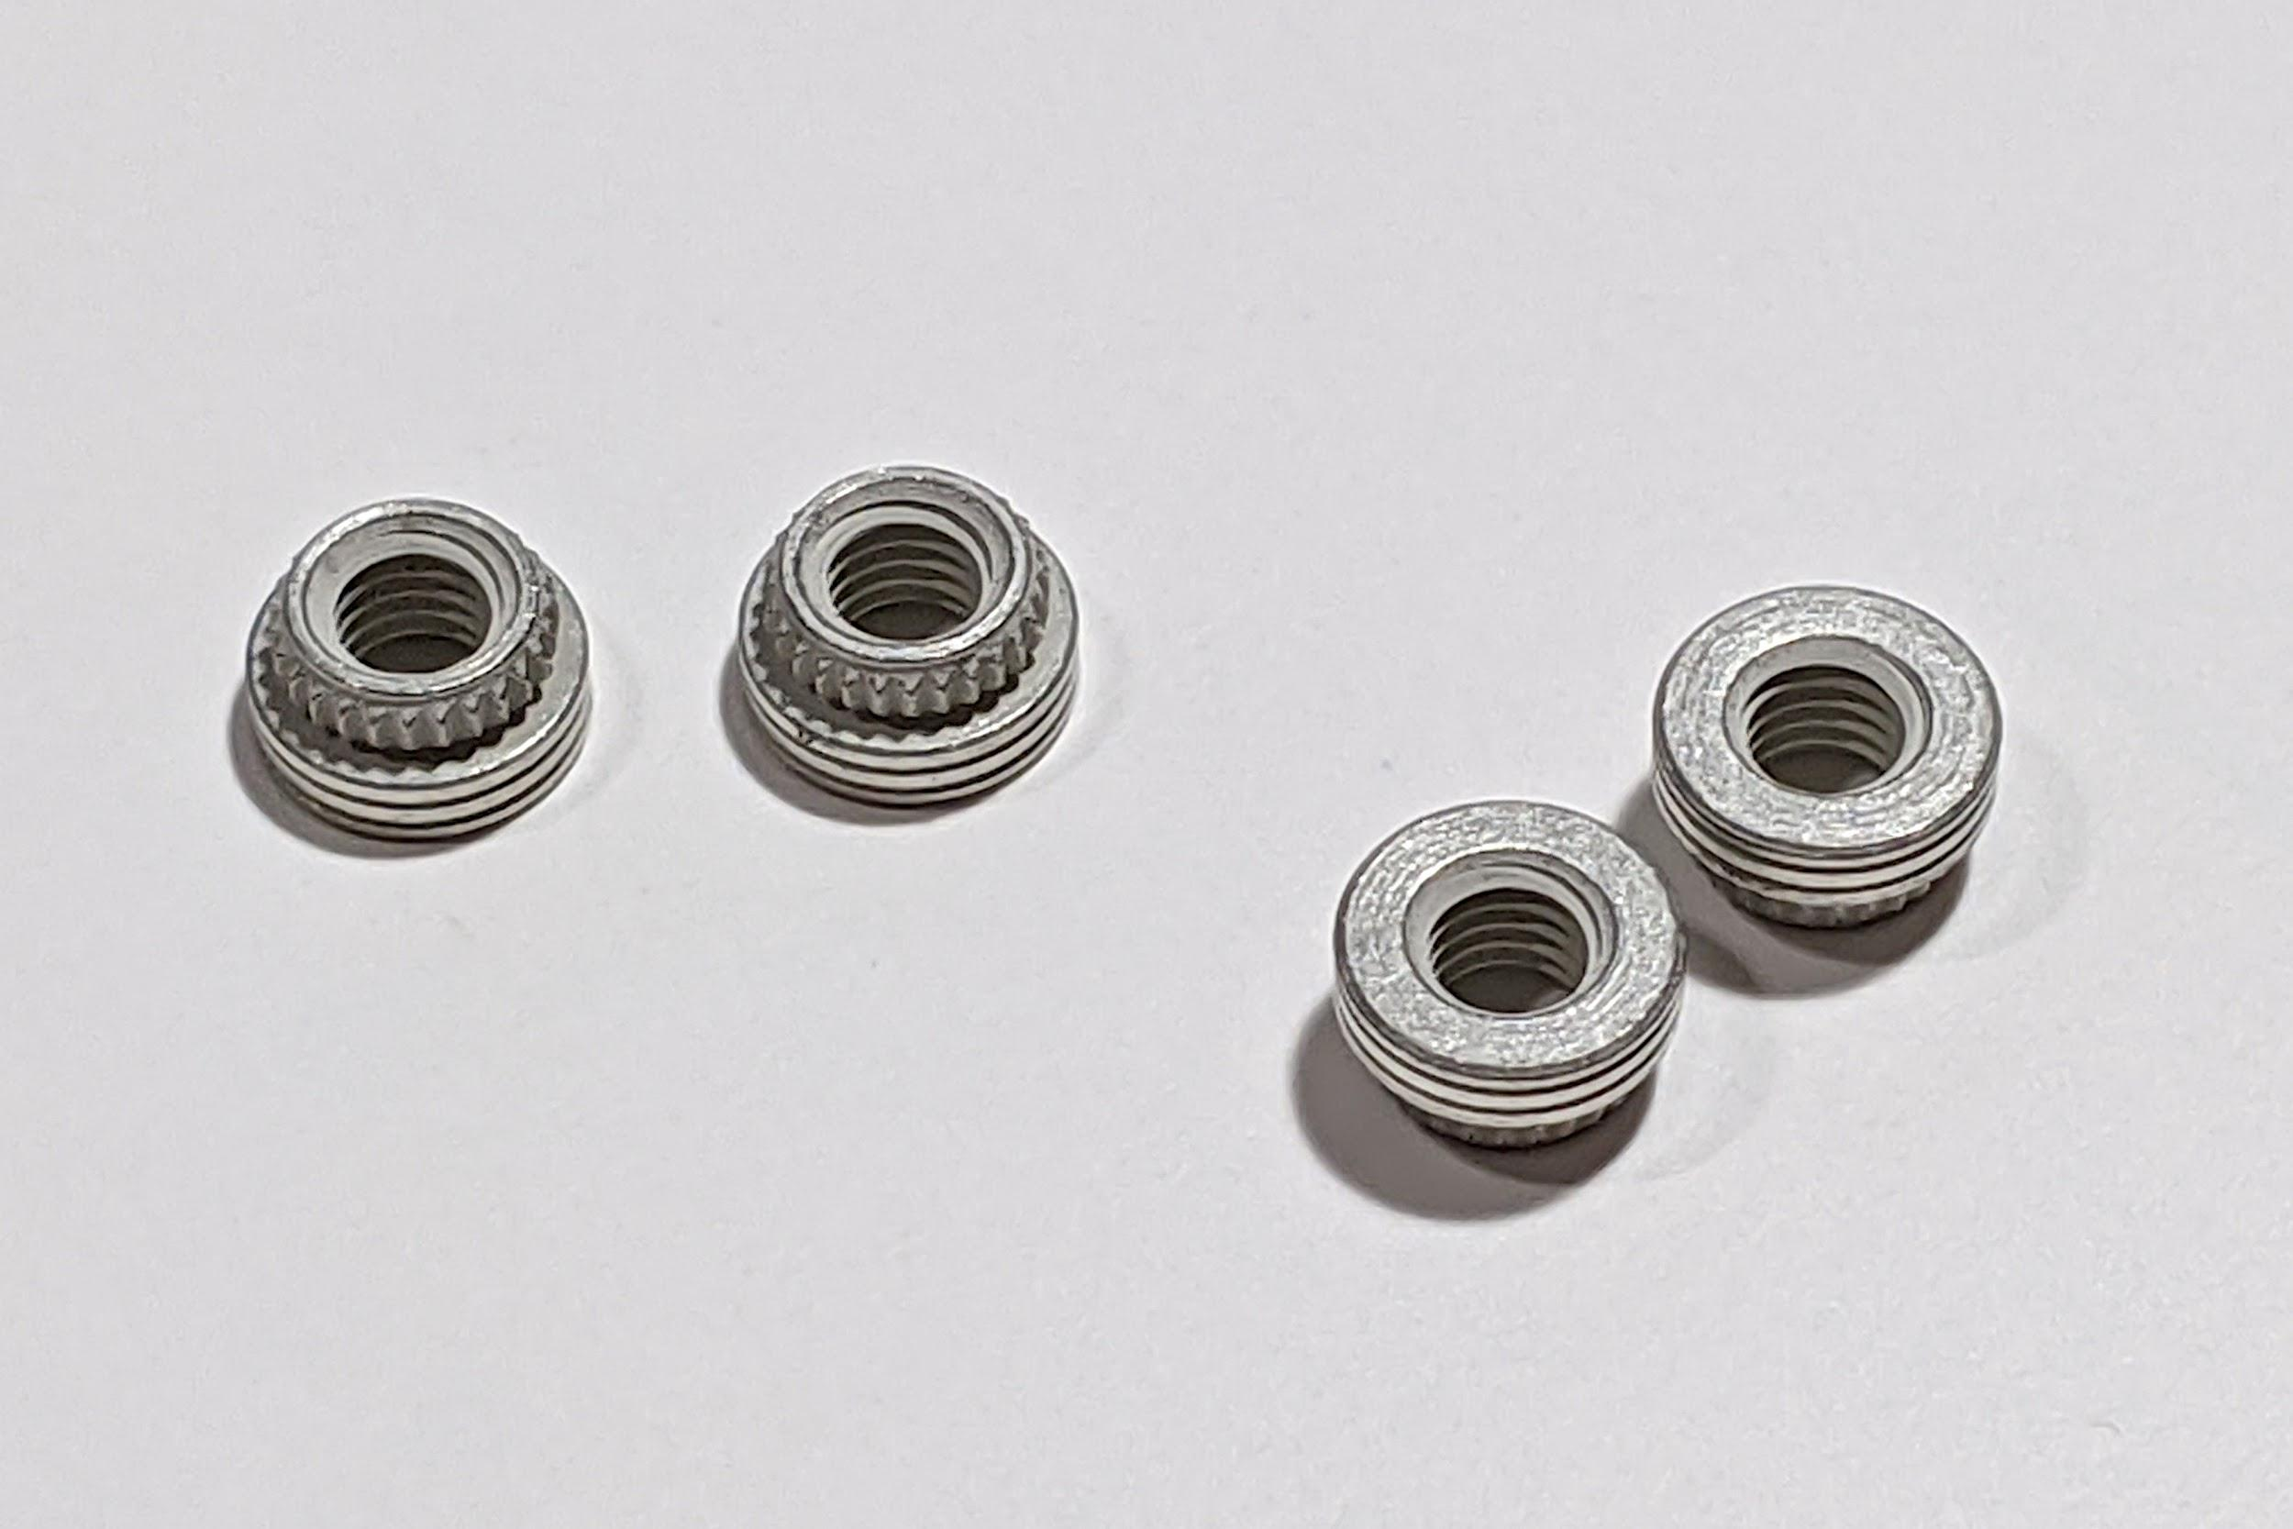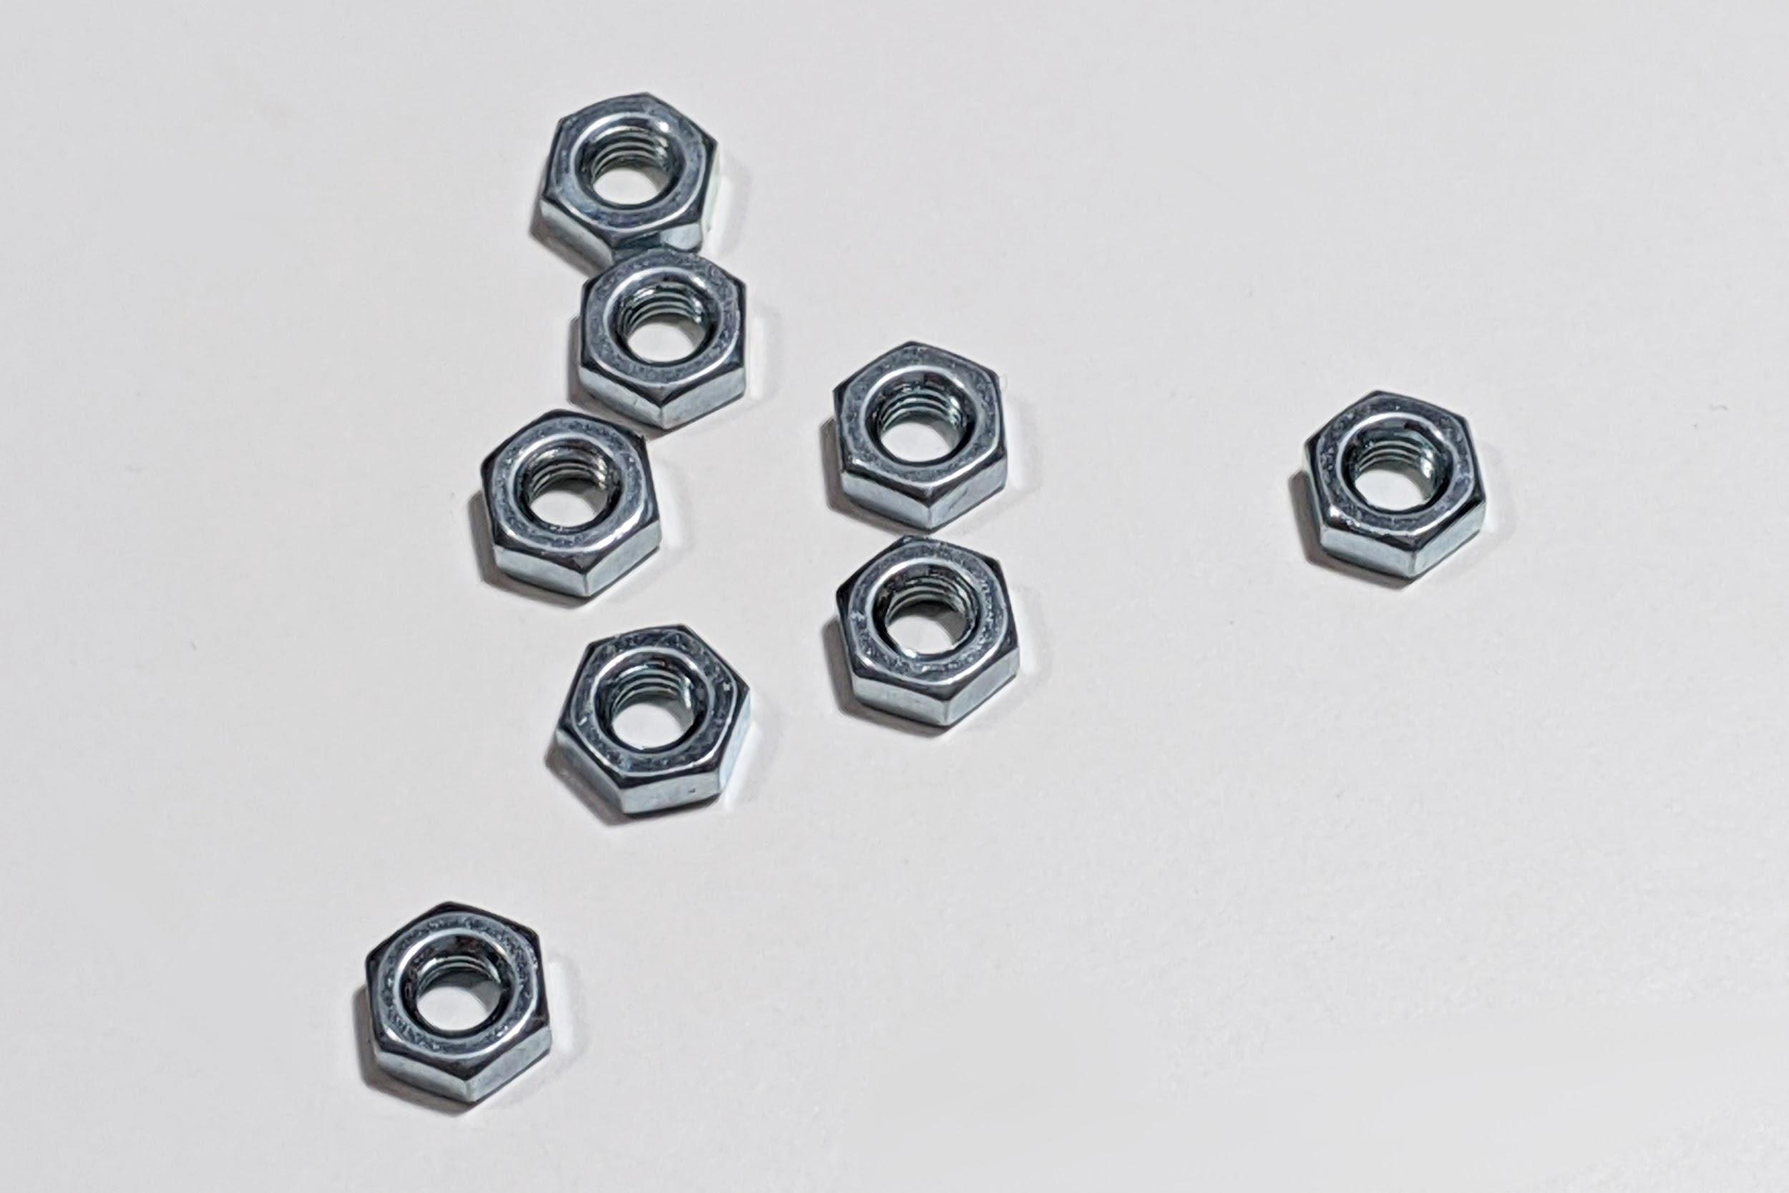
- 14 M2x5mm self-tapping screws
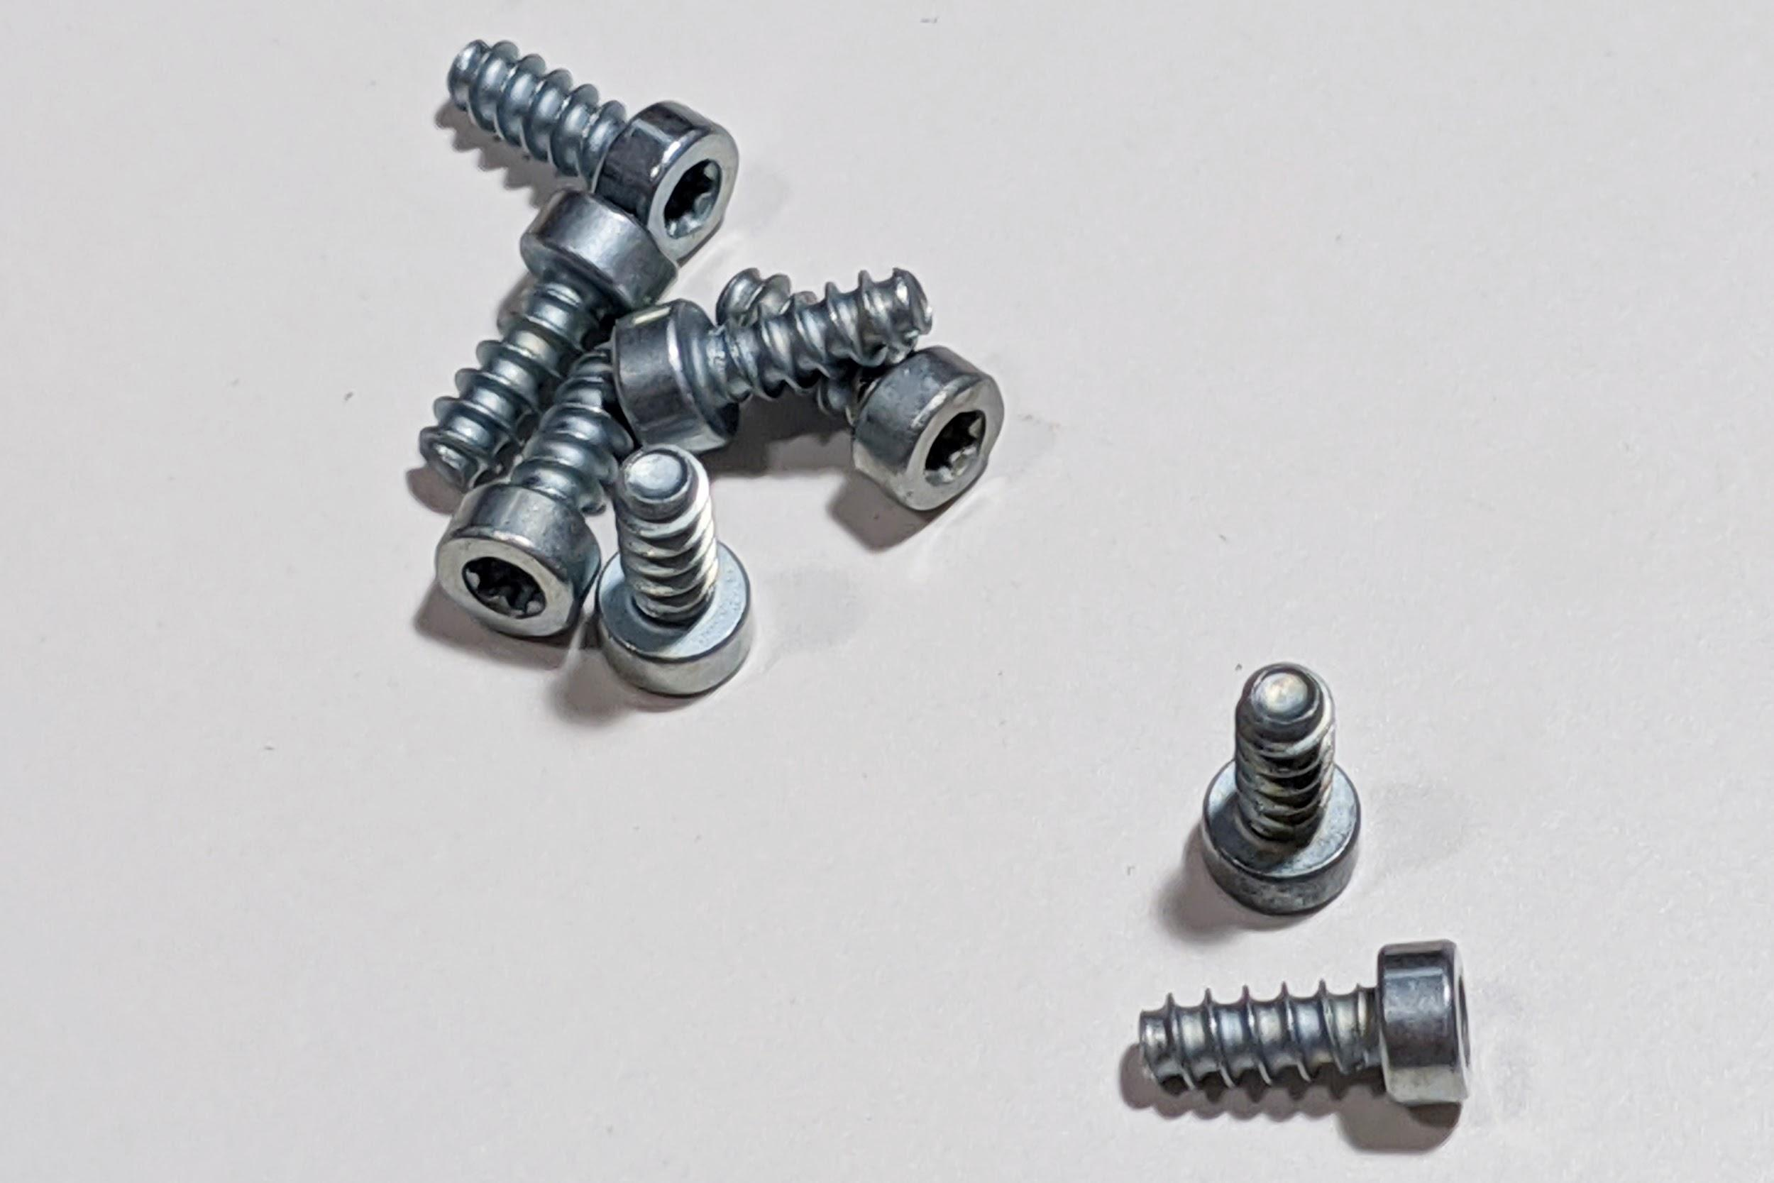
Please let us know if any of the above is missing.

Tools you’ll need to assemble the keyboard
- A T6 Torx screwdriver or key. Make sure it is actually a T6 size!. A smaller bit can fit, but will significantly increase the risk of stripping the head.
- A T10 torx screwdriver or key. Likewise, make sure it is actually a T10 size.
- A soldering iron and solder.
- Super glue
- A blue threadlocker, such as Loctite 242, is strongly recommended to prevent screws from loosening over time.

Parts you’ll need to assemble the keyboard
- MX-style switches. Depending on the layout you choose, you will need between 119 and 127 switches.
- Keycaps of your choice. Make sure that they support your desired layout.
- PCB-mount stabilizers of the correct size and quantity for your preferred layout. Screw-in stabilizers are recommended.
- A USB-C cable

Before You Start
- Please read the entirety of this guide before you begin. The assembly process for the 3D-printed version of Boston’s is somewhat different than that of most custom mechanical keyboards.
- Do not use strong chemicals such as acetone to wipe down any part of the case or PCB. This may cause damage.
- Please observe basic procedures to prevent damage from electrostatic discharge (ESD) while handling the PCB or assembling the keyboard. Wear an ESD wrist strap while you are assembling the board. Touch a grounded metal object before you begin handling the PCB to reduce risk of ESD damage, and touch a grounded metal object regularly (every couple of minutes) to discharge any ESD buildup. Remove any clothes (e.g. sweaters, socks) that can cause ESD buildup, and avoid working on a carpeted surface. The PCB has an ESD protection chip to provide some protection against electrostatic discharge (ESD) when it is fully assembled, but cannot protect the keyboard while you are building it. A guide on basic ESD protection is available here. We are not responsible for any damage to the PCB as a result of ESD.
- Soldering can be hazardous. The hot tip of a soldering iron can cause serious burns. Hot droplets of flux may fly towards you while you are soldering. Wear safety glasses while soldering. Flux fumes can be hazardous and can cause long-term lung issues. Use a fume extractor or filter while soldering, or solder in a well-ventilated location to avoid breathing in hazardous flux fumes. If you are using leaded solder, remember to thoroughly wash your hands after soldering, and do not eat or touch your face, mouth, nose, or eyes before thoroughly washing your hands to avoid lead poisoning.
- Do not overtighten the screws! This can strip the head or the threads and cause other damage.

Part 1: Putting Together The Plate
(note on the GB version I may actually do this assembly part myself, since this is tricky and difficult to explain)

Soldering the threaded inserts into the plate
Flip the plate over so that the underside of the plate (the shiny side) is facing you. Press in the PEM threaded inserts into the 11 holes on the plate.
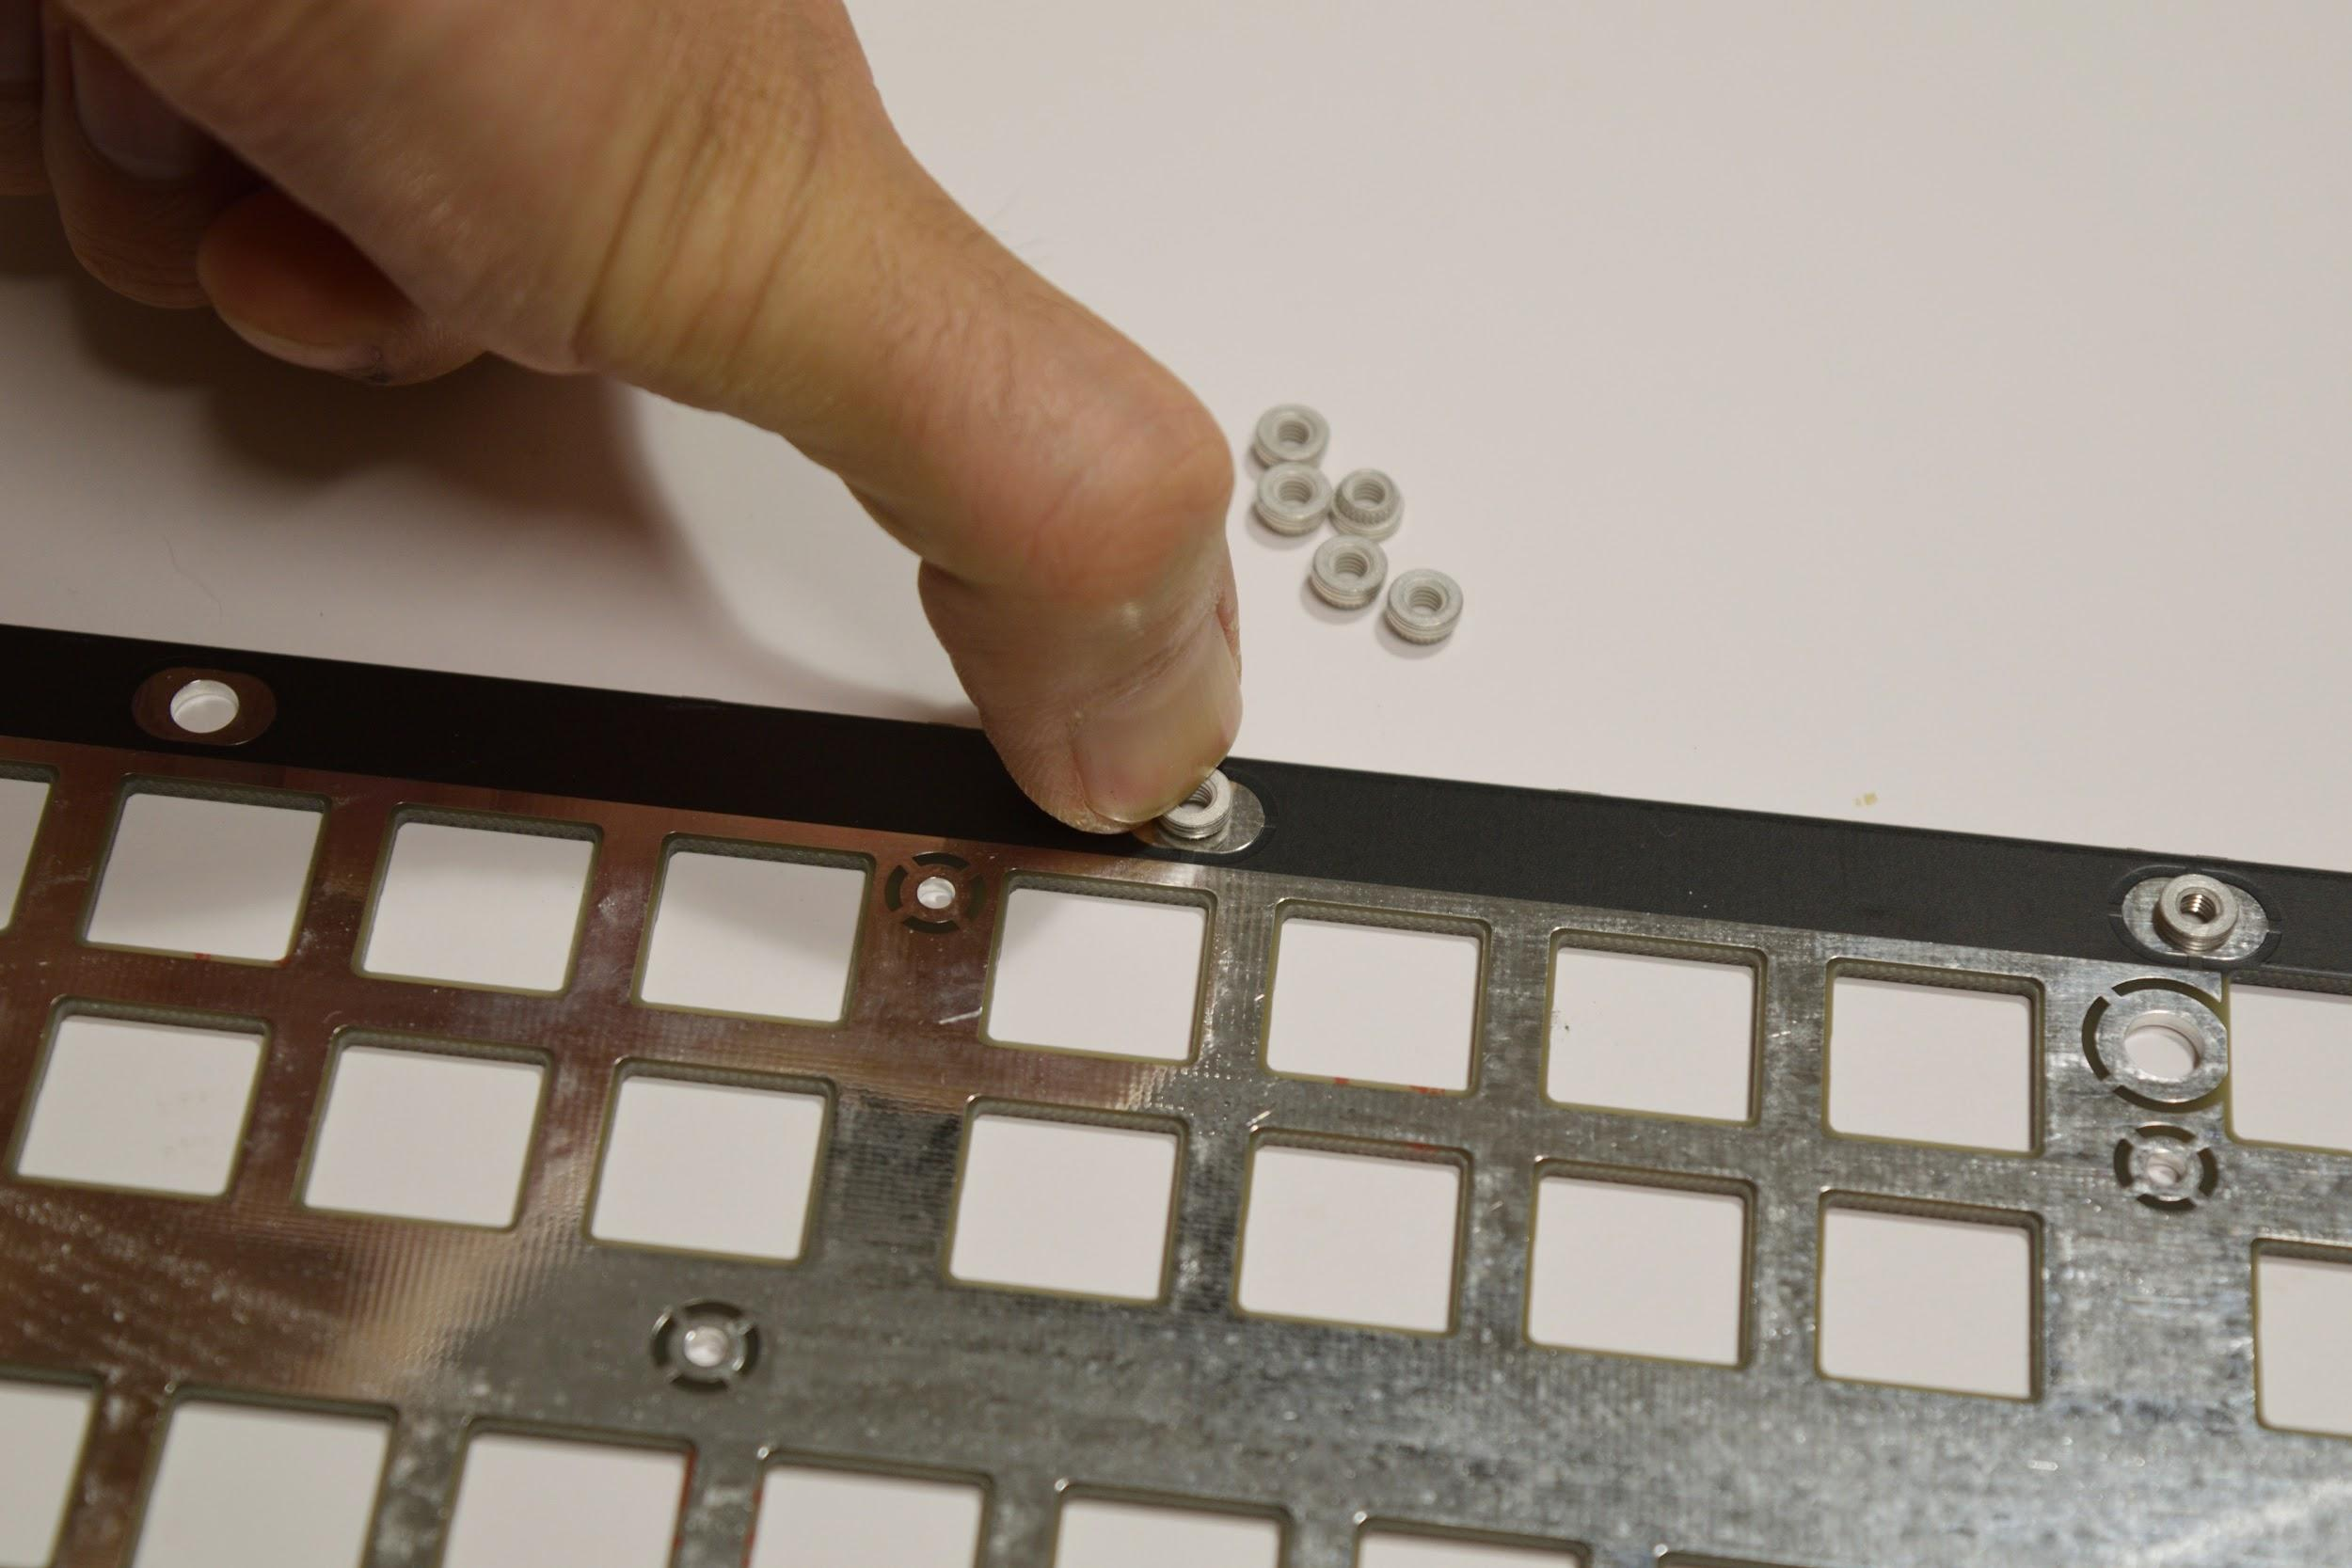
If it’s too hard to push the inserts in, you can use one of the M3x6 screws to drive the insert in, using a T10 Torx screwdriver. Remove the screw when the insert is all the way in.
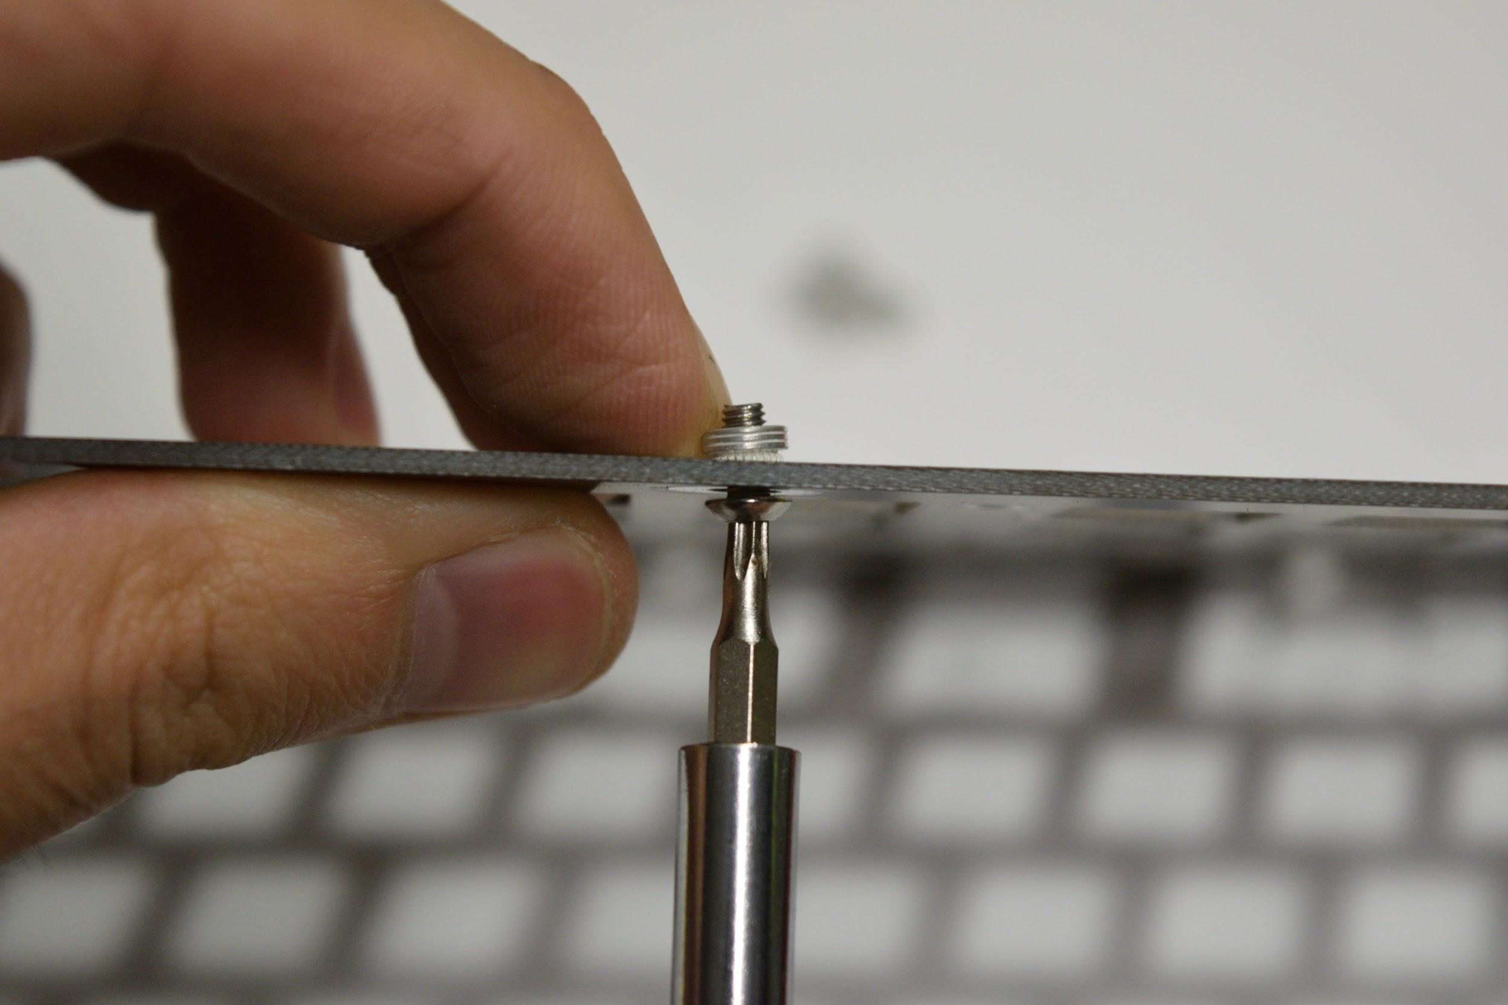

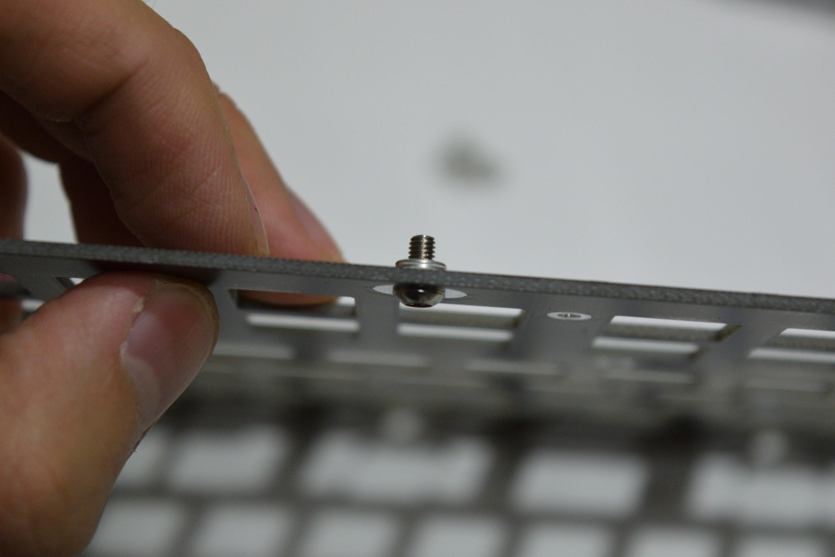
With the inserts pushed in, double check that they’re on the correct side - they should be on the bottom of the plate, not the top. Then solder, them in place:
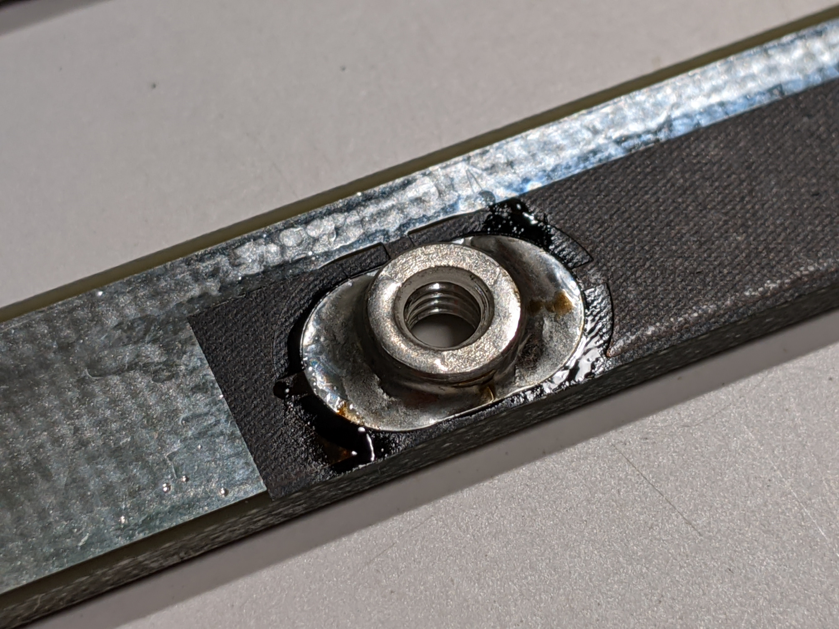
It may take some time for your soldering iron to get the nut and plate hot enough to get the solder to flow well. Also, avoid getting solder on the threads. If you get solder on the threads, try running an M3 screw through to clear solder off the threads. If that doesn’t work, use an M3 tap to remove the solder from the threads.

Attaching and adjusting the key separators
Next, grab the 3D-printed left-key-separator and right-key-separator pieces, and the M2x5 self-tapping screws.. These pieces need to attach to the plate before the switches are soldered in.
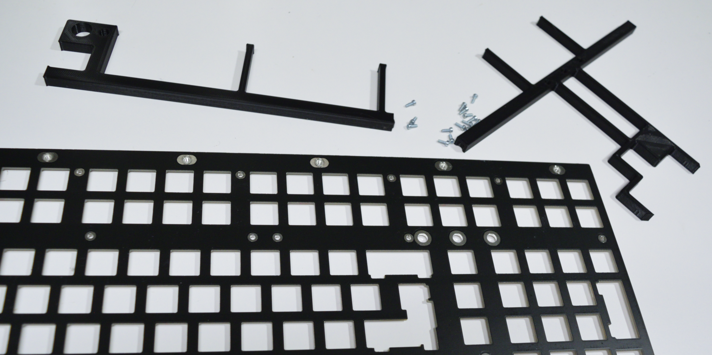

Attach the key separators to the plate the M2x5 self-tapping screws, via the small holes located in the plate. Use a T6 Torx screwdriver for this. Make sure the screws go in straight! Do not tighten these all the way - leave about a full turn, since we’ll need to adjust these in a little bit. There are 14 screws that need to be attached in total - 6 on the left separator, and 8 on the right separator.
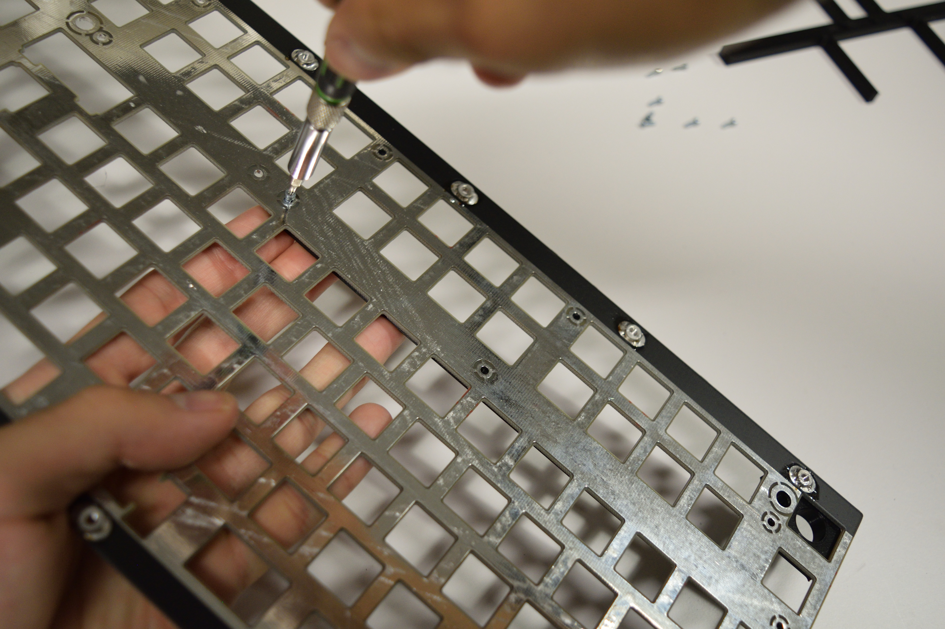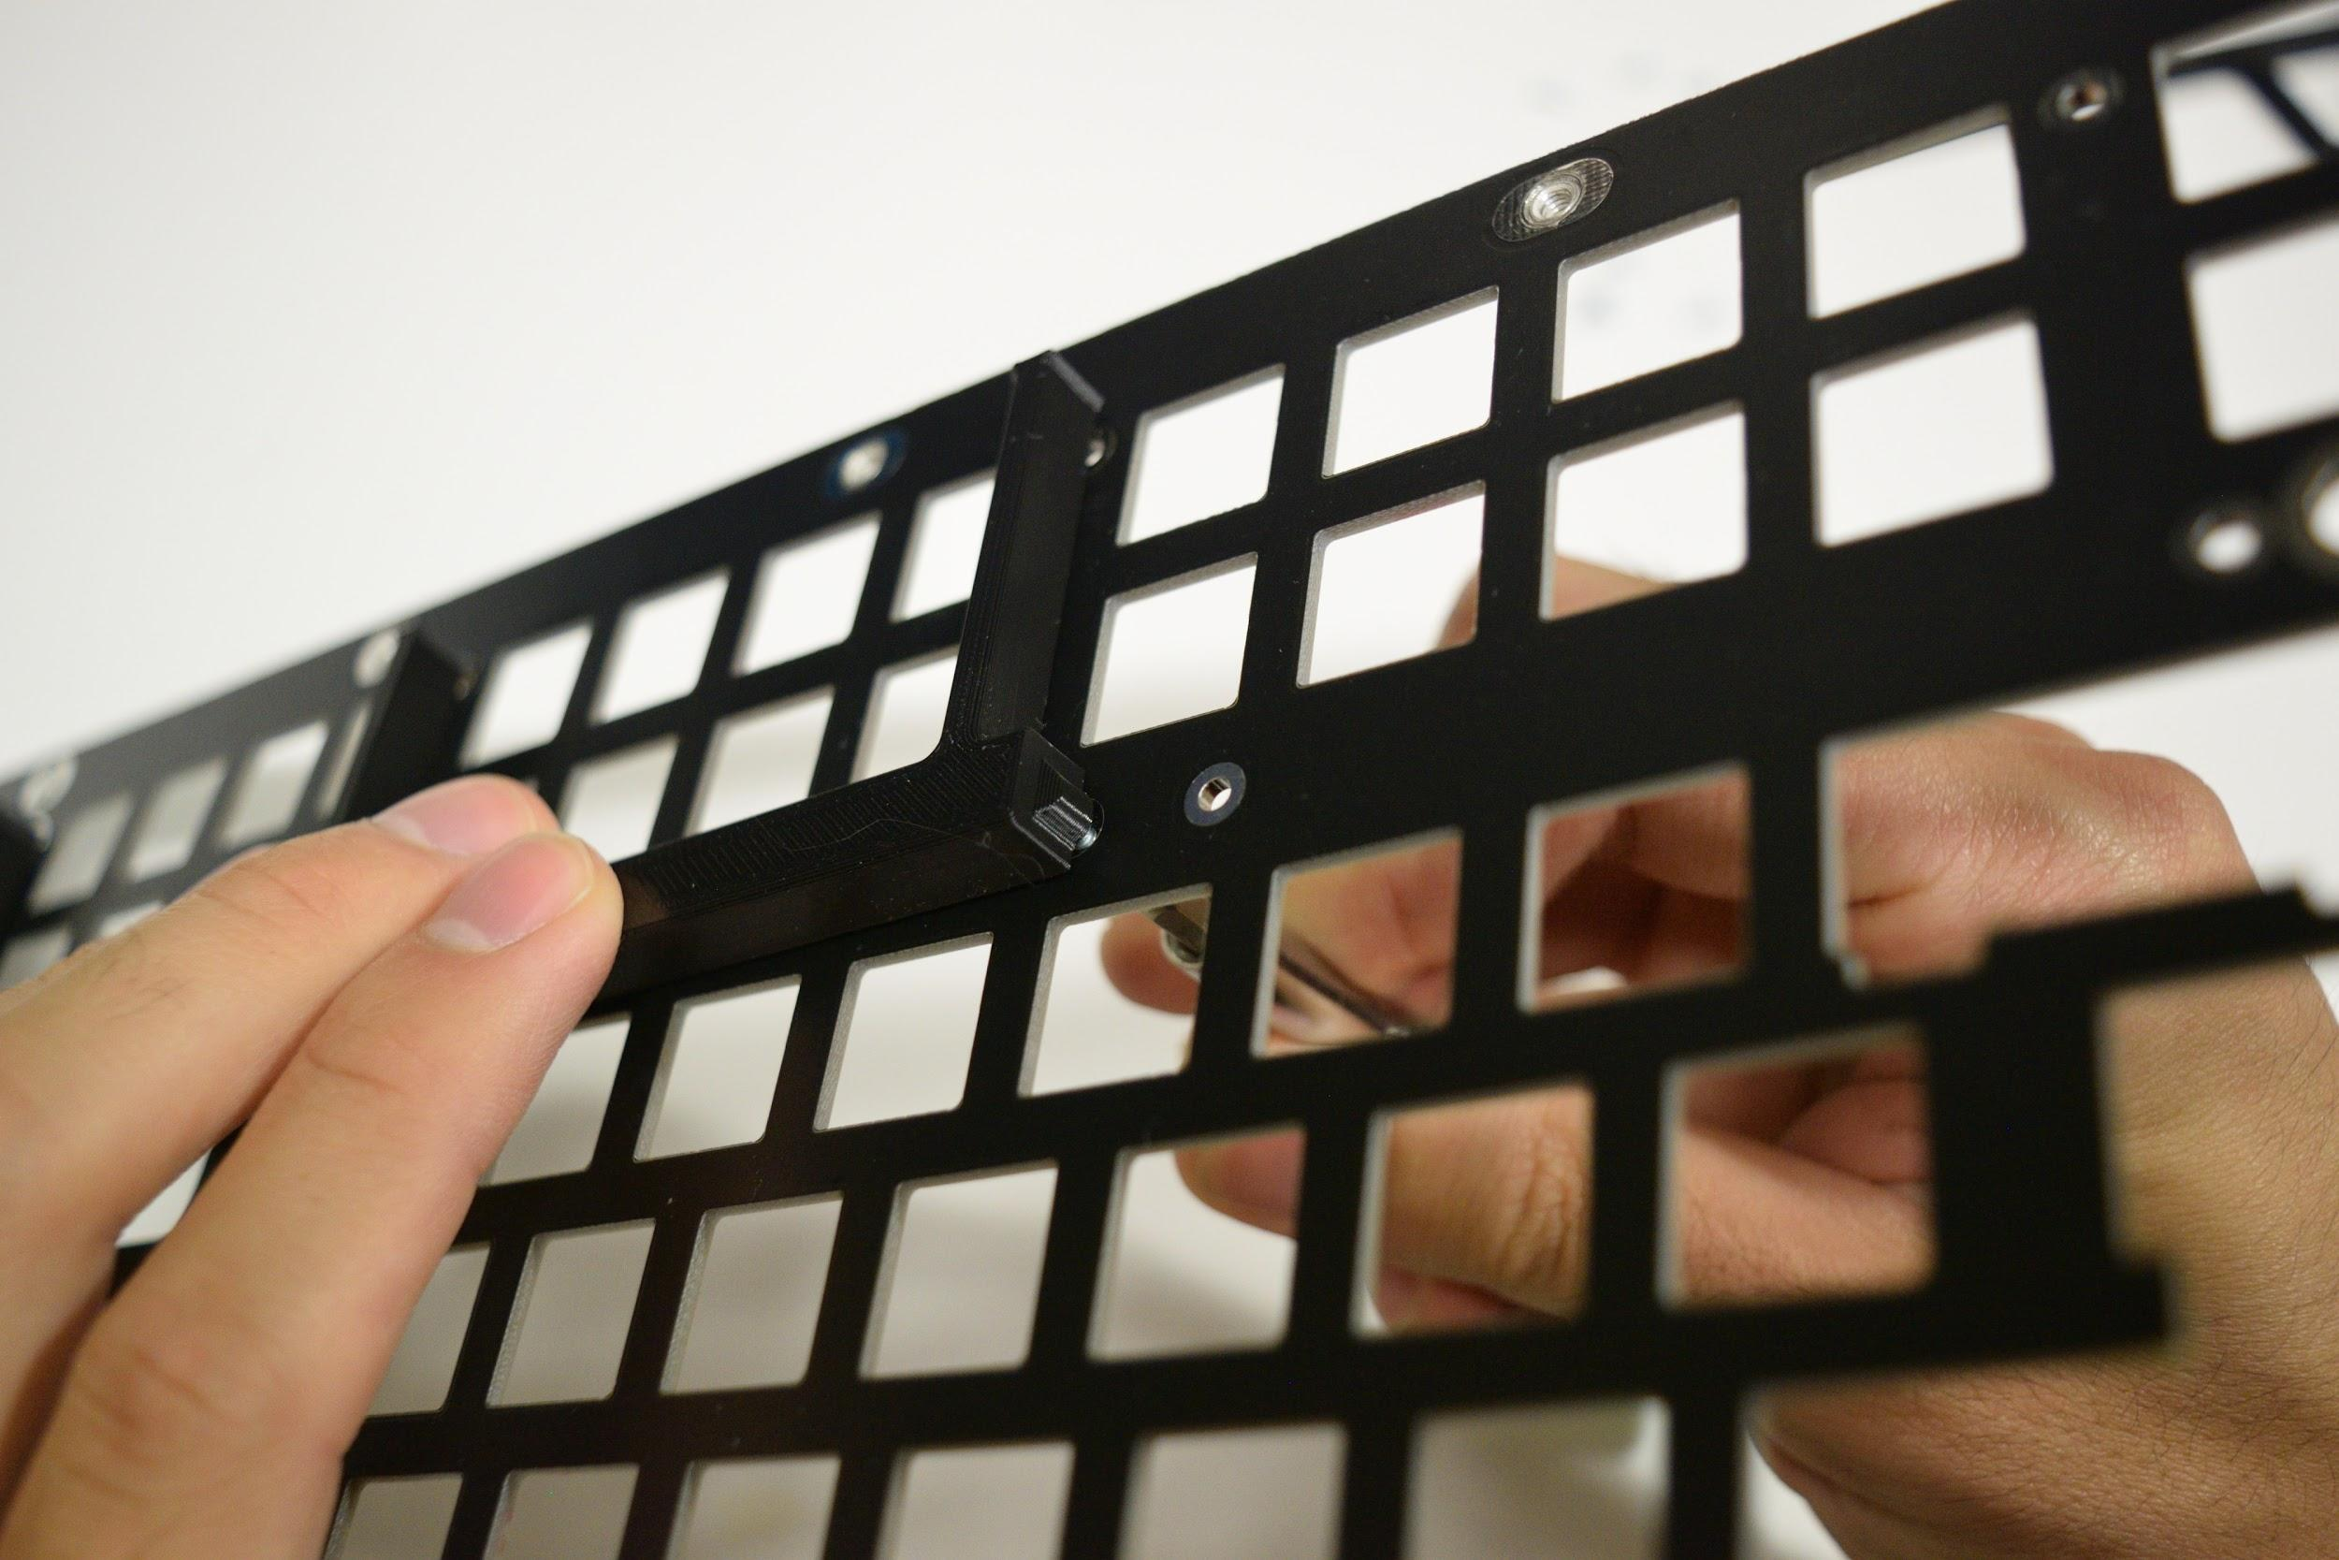
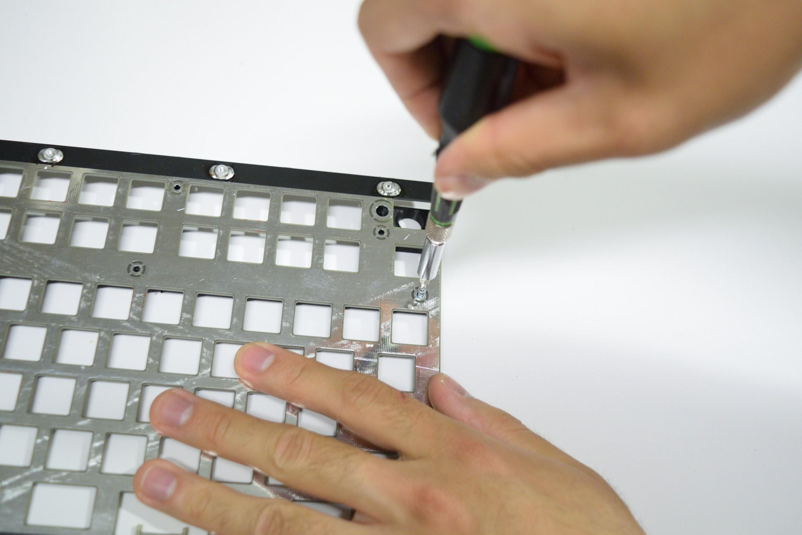
With the screws in but not tightened fully, do a test fit against the left and right case halves by sliding the plate into the left and right case halves. Note that you’ll have to slightly spread apart the right case half to get it past the arrow key cluster.

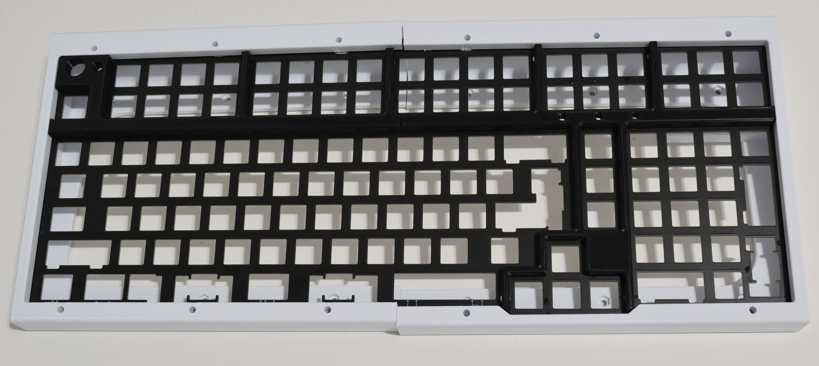
Attach the plate to the case using M3x10mm screws. 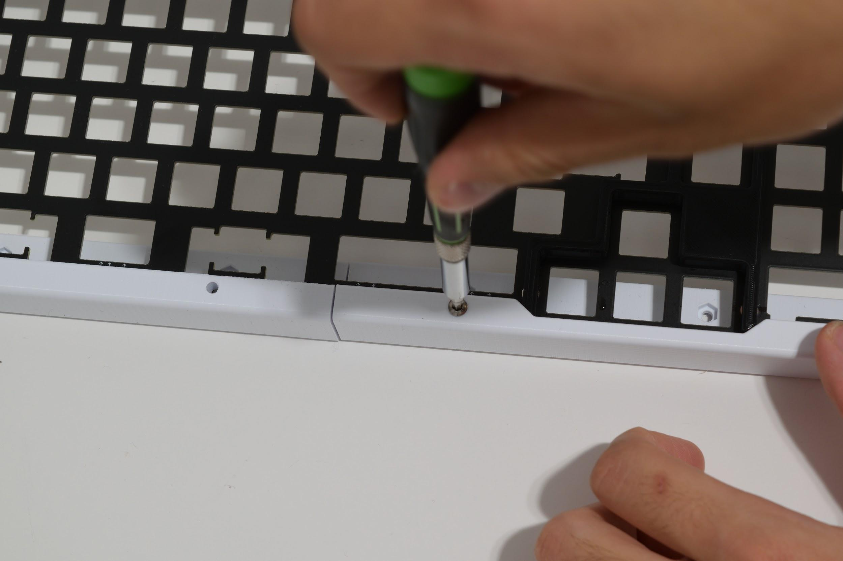
Adjust the separator pieces so that the gaps between the separators and the case halves (marked in orange) are minimal when the plate is slid into the very end of the case halves. There may be a small gap between the two separators (gap marked in pink) - this is normal.
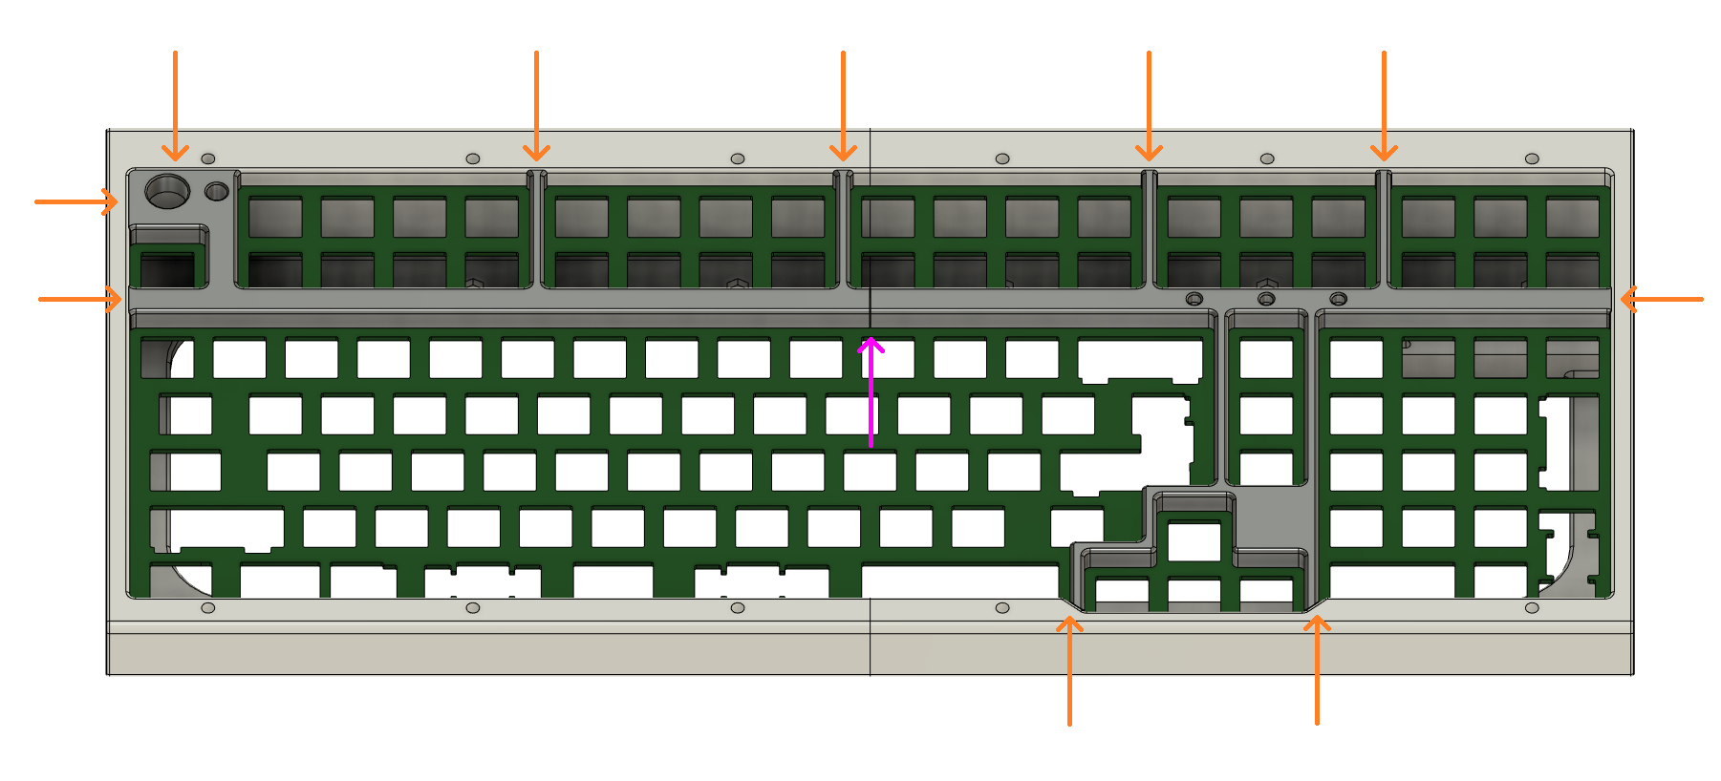
Flip the assembly over, and tighten the screws that can be accessed:
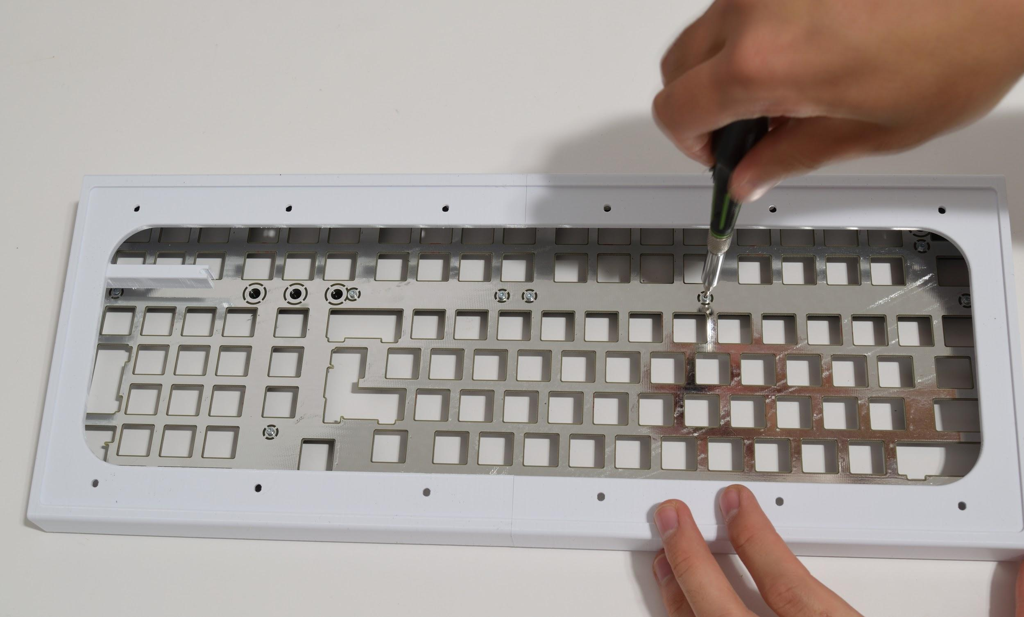
Remove the case halves, and tighten up the remaining screws:
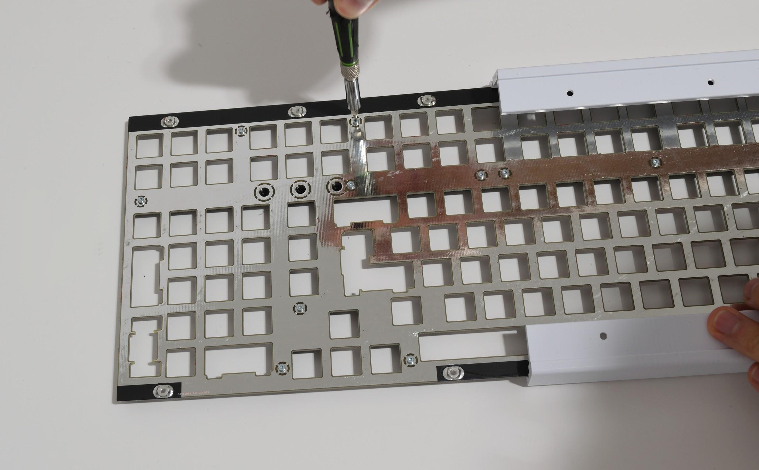Put everything back together and do a final check. Make any adjustments as necessary.
When everything looks good, remove the case halves again.

Part 2: Soldering Additional Parts on the PCB
Soldering on the 1KΩ resistors
Grab the 3 1KΩ resistors and solder them into the spots for R200, R201, and R202, on the top side of the PCB. (if you’re using your own LEDs and want them brighter or dimmer, you may want to use different resistors than the provided resistors).
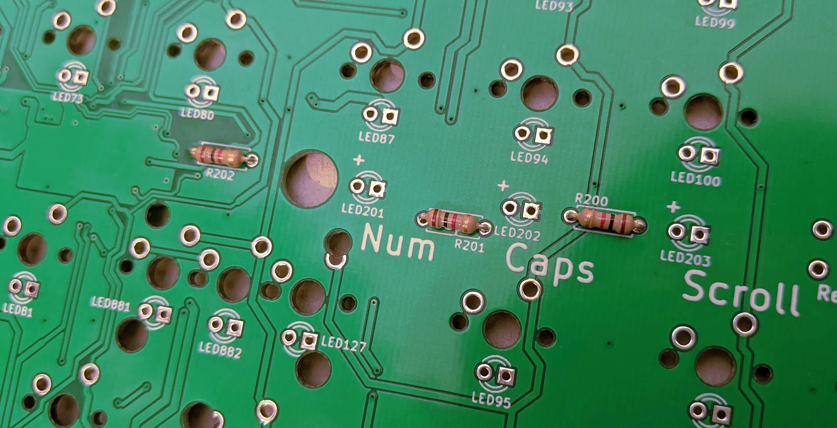
Soldering on the LEDs
Grab the spacer for the LEDs, and run the LEDs legs through it. Place the LEDs and spacers onto the PCB, for spots LED201, LED202, and LED203. Note that the spacer only fits in one way.
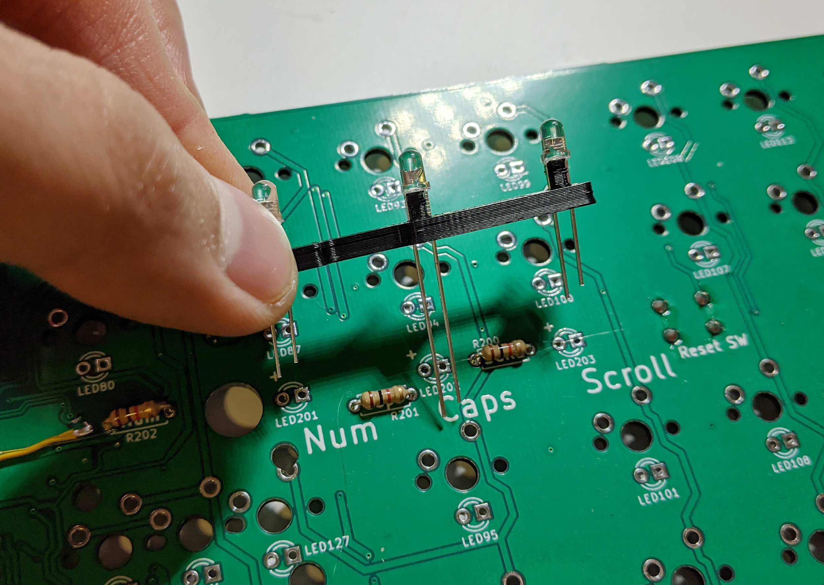
Note that LEDs are directional and will not work if soldered in backwards. The longer leg on an LED is +. Make sure this matches up with the + and - symbols on the PCBs.
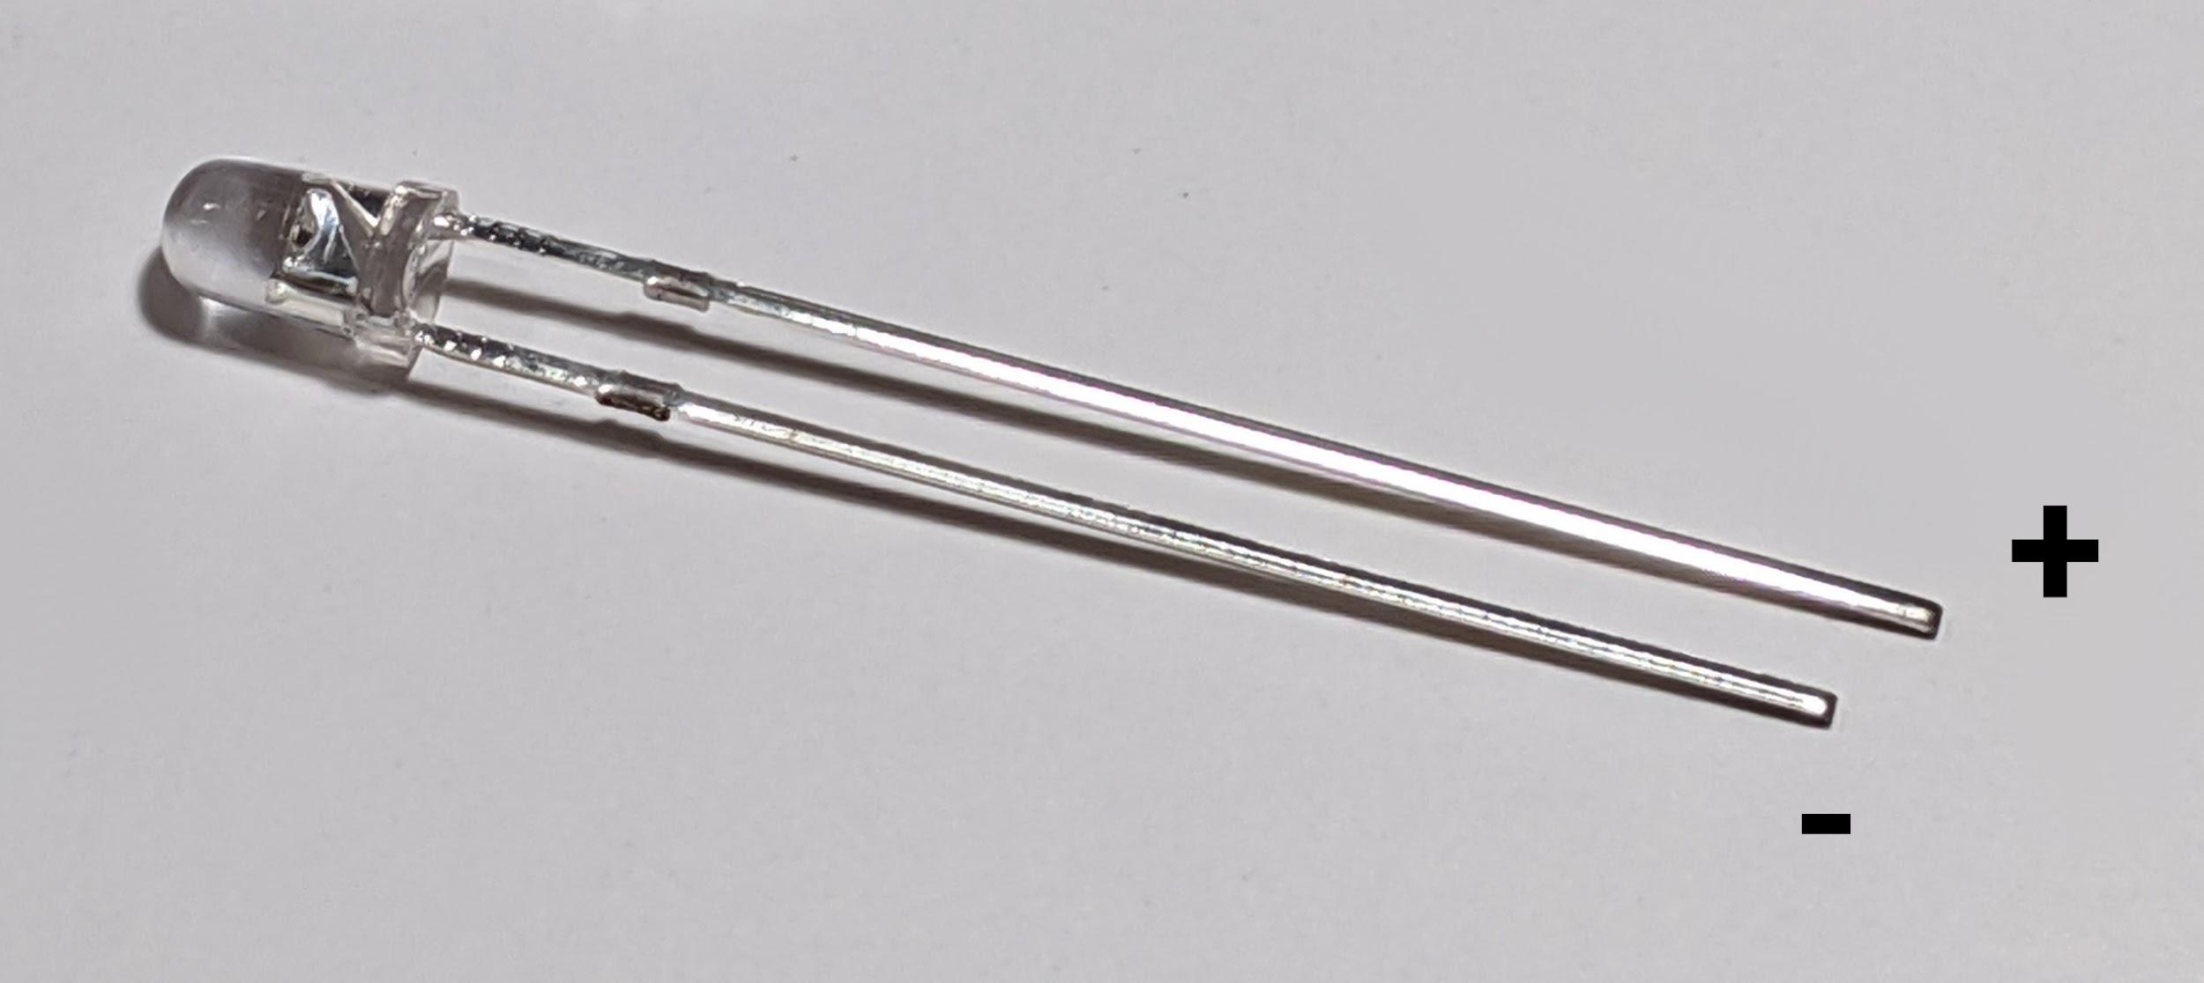
Once the LEDs are in, solder them in. Make sure that they’re in straight!
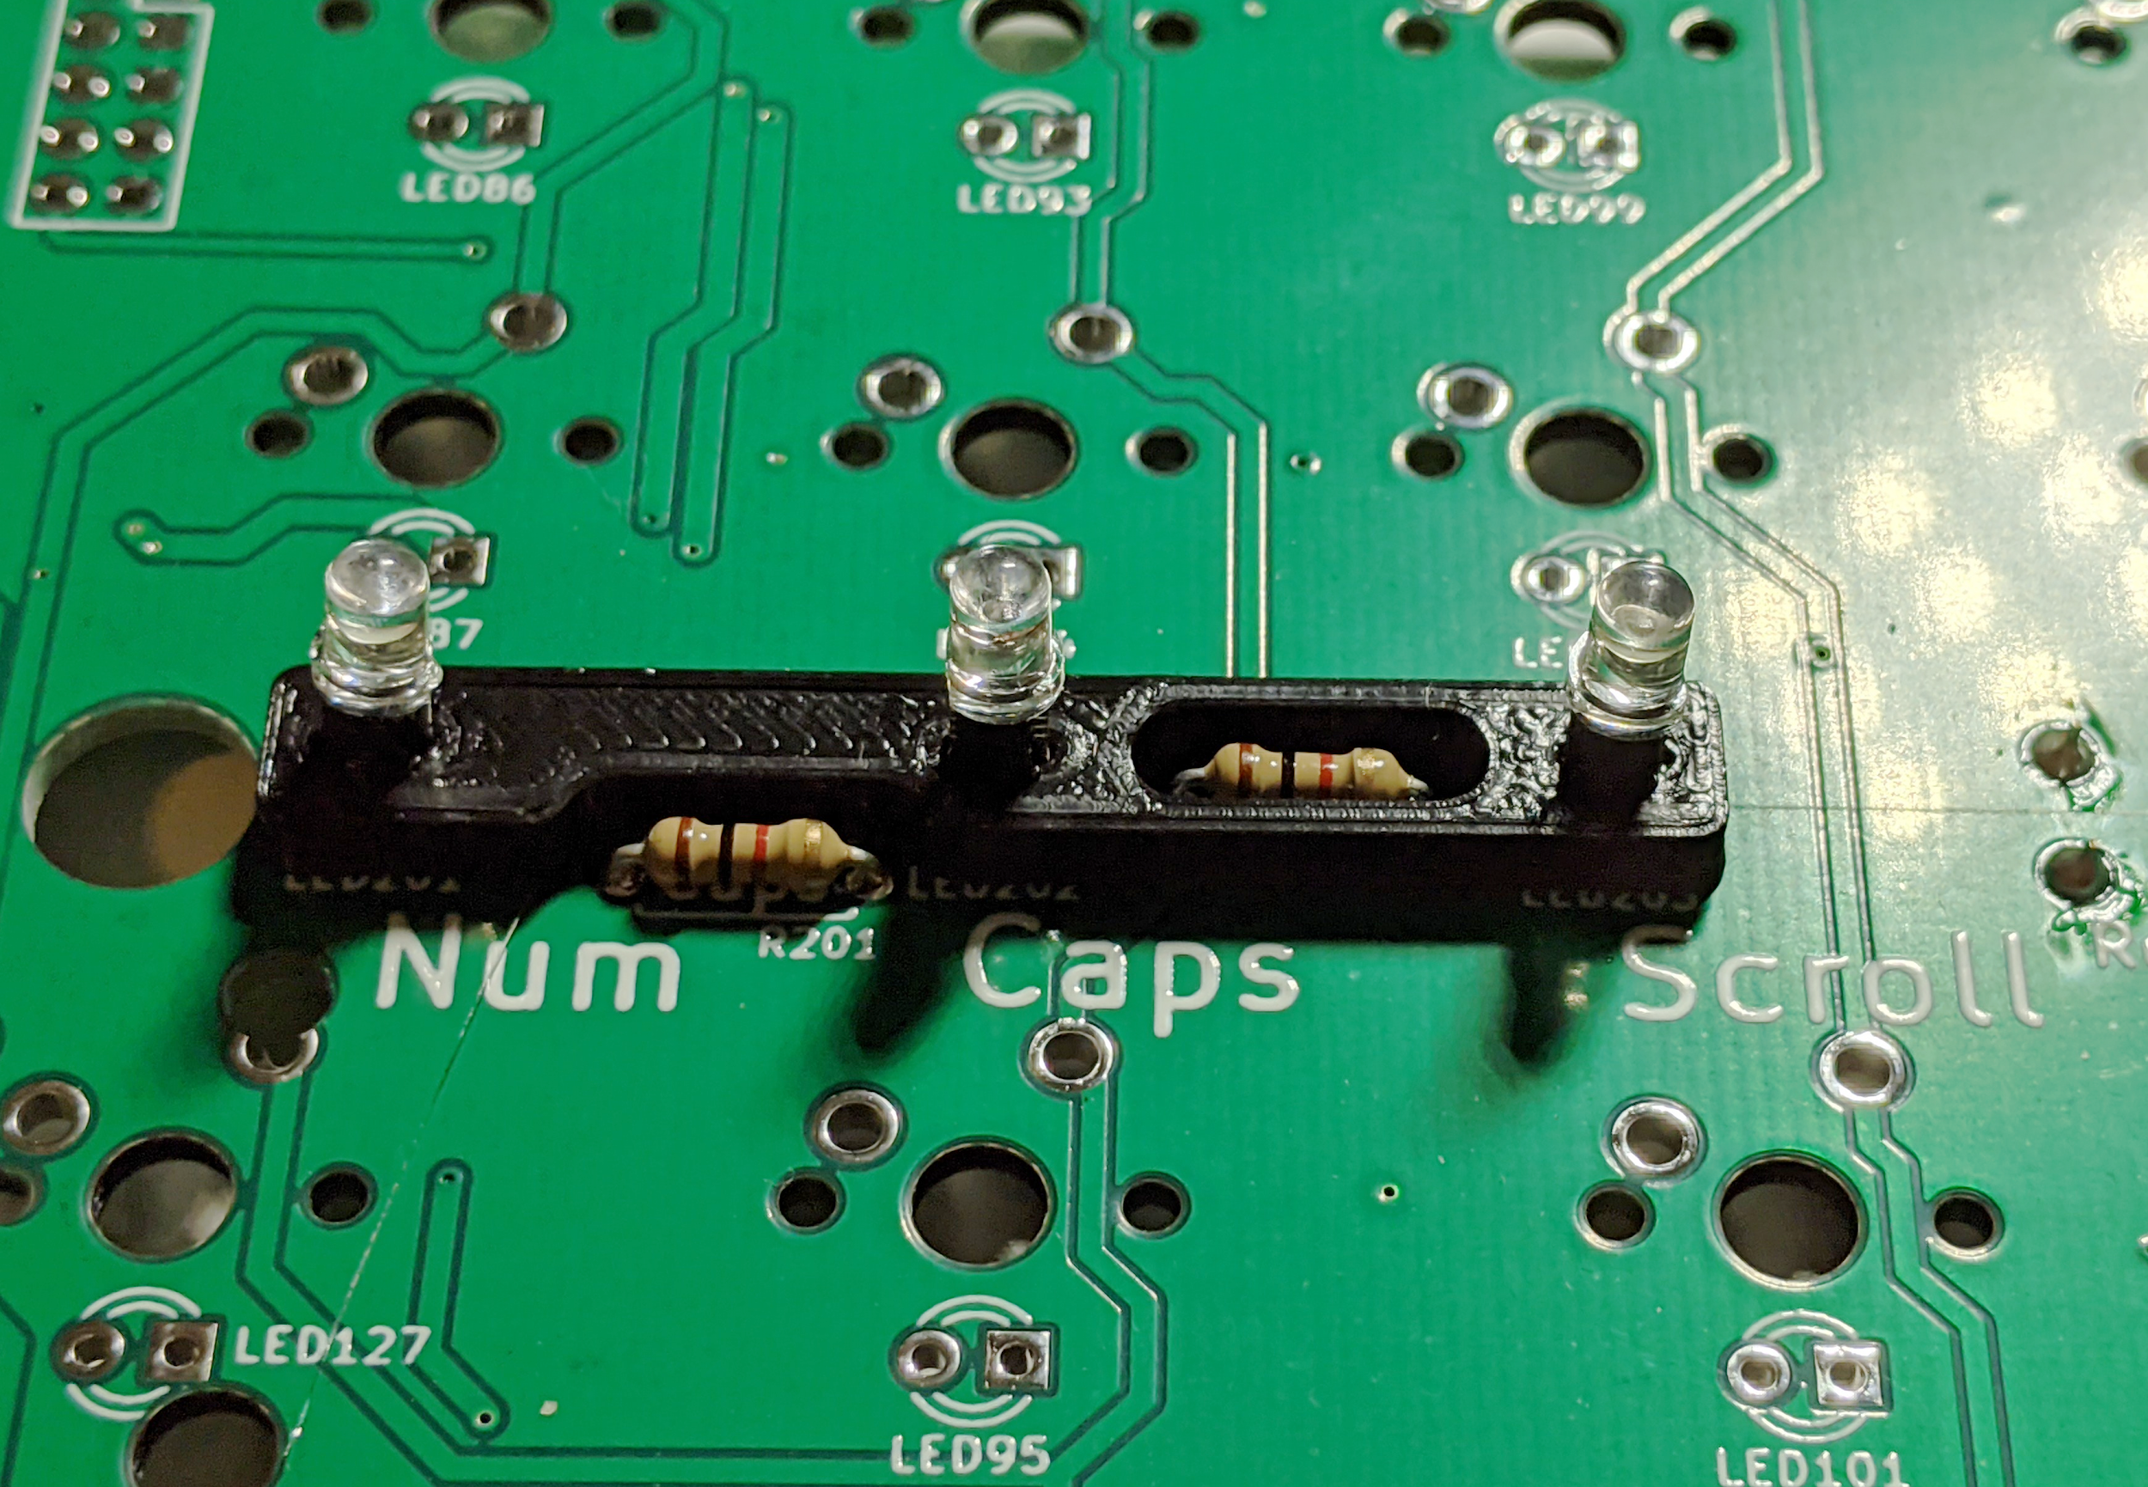

Soldering the rotary encoder onto the PCB
Next, solder on the rotary encoder onto the top left corner of the PCB.
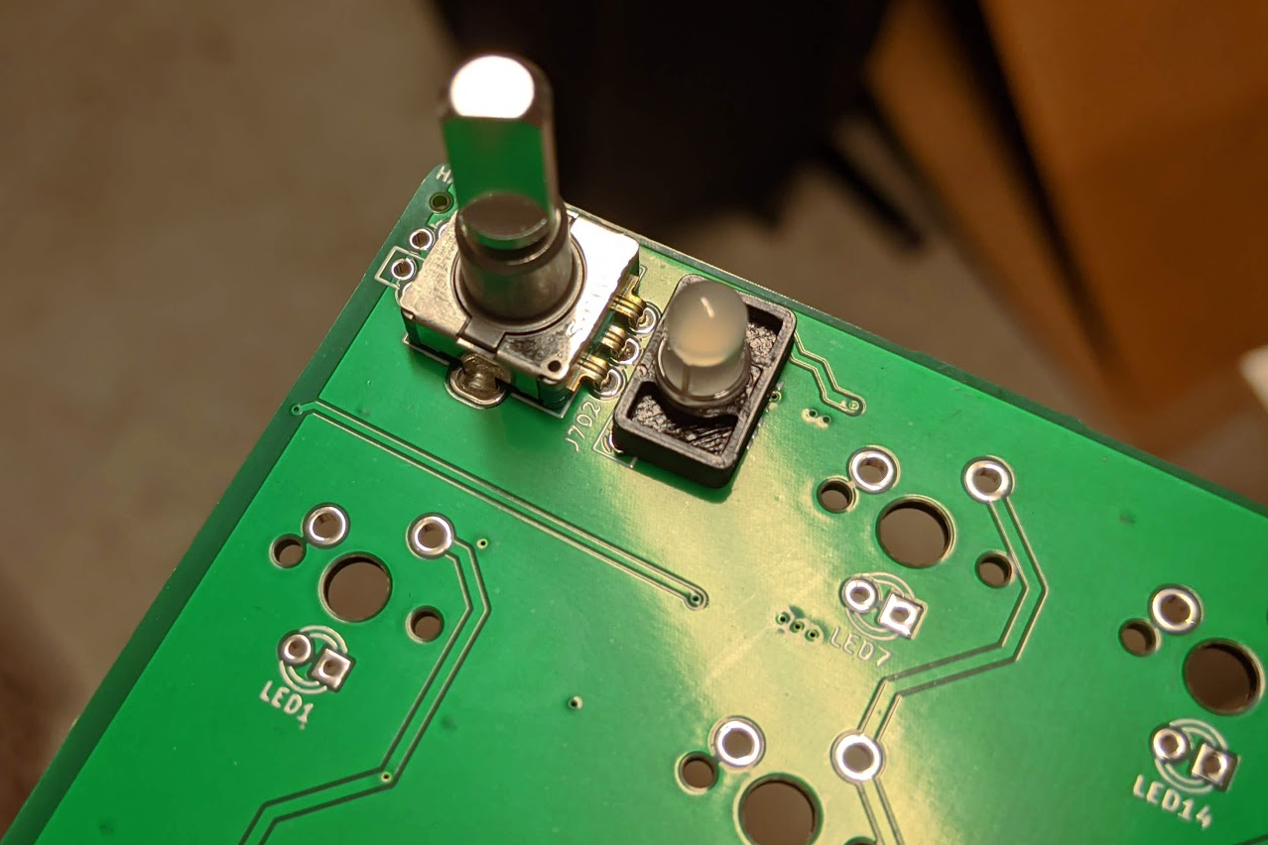

Part 3: installing stabilizers and switches
Deciding your layout
Boston supports the following layouts:
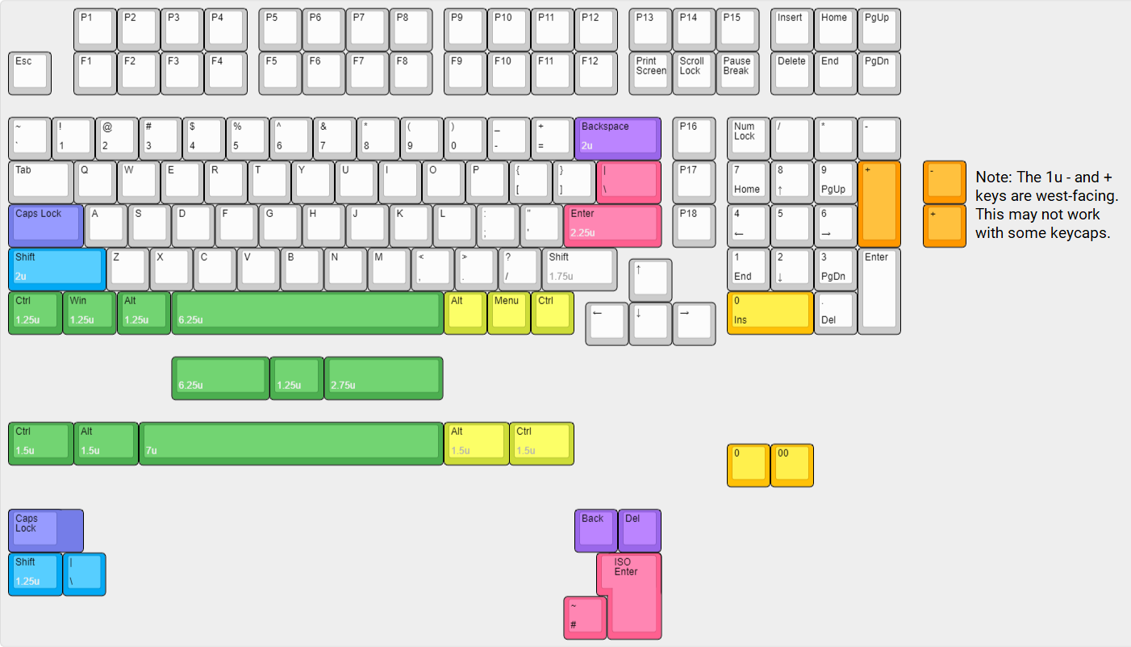

Decide what layout you want (for example, do you want ANSI Enter, or ISO Enter?), and determine where you’ll need to install stabilizers. Any keys 2 units wide or longer (for example, a standard backspace key) will need stabilizers. Also, make sure you have the keycaps for the layout you want.
Modding switches and stabilizerse
If you want to mod or tune your switches or stabilizers (e.g. lubing them, or changing the springs in them), do so before installing them. It is much harder to make any changes after they’re installed.
Installing the stabilizers
Boston takes PCB-mount stabilizers, either screw-in or clip in style. These are available from several manufacturers (e.g. GMK, C3, Durock, Zeal, and others all make PCB mount-stabilizers).
Install stabilizers according to the instructions from their manufacturer.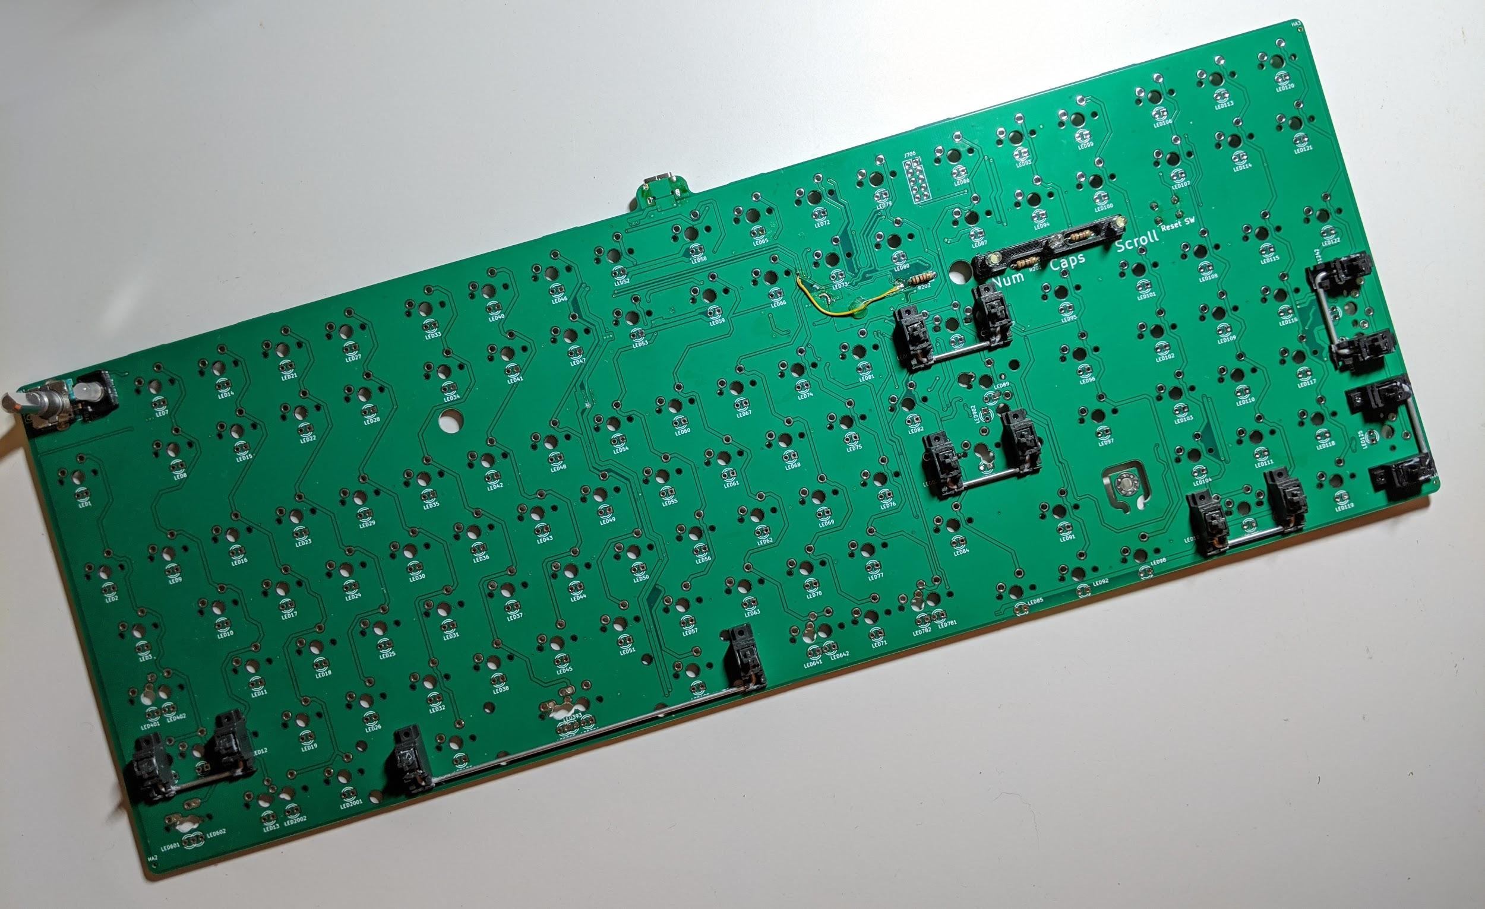
(this is a prototype PCB and has a yellow wire to fix a mistake on the PCB. Actual GB PCBs have this fixed and don’t have the yellow wire)
It’s strongly recommended to test your stabilizers before proceeding, as any fixes to your stabilizers after soldering the switches will likely require desoldering all the switches and removing the plate from the PCB.

To do this, take the plate, a switch, and the appropriate keycap for the stabilizer you want to test, and install them over the PCB (without soldering the switch). Make sure the key feels okay - that it’s not binding, or failing to go all the way to the bottom, or failing to return, for instance. Do this for all your stabilizers to make sure that they’ve been installed properly.
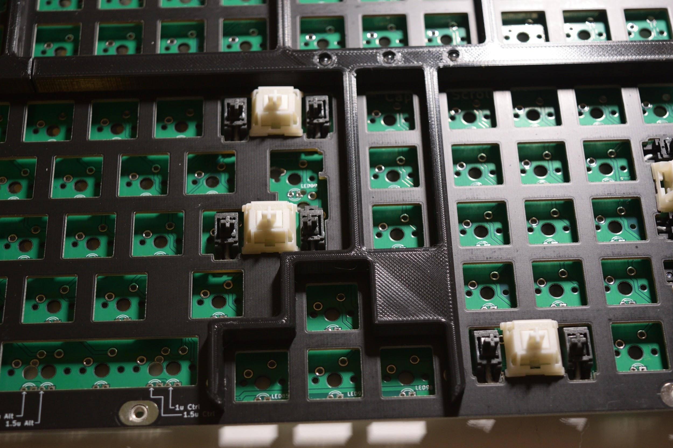
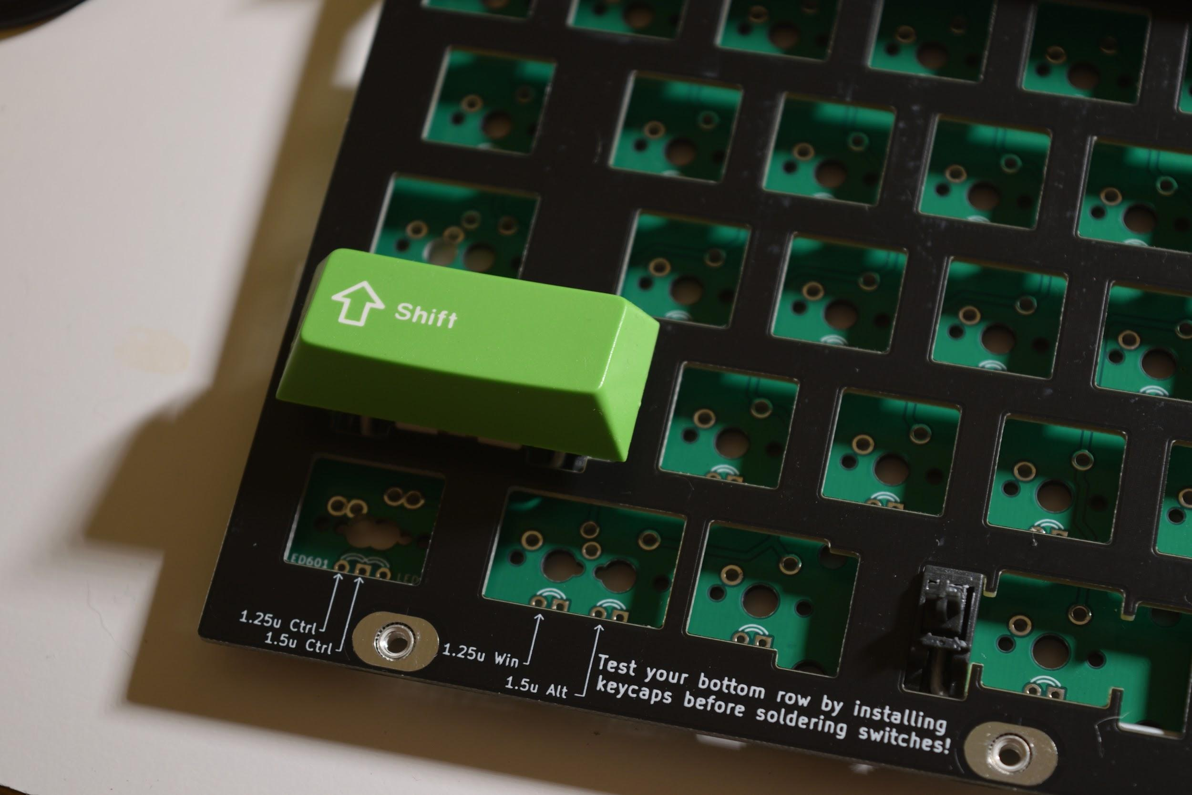

Installing your bottom row
We’ll start installing and soldering switches on the bottom row as this is the most likely place that mistakes are made.
As you can see from the “supported layouts”, Boston supports several different bottom row layouts, and it’s easy to accidentally put a switch in the wrong place.
Both the plate and PCB are marked with where to put the switches in for your desired bottom row positions. Install switches into the desired positions on the bottom row. Make sure that the switches are fully seated into the plate.

After installing the switches into the plate, and before soldering the switches, install keycaps on your bottom row to ensure that everything is in the correct place, and that the switches are in the right place. Make any fixes as necessary.
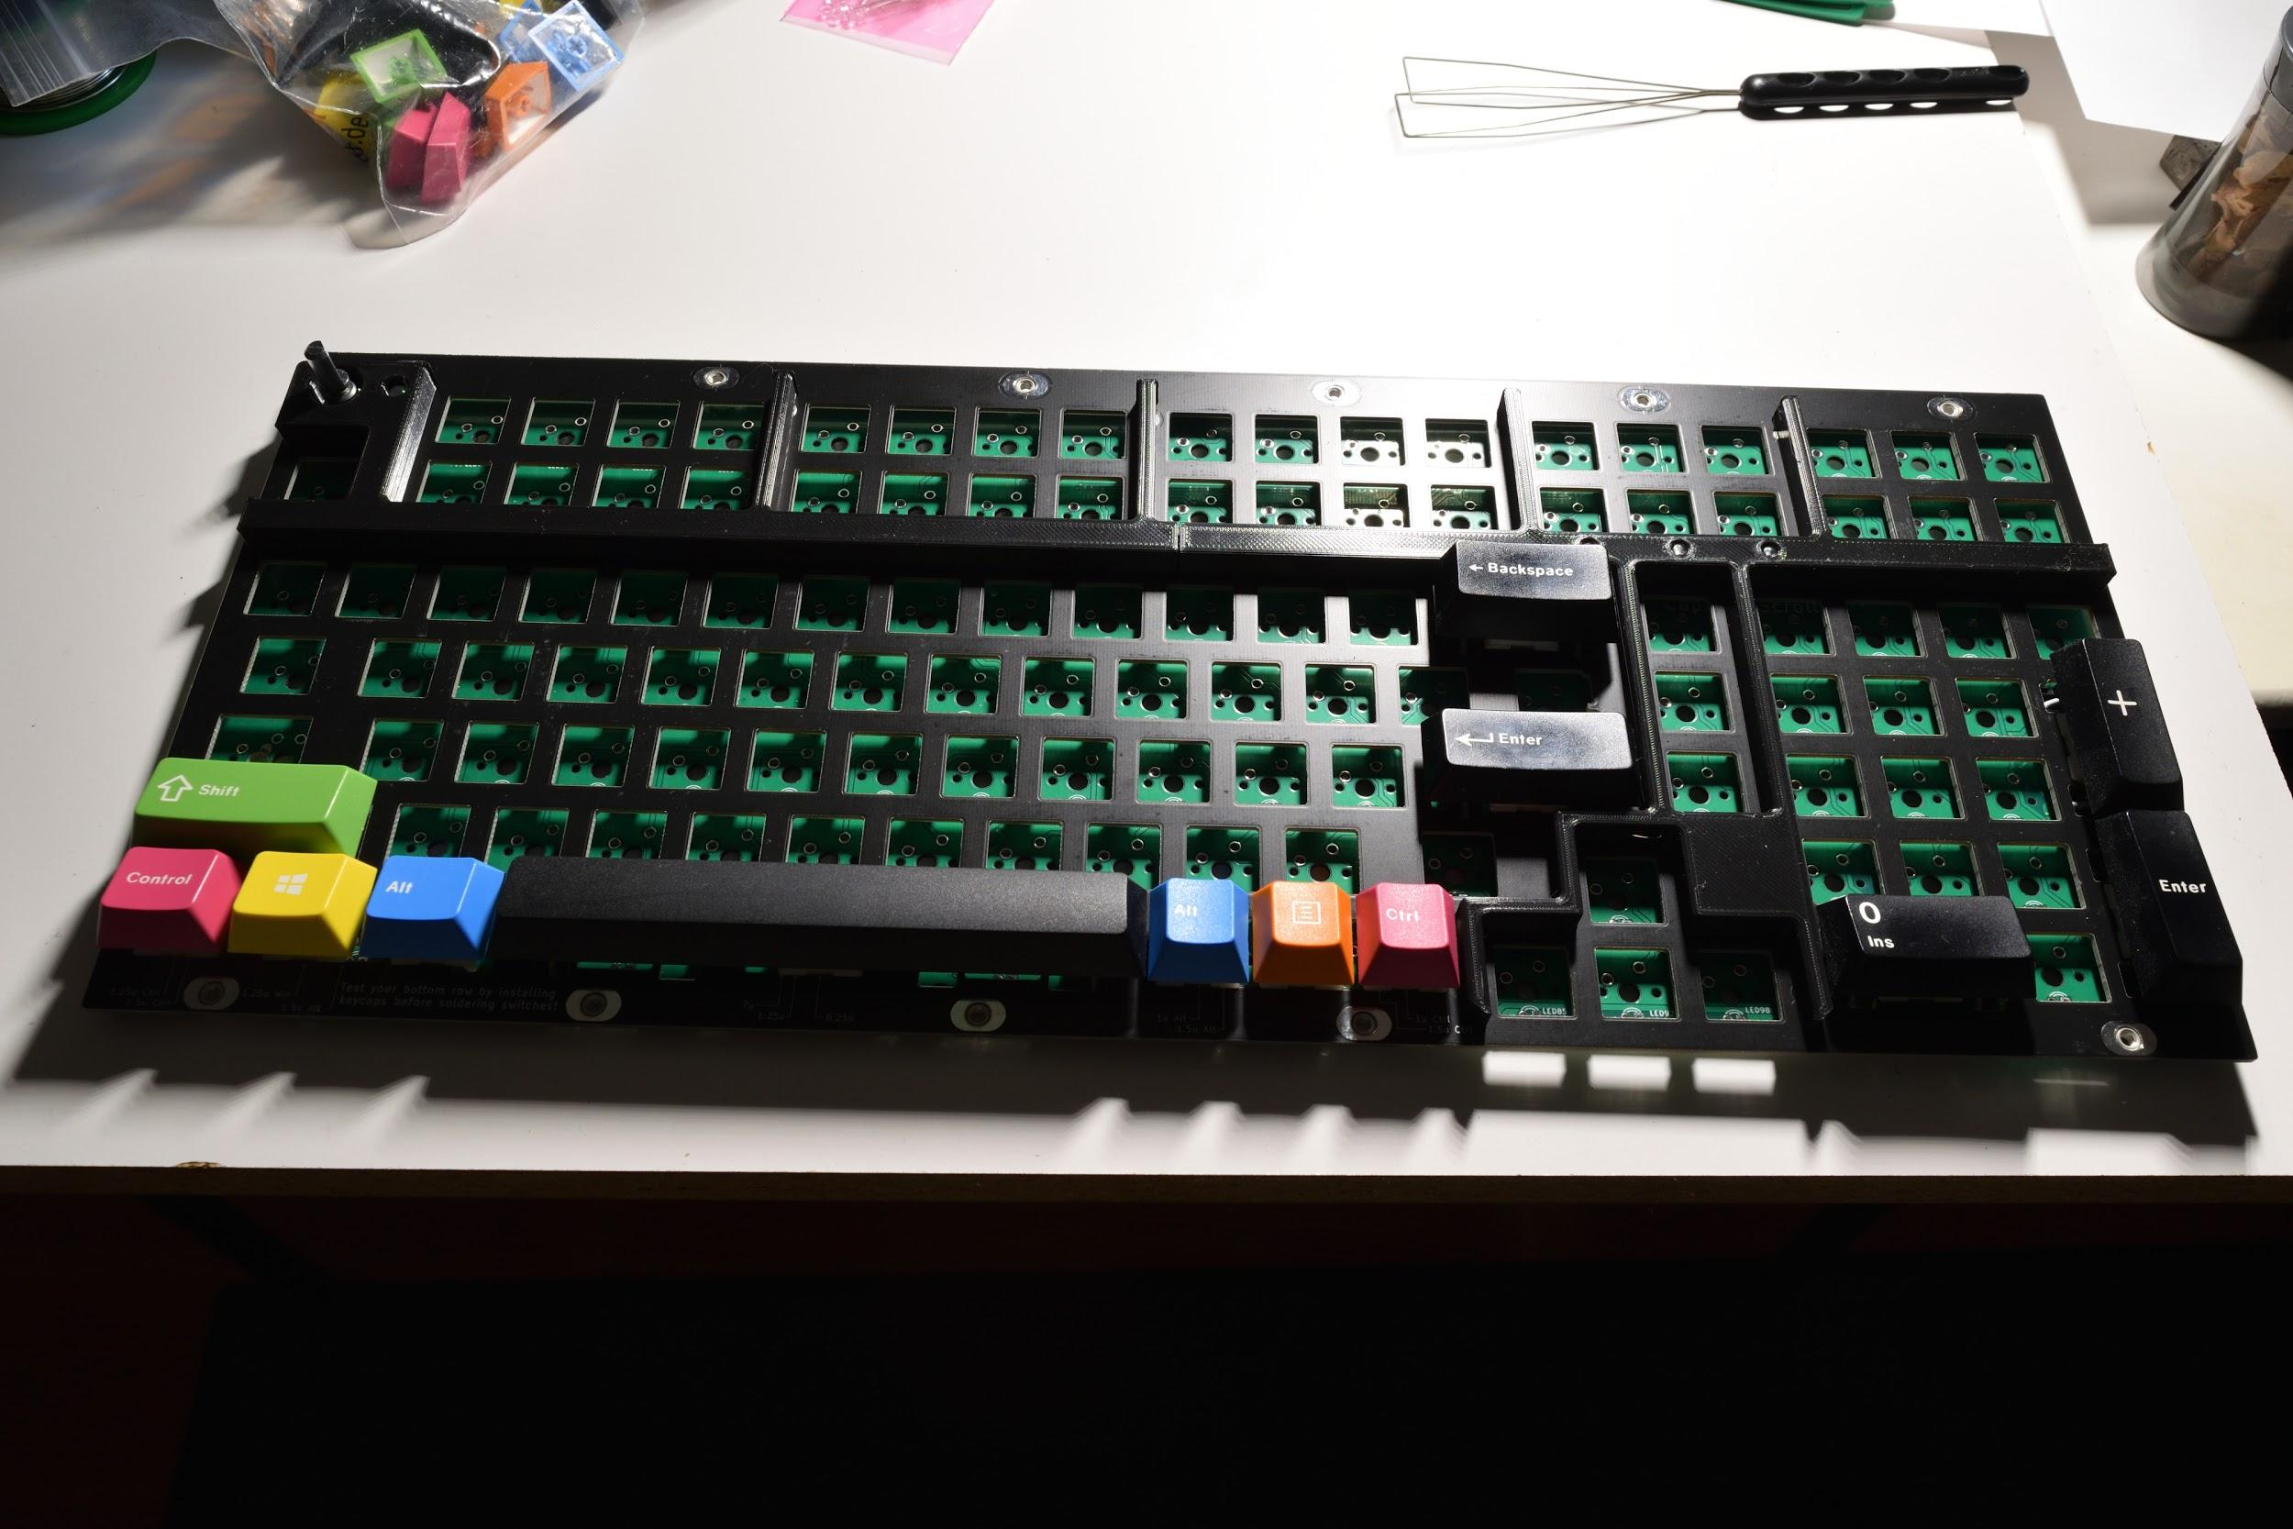
If everything looks correct, solder the switches in.

Soldering the rest of the switches
Install and solder in the rest of the switches.

Part 4 - Case Prep and Assembly
Installing the M3 hex nuts into the case
Take the left and right case halves from earlier, and the M3 hex nuts. Push the hex nuts into the hex-shaped pockets on the bottom of the case. If it’s difficult to push them in, you can use an M3x6 screw to pull the nuts in. If the nuts fit in loosely and fall out easily, glue them in with super glue.
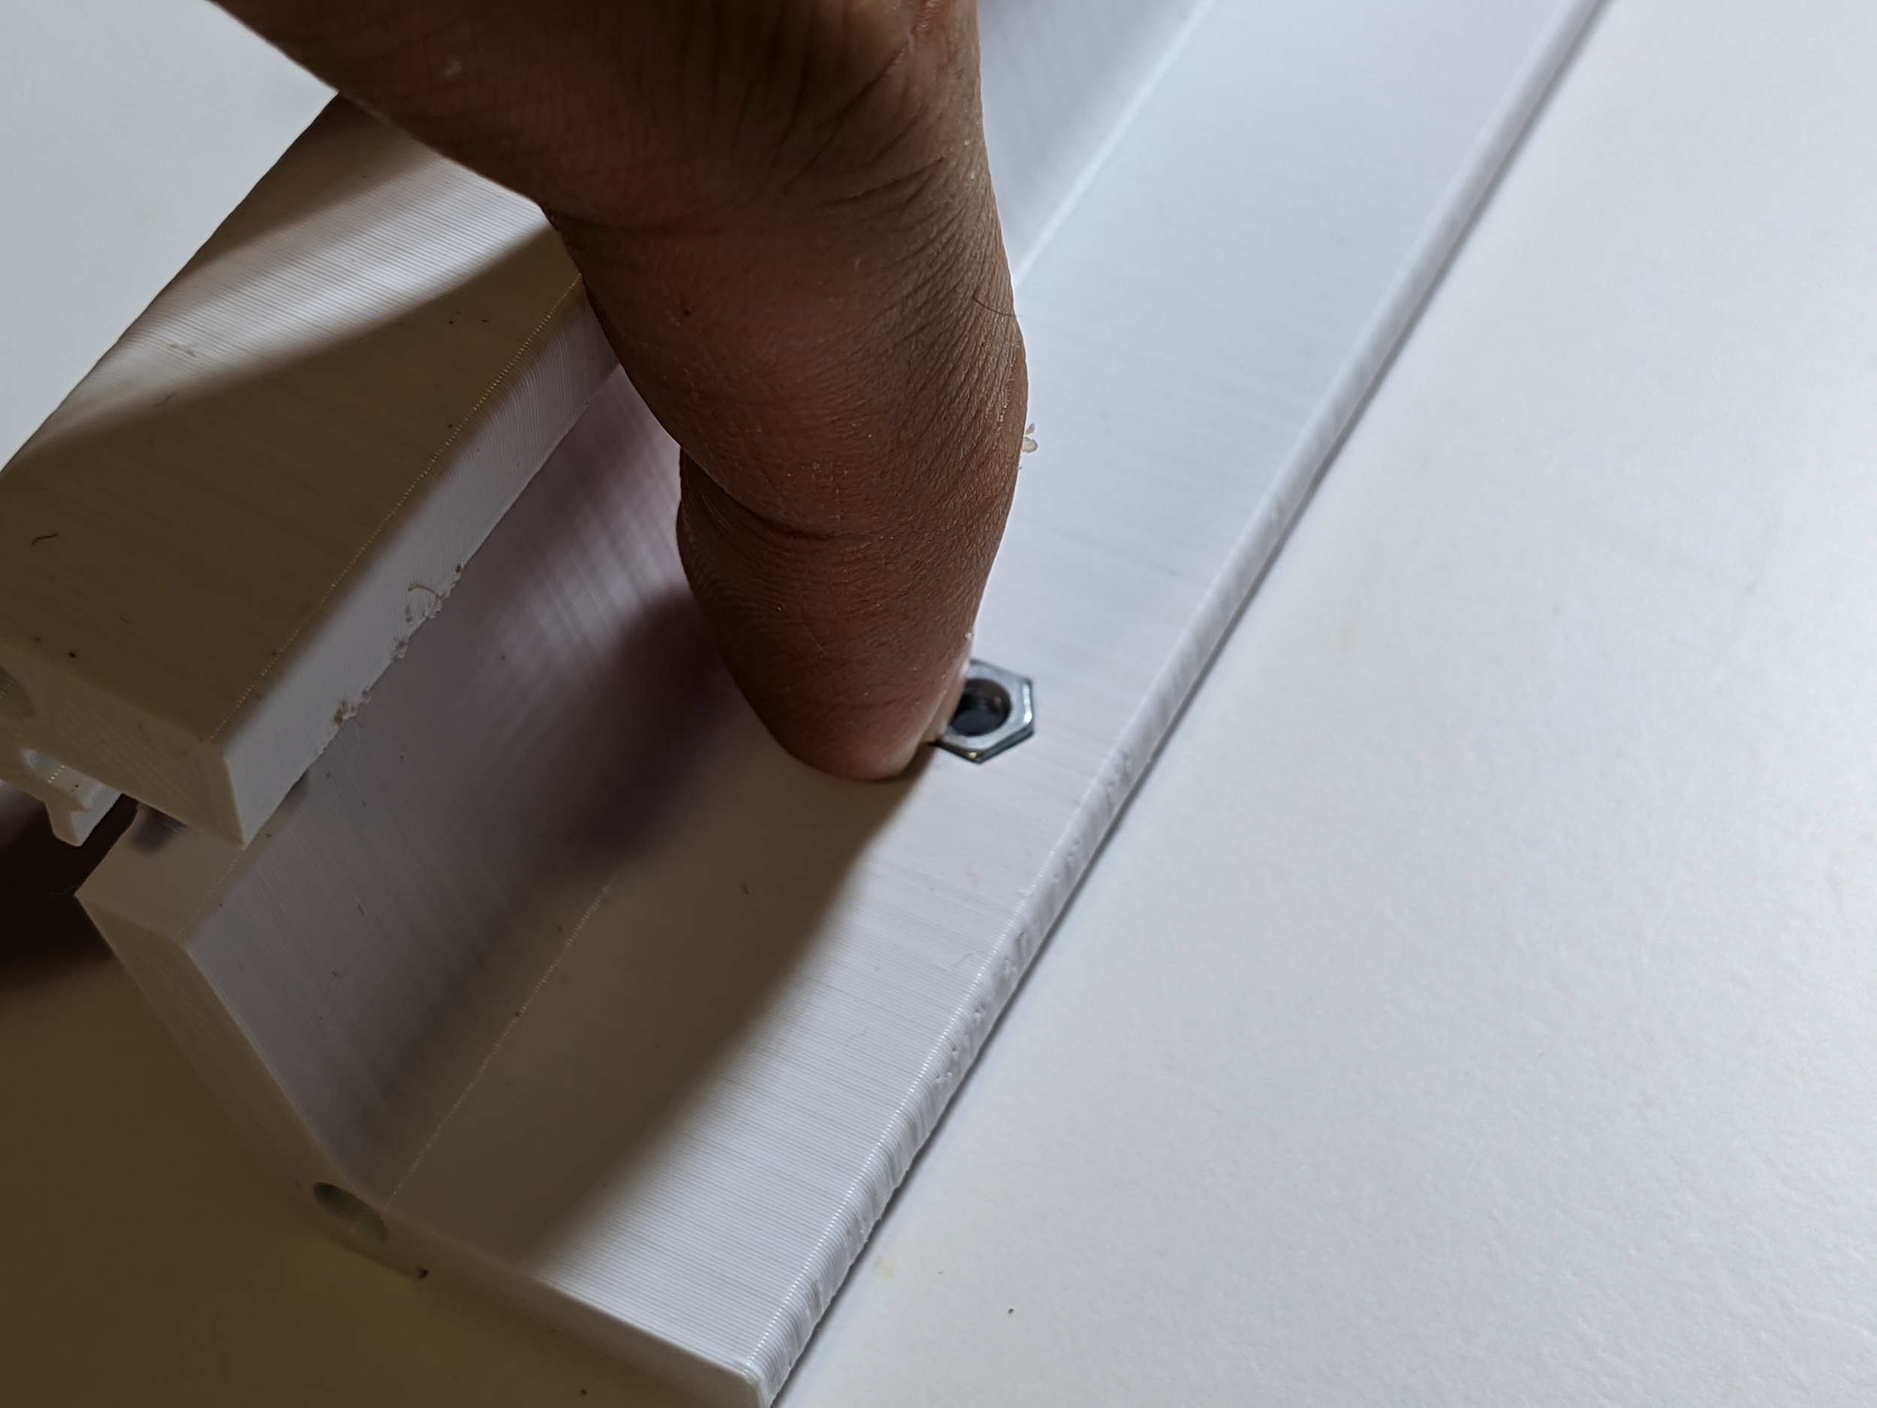

Installing the case halves
Take the left and right case halves and slide them onto the plate, and screw them into the plate using M3x10 screws. Do not tighten these down all the way - leave them about 1 turn loose. For the right case half, you’ll have to to spread the case apart slightly to get it past the arrow key cluster.

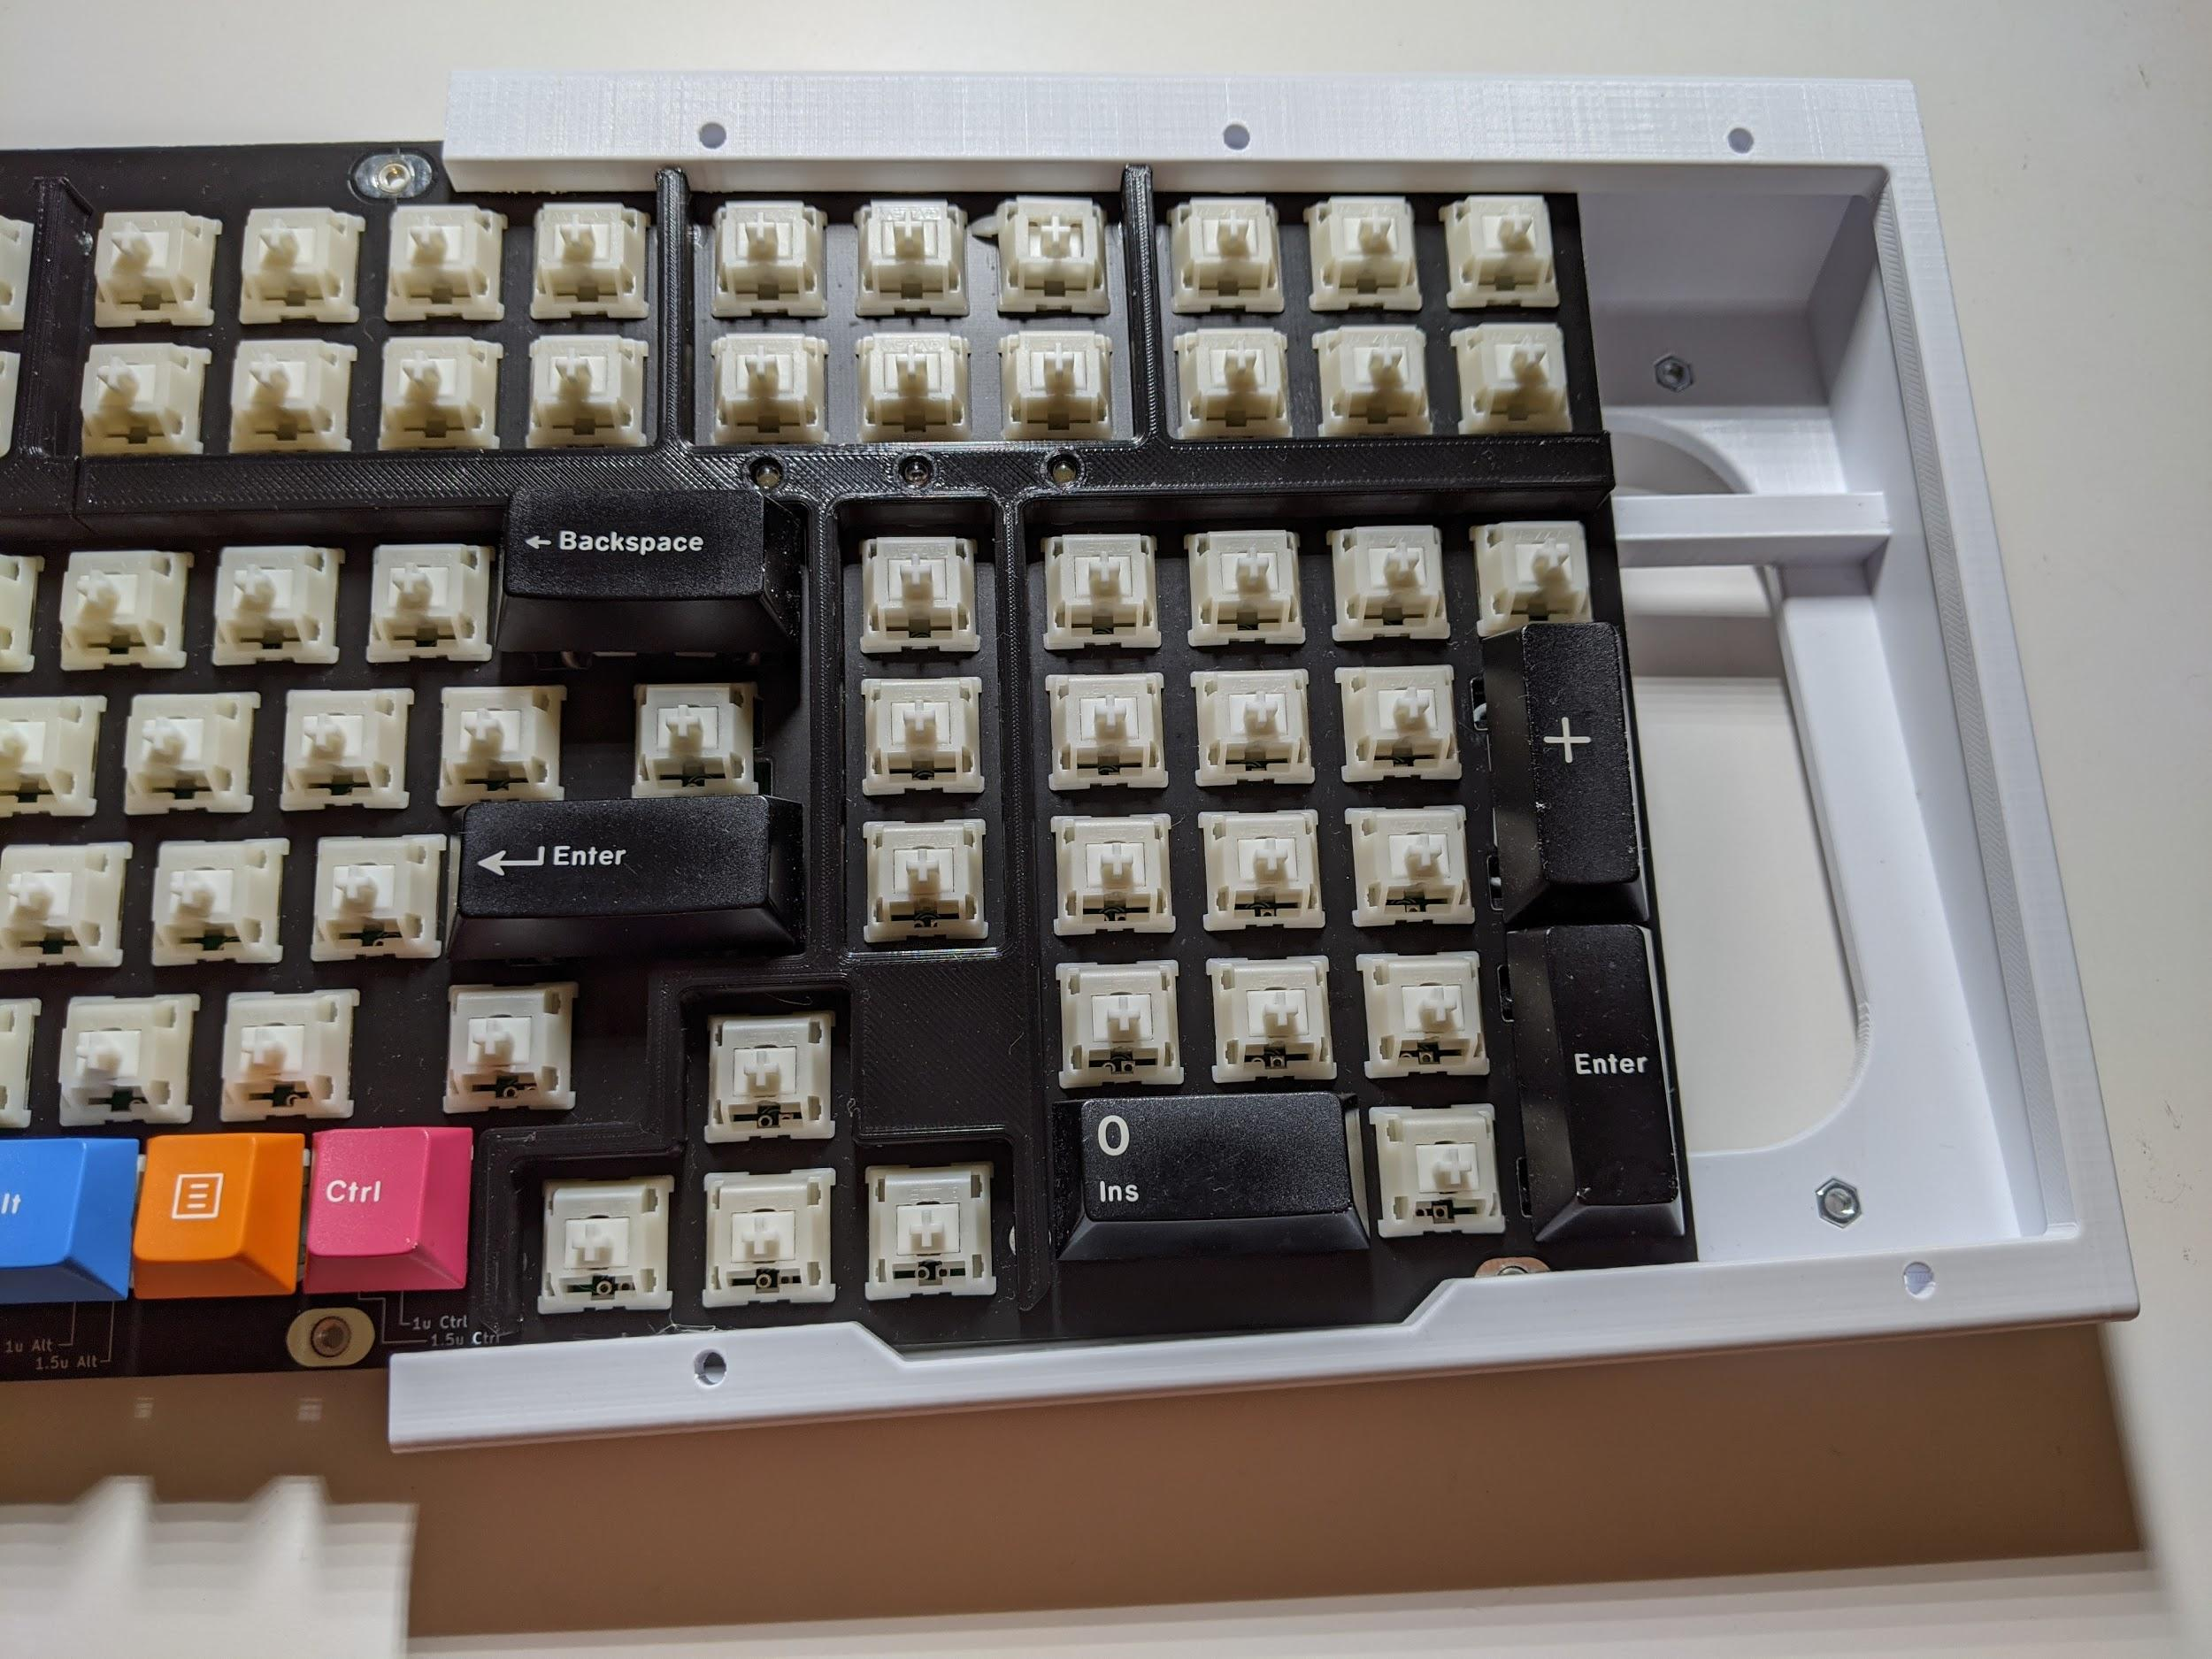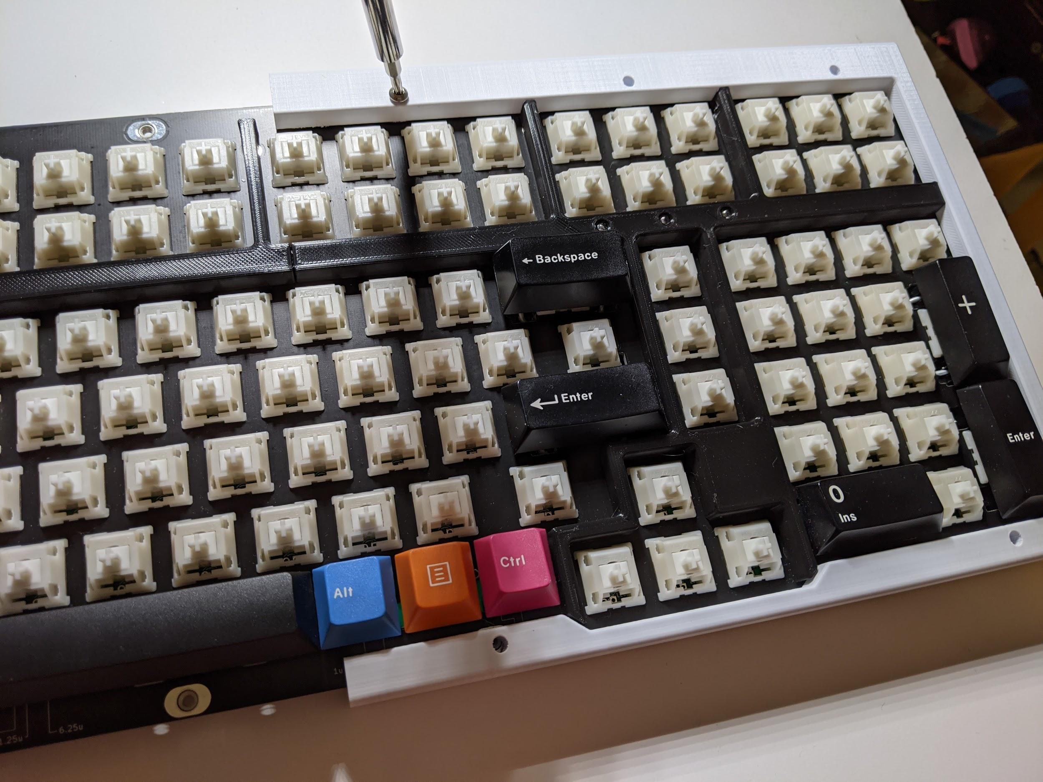
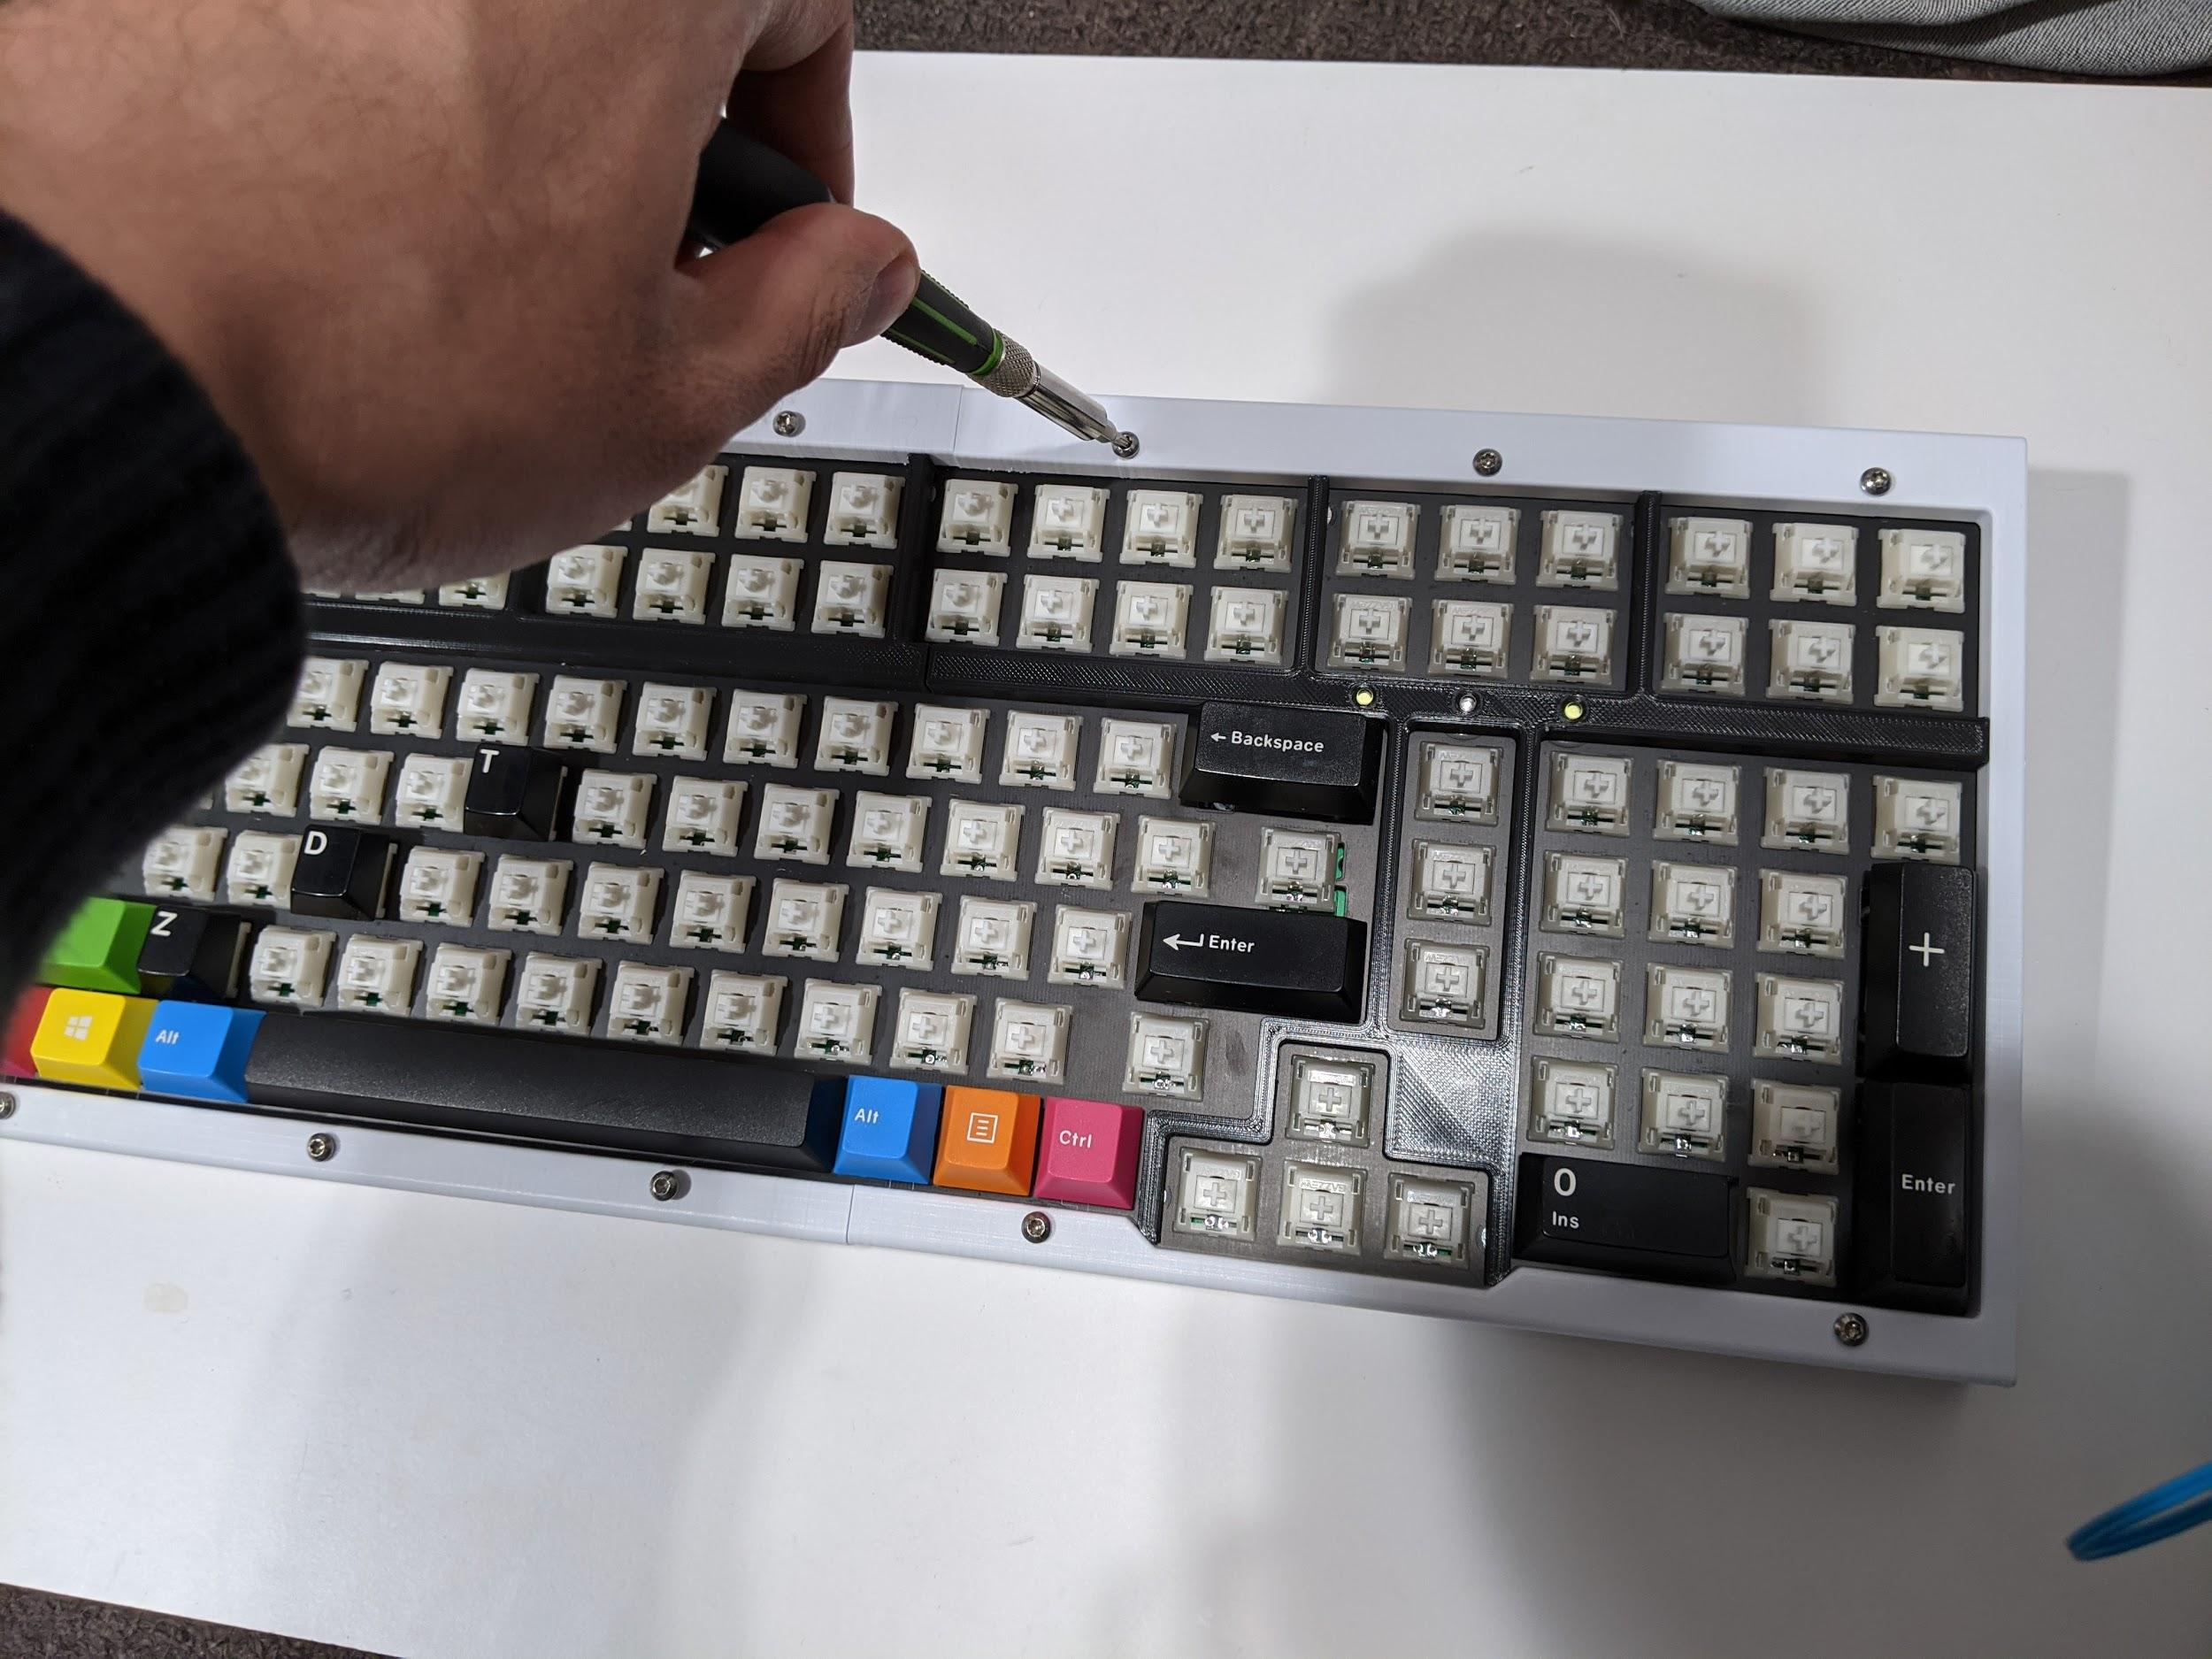

Installing the bottom panel and the rubber feet
Flip everything over, and place the bottom panel in the orientation shown. Install the middle 8 screws M3x6 screws. Again, don’t tighten these in all the way, but leave them about a turn loose.
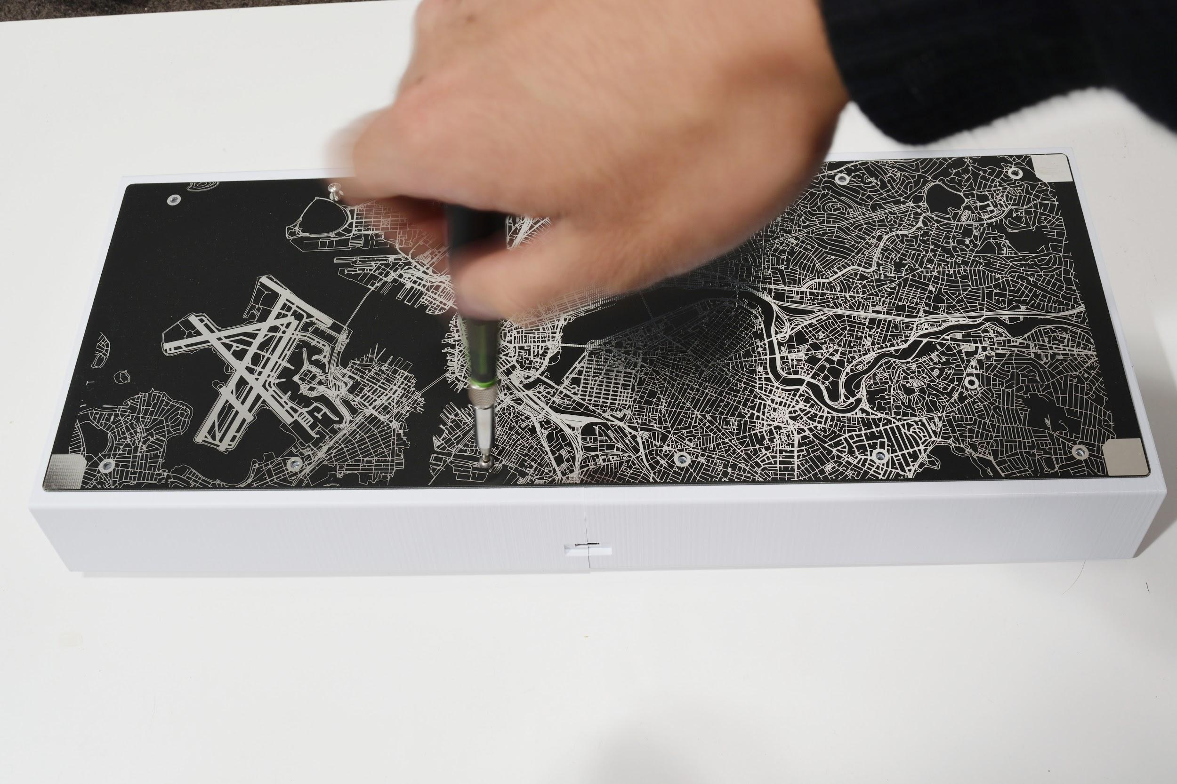

Take the FR4 rubber feet holders and install them on the ends using M3x10 screws. Tighten these screws in all the way.
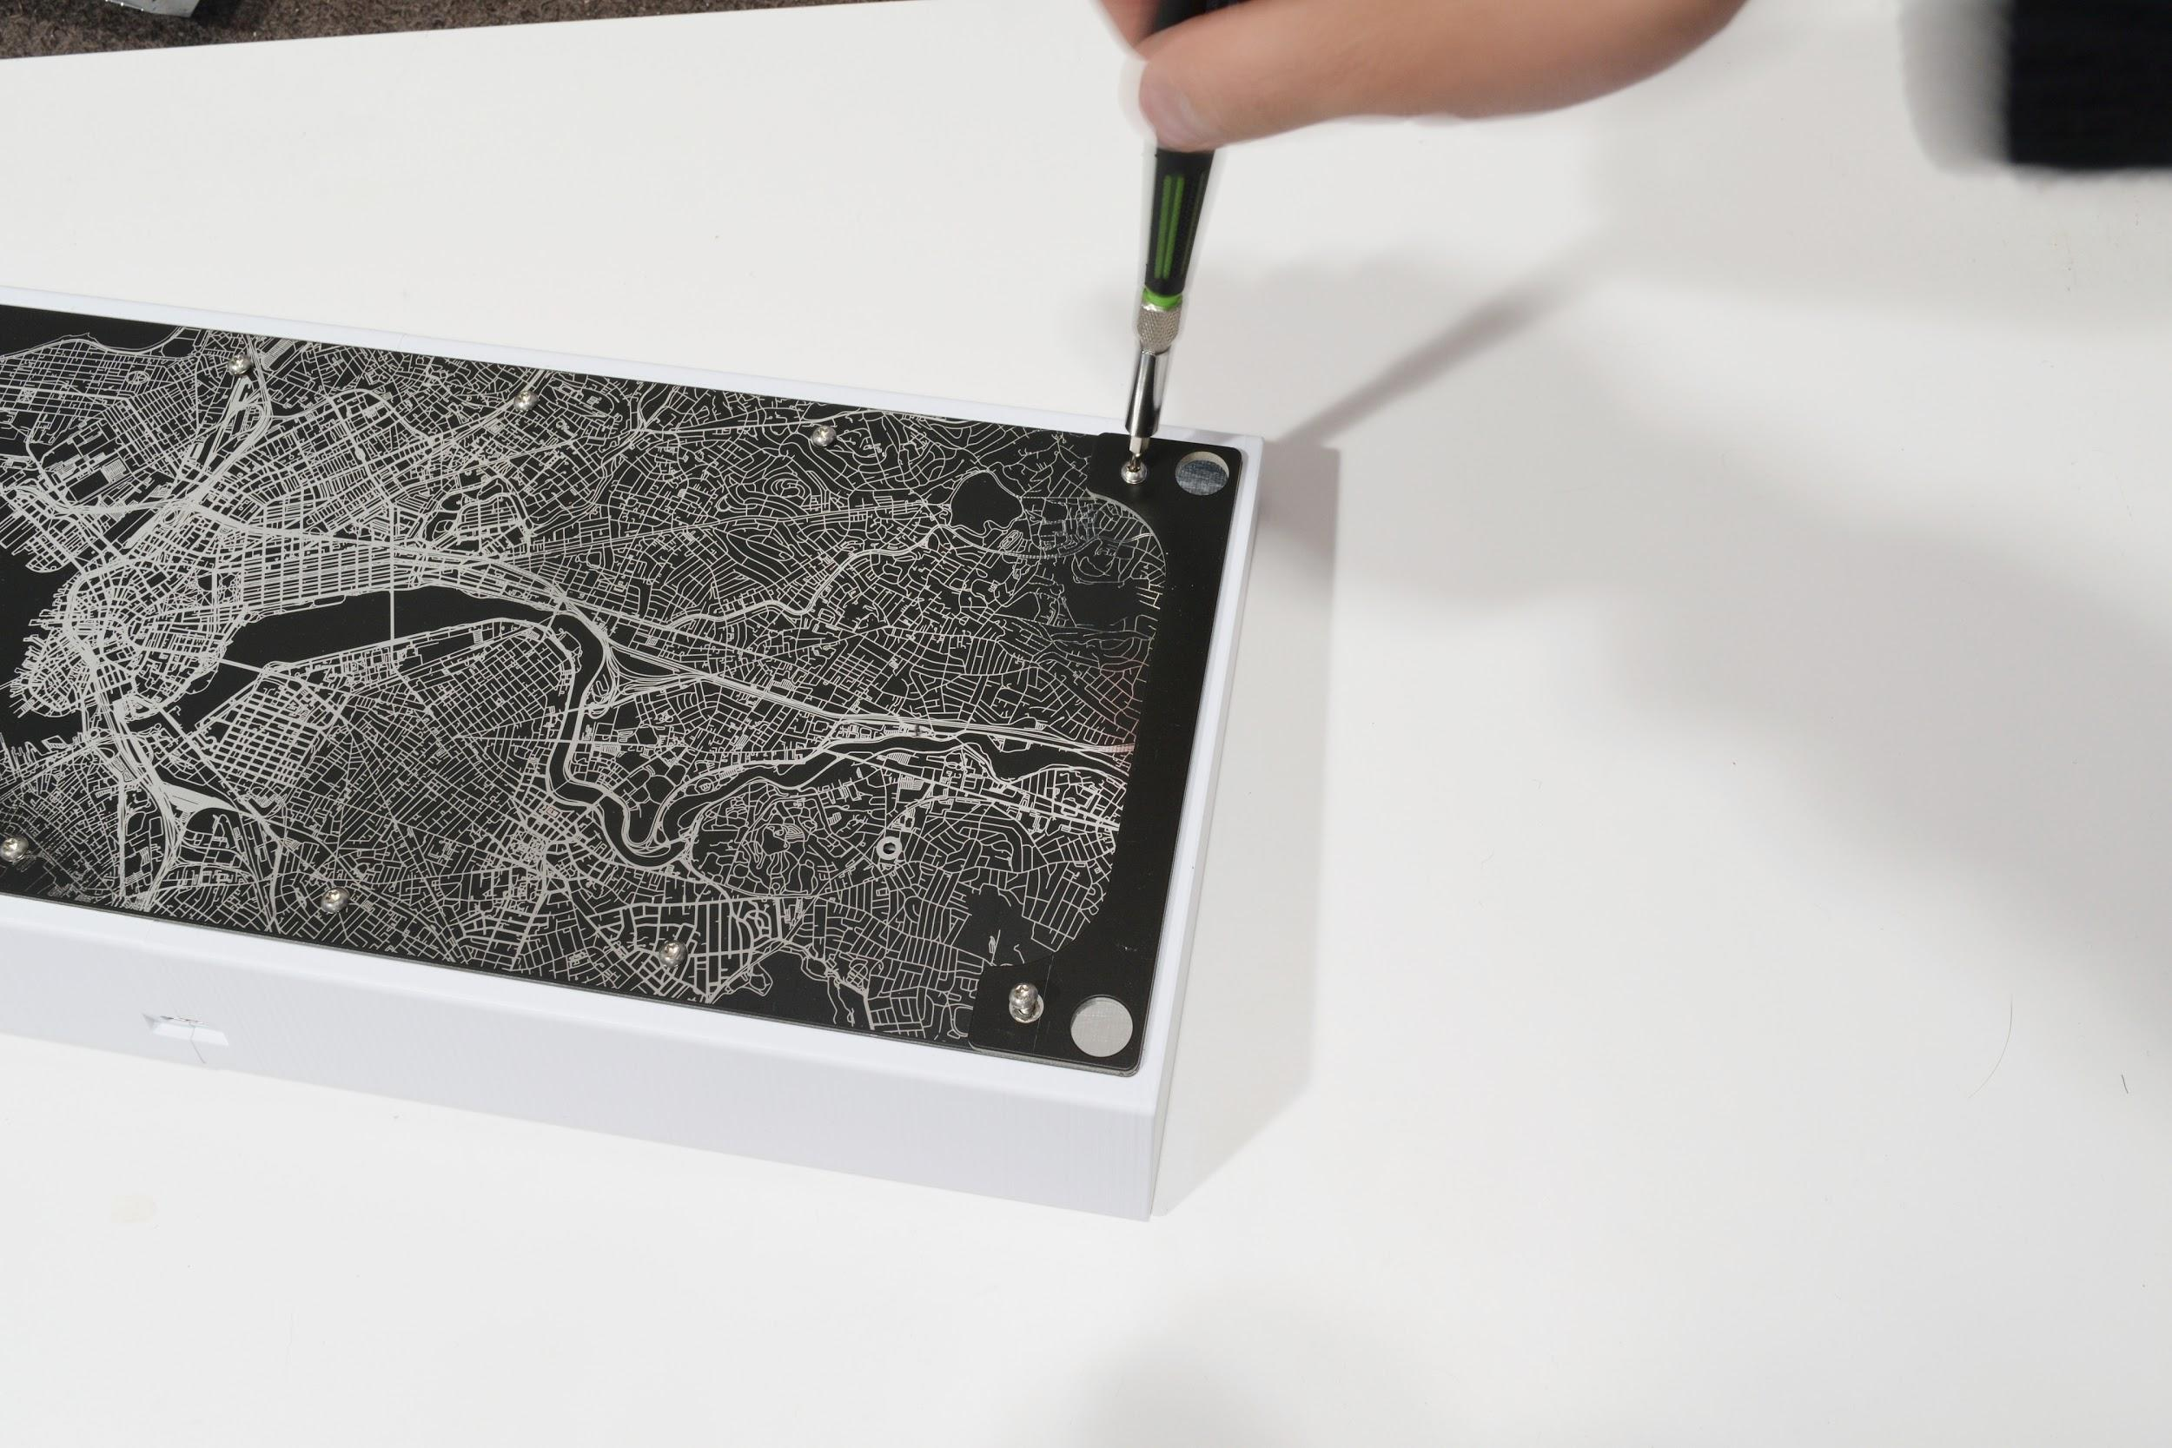

Once the rubber feet holders are installed, peel the rubber feet off from the backing sheet and stick them on the four corners.
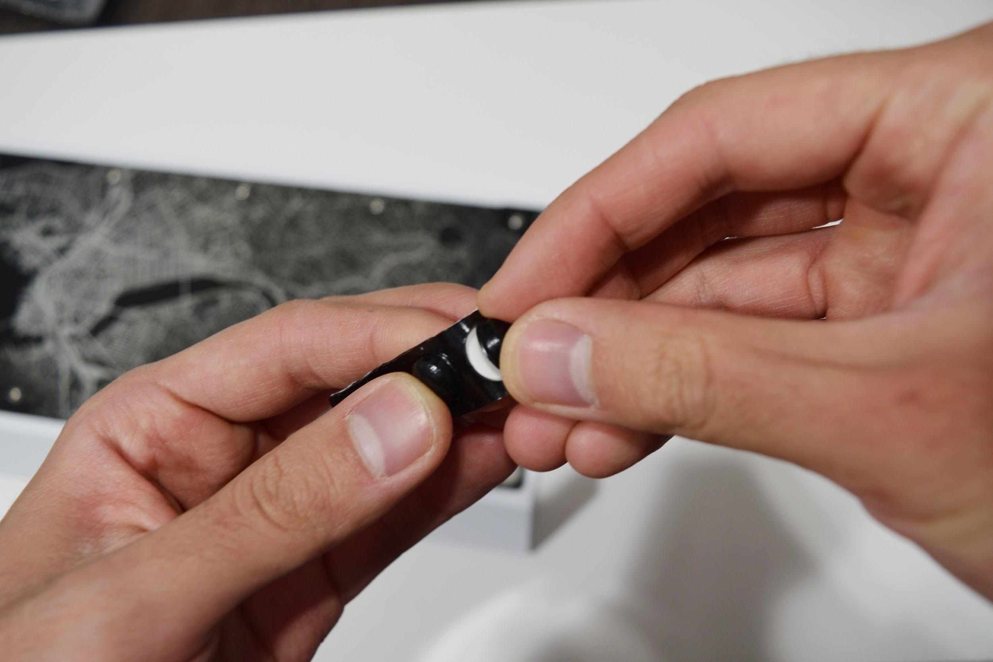
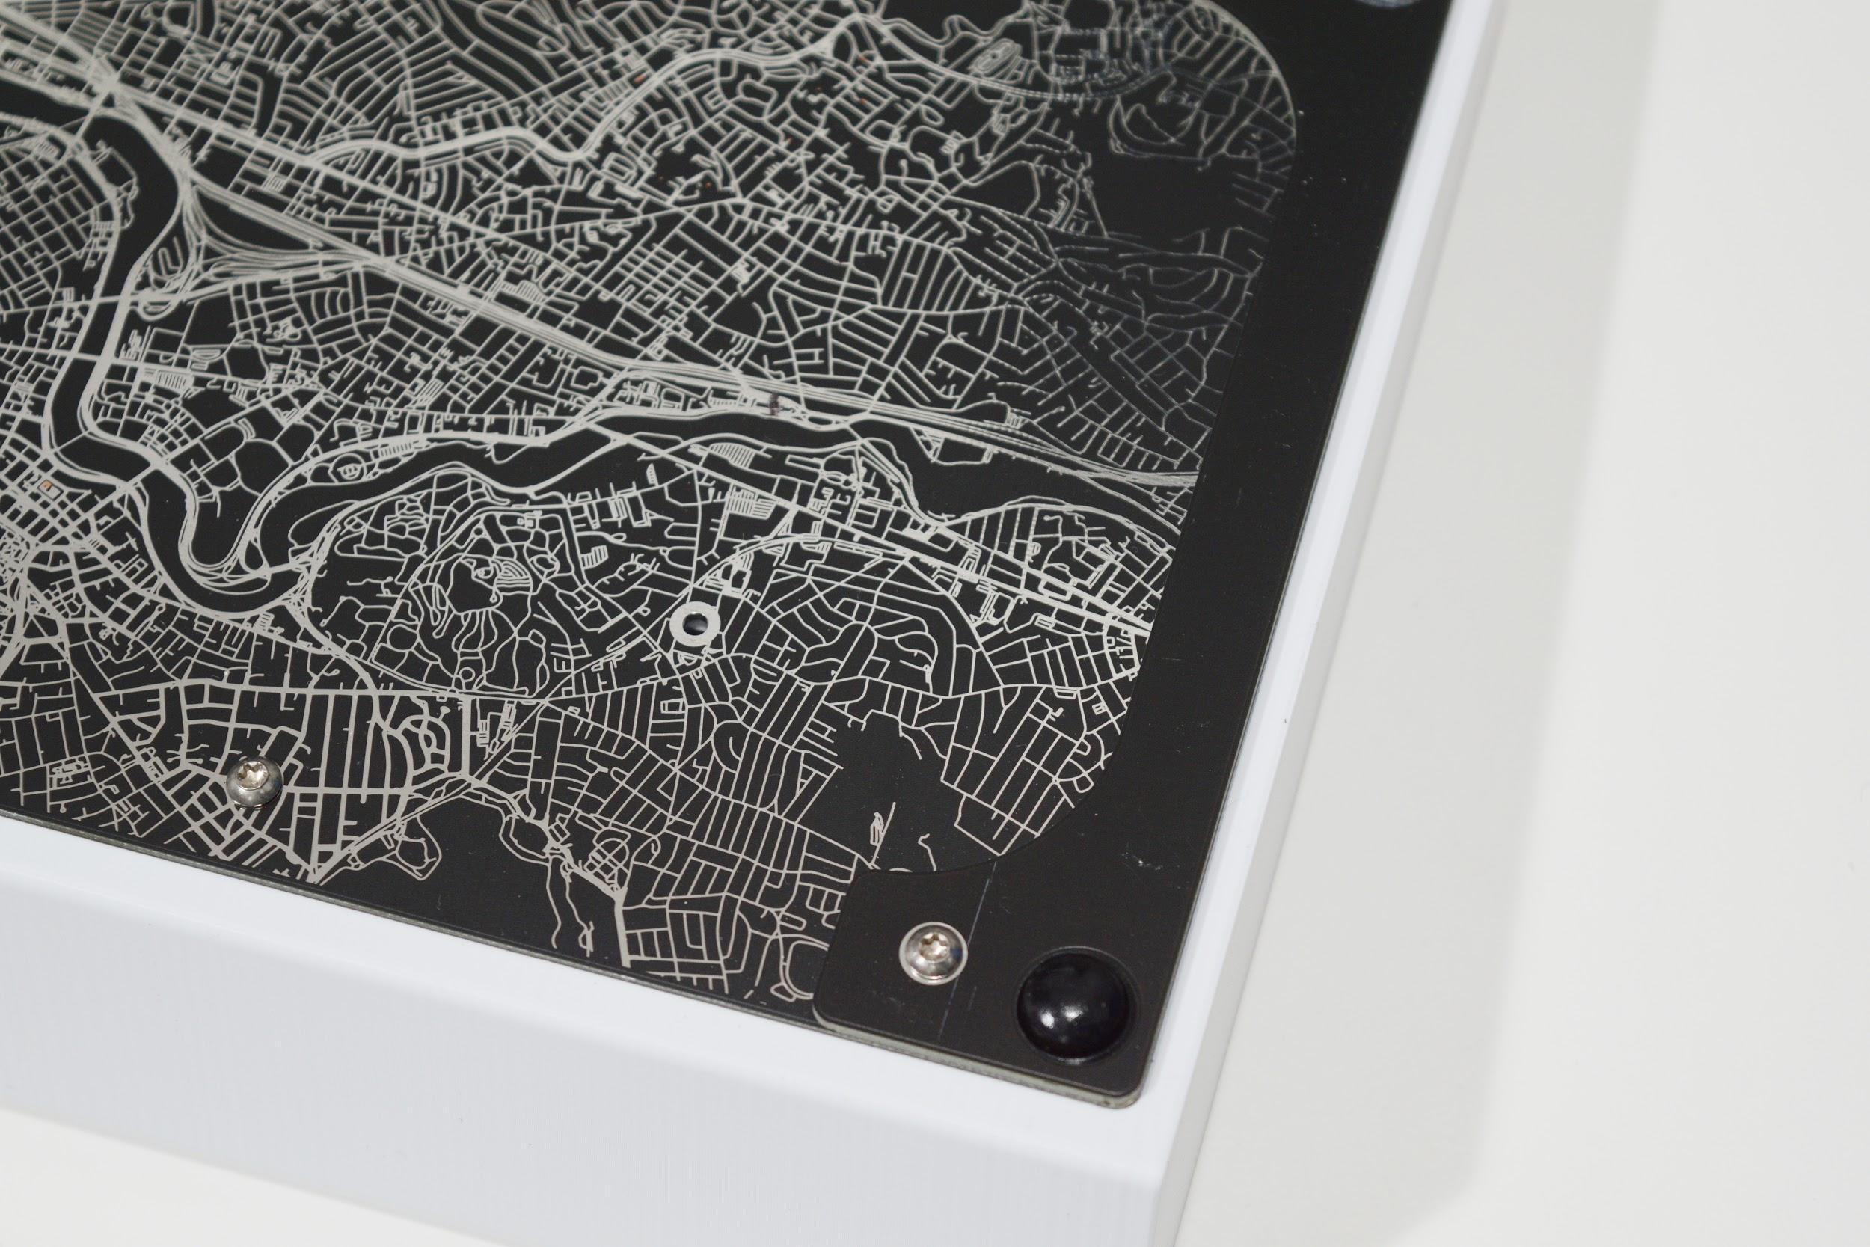

Leveling the keyboard

Next, take the keyboard and place it right-side up over a flat, level surface. Take your palm or forearm, and push the keyboard down against your flat, level surface, and tighten all the exterior case screws. This is to make sure the case and feet are flat and do not wobble.
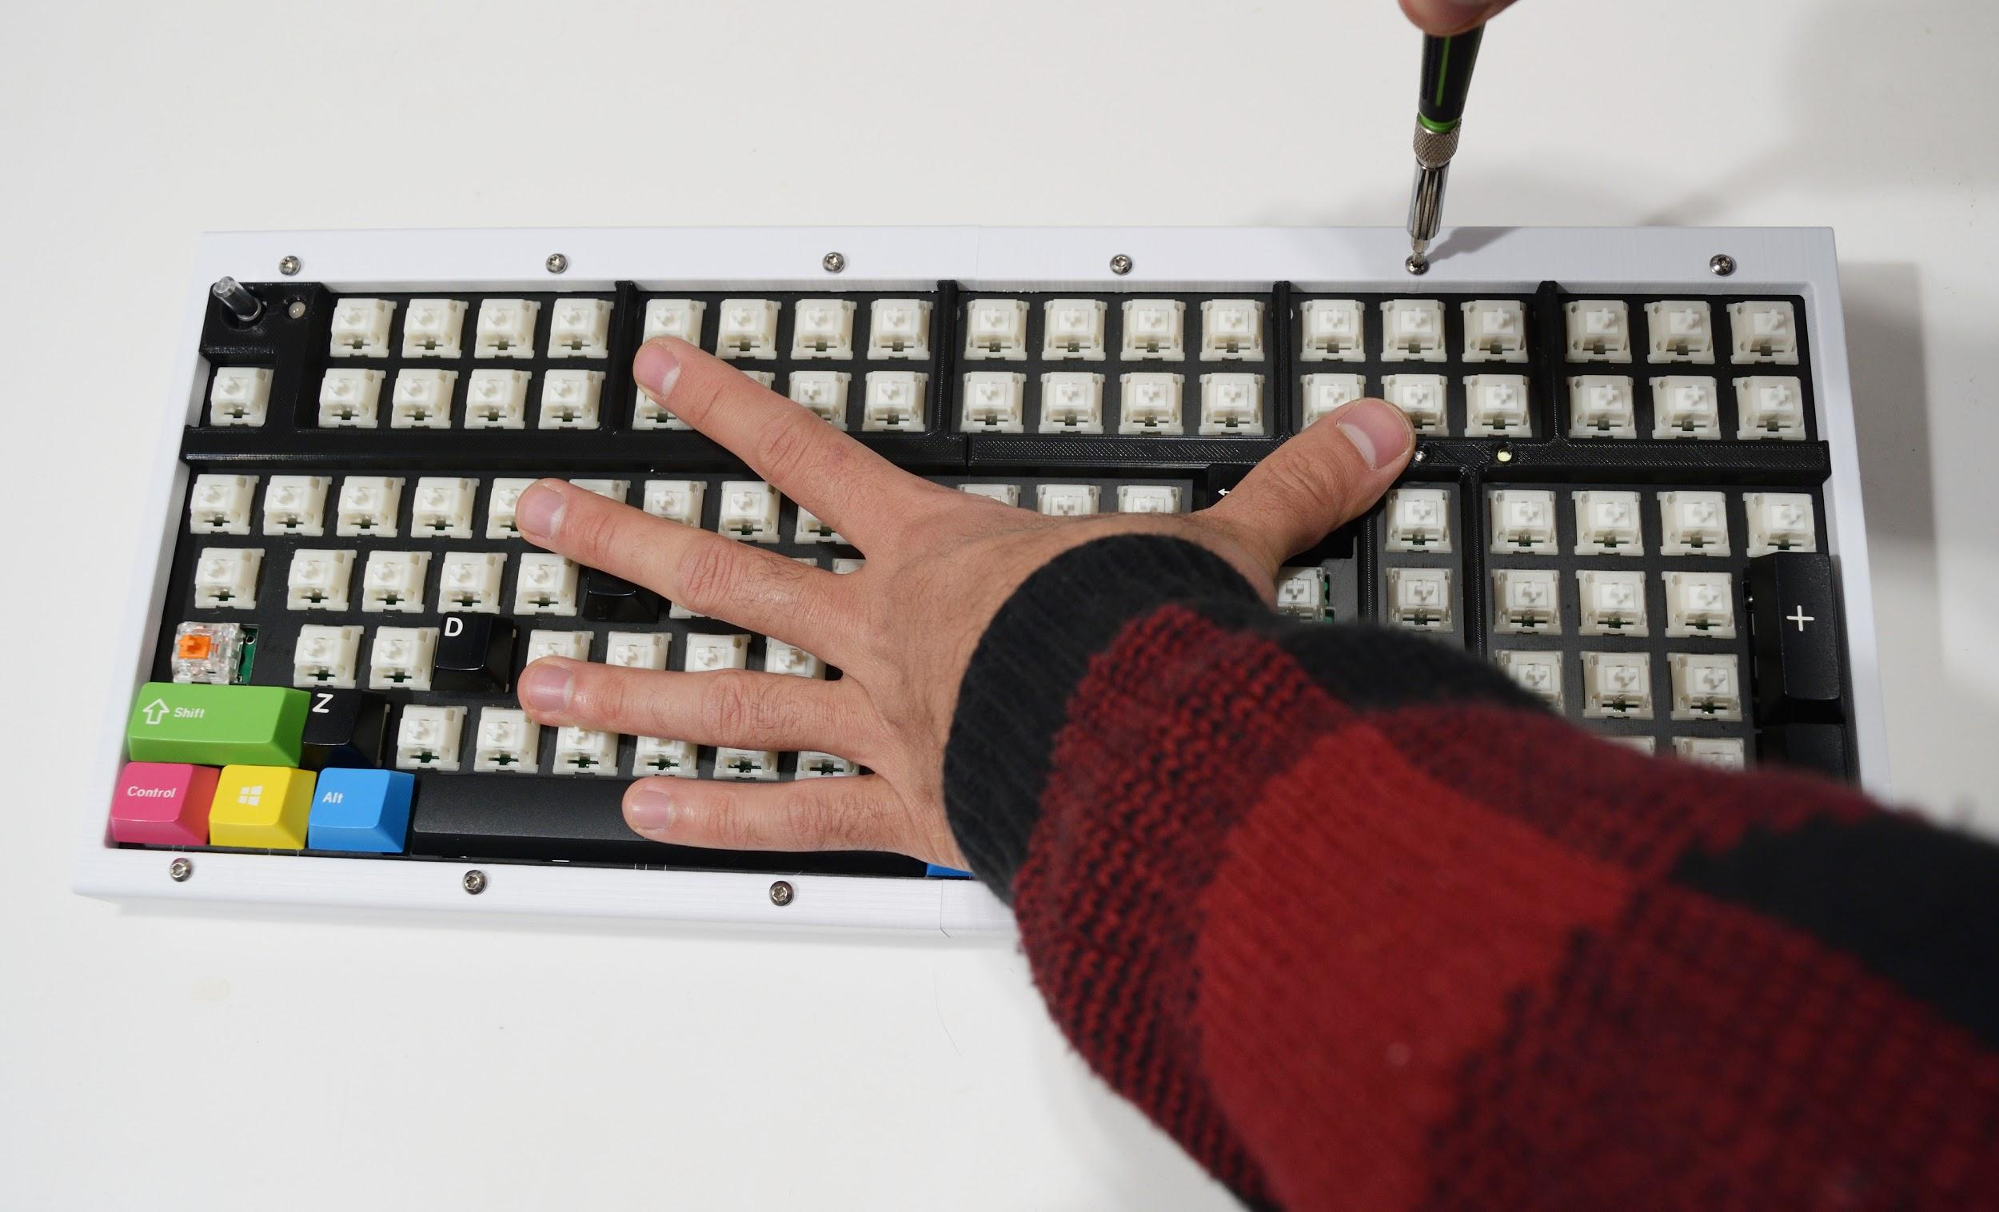
Once this is done, press down on the corners of the keyboard and make sure the keyboard doesn’t wobble or see-saw. If it still does, make adjustments as necessary. There may be a slight misalignment between the left and right case halves after this adjustment - this is normal, as unfortunately 3D printing is an imprecise process.
After all this, install the knob and keycaps. Plug the keyboard into a computer and check that it works (it may take a couple of seconds for the keyboard to initialize). You’re done!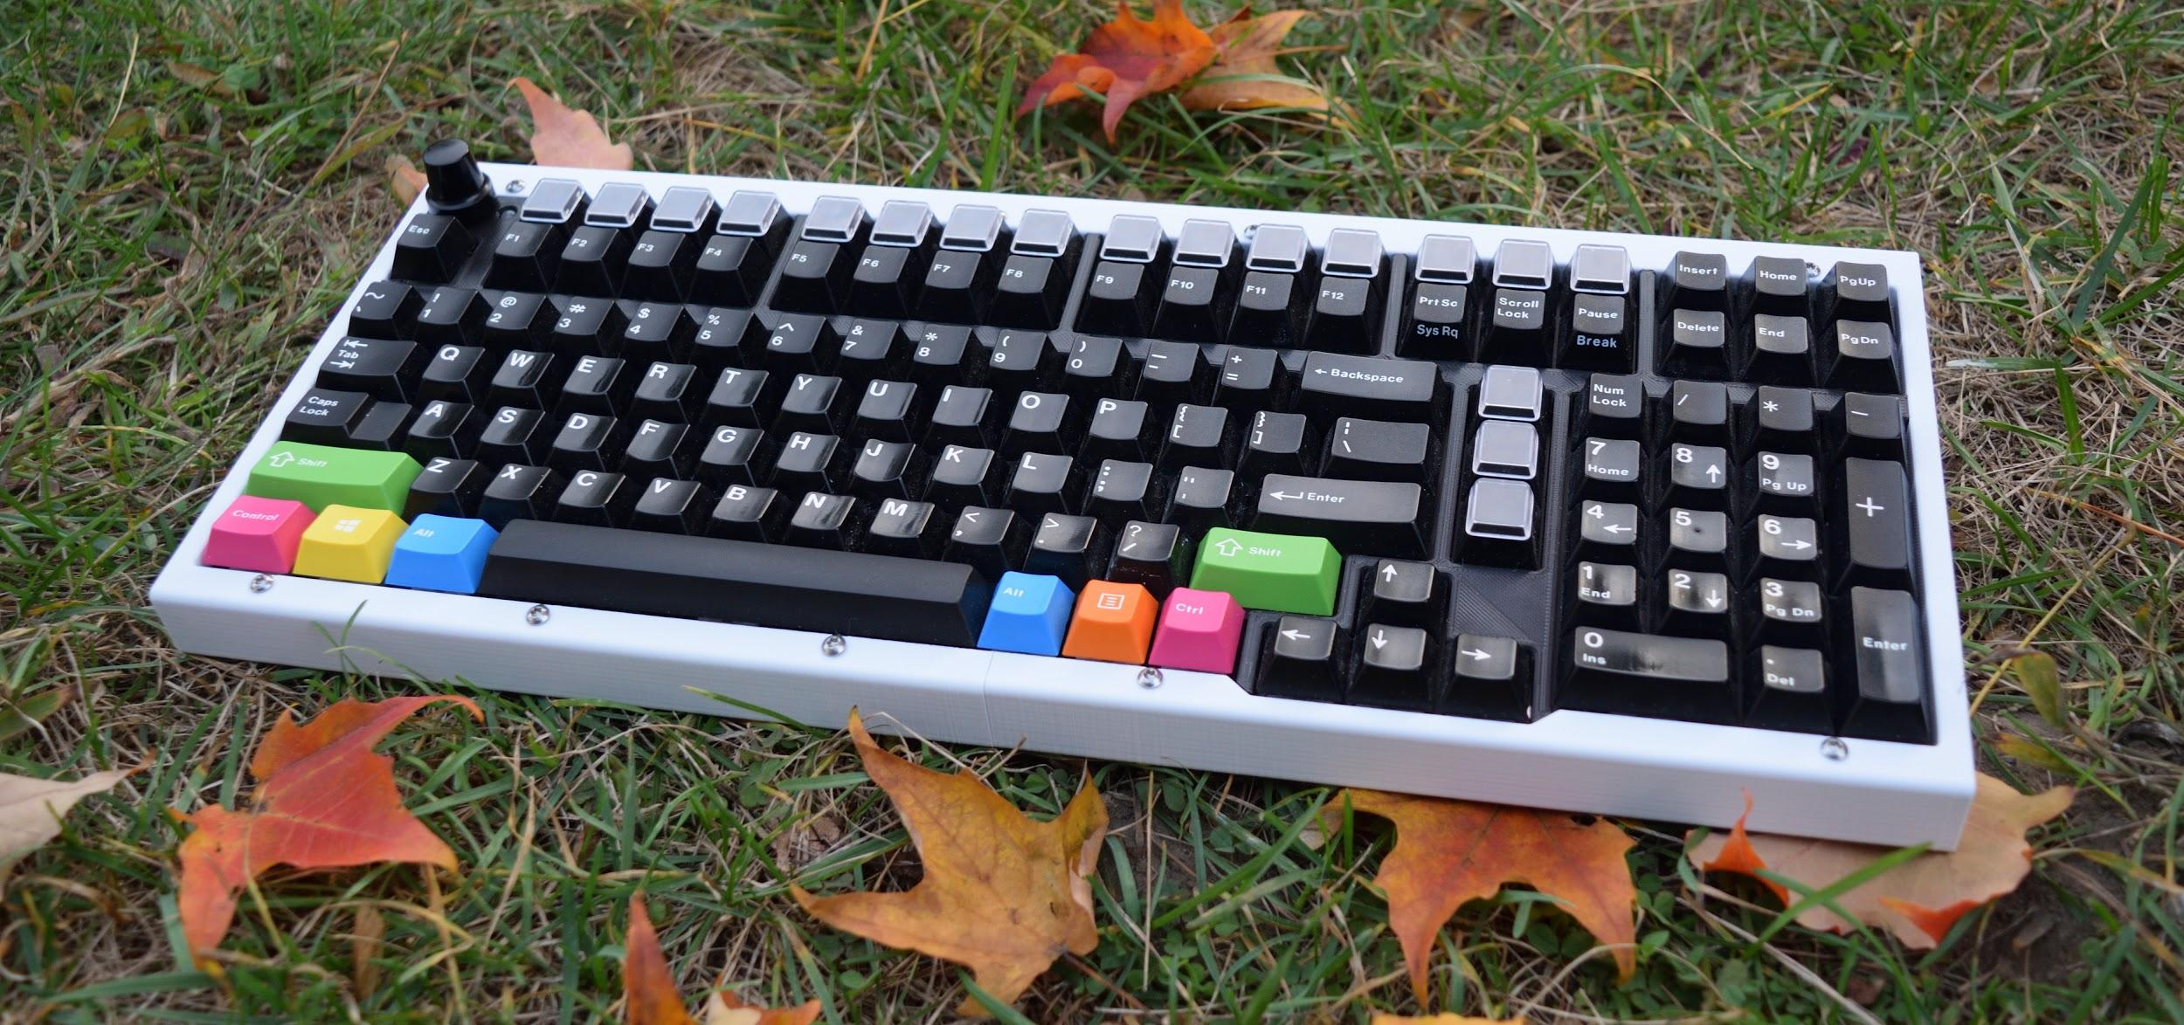

Part 5: Flashing Firmware
Your keyboard comes with a default keymap, but if you wish to customize the keymap, you’ll have to install DFU-UTIL to flash the keyboard over USB, and QMK to edit and configure keymaps and other features.
TBD (still working on QMK configurator)

